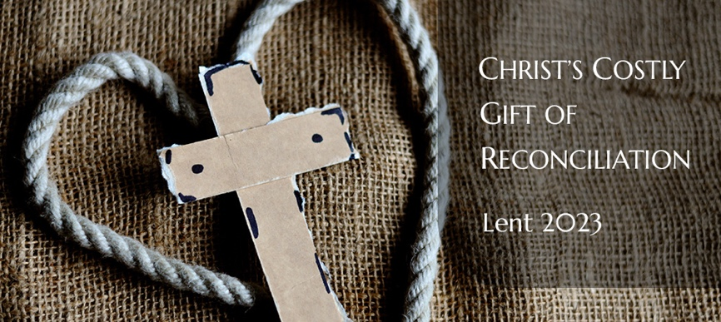

CHRIST’S COSTLY GIFT OF RECONCILIATION

WEEK 4

‘Reconciling a wounded land — learning from the Church in Sri Lanka’

Scripture: Romans 8: 18-30 NRSV (Anglicized)

Reflection

“It is our fervent prayer that ‘change’ will be achieved through peaceful means. We call for calm, restraint and patience among our people in this very tense and delicate situation.”
(Statement of the National Christian Council of Sri Lanka, 10th May 2022)

This week we pray with the people of Sri Lanka, and in support of the work of the National Christian Council of Sri Lanka, at a time of great uncertainty and political upheaval in that country. CTBI is supporting work by the National Christian Council of Sri Lanka (NCCSL) to deepen the spirituality of reconciliation through faith-centred engagement with the legacy of violence and division, and the resulting inequalities that exacerbate an uncertain political and economic future.

CTBI and some of its member churches have a long-standing relationship with the Church in Sri Lanka. This multination island state is a former British colony which provided substantial plantations for the British East India Company. Post independence, ethnic tensions resulted in decades of violent conflict between the Sri Lankan Government and the Liberation Tigers of Tamil Eelam, with a death toll of at least 60,000, and widespread displacement of people and other human rights abuses. Churches in Britain and Ireland supported the peace-building work of the Church in Sri Lanka, sharing experiences from the peace process in Ireland.

Our current project builds on that work with a focus on the theology of land. Much of the conflict in Sri Lanka has centred on questions of land. Landlessness and the absence of property rights are significant barriers to reconciliation and the securing of lasting peace. Through the project the NCCSL seeks to support the Church in engaging in self-critical reflection, to address its own blindspots and past failings, and ensure that its theology connects with the reality of people’s everyday lives, especially the most vulnerable and marginalised communities. Issues of land rights and land-centred conflict are explored through the lenses of climate justice, gender justice and conflict transformation, noting the many points of connection between these themes.

Throughout 2022 the NCCSL made a series of interventions on Sri Lanka’s deepening political and economic crisis. Church leaders recognised that youth had played a particularly significant role in instigating and leading the movement for change, and faced great risks to their safety: “We call upon the people, especially the Youth of our country who fearlessly made many a sacrifice denouncing the prevailing system of corrupt governance and for remedial reforms, to continue their peaceful, non-political agitation for the much- anticipated rule of law and governance, by respecting the existing governing laws of the country and to desist from any acts of damaging public or private property, including those of heritage value” (NCCSL, 21 July 2022). They called for the formation of an all-party government “so that all may rightfully live as citizens with equality and dignity” (NCCSL, 20 July 2022). At the level of local communities they placed particular emphasis on women’s leadership, organising a national conference that brought together women from different identity backgrounds with the theme ‘Tears in paradise and the need to stand together’, recognising that within the beauty of the Sri Lankan landscape lies a great depth of suffering that can only be healed by communities coming together.

In 2023 the project will have a major focus on marking two hundred years of the presence of the plantation community, brought to Sri Lanka by the British authorities for labour in the coffee and tea plantations. The NCCSL is working to highlight the contribution of this community to the economy of Sri Lanka and to the nation as a whole, while also seeking to highlight the challenges they face today, living without homes or postal addresses, working for less than a living wage. Through prayer and worship they will seek to create opportunities for witness, solidarity and repentance.

This week’s Scripture passage reminds us that God is present in the midst of our suffering, keeping before us the promise of reconciliation. We pray that God will bless the efforts of the NCCSL as it seeks to guide and support people through these challenging times.

Questions

- What can we learn from the approach of Church leaders in Sri Lanka to political upheaval and threats to democracy?
- Church leaders in Sri Lanka have been inspired by youth activists in their protests for change and have spoken out in support of them. Do you see similar support for youth activists in your Church?
- Do you feel the Church is sufficiently vocal on threats to democracy in your context?

Actions

- Visit the website of the National Christian Council of Sri Lanka (NCCSL) or follow it on social media to stay informed about its work. Share what you are learning with others to raise awareness.
- Explore how you could use the example of Sri Lanka, and the work of the NCCSL, to open up conversations about the legacy of colonialism and slavery and the practical ways in which the Church can promote healing and reconciliation.
- Could you include prayers for Sri Lanka as part of your worship at different times throughout the coming year to support the work of healing being undertaken by the NCCSL?

Prayer

Loving God,
We pray for the people of Sri Lanka
as they work to heal the wounds
of centuries-old injustice.
Give the churches in Sri Lanka
the courage to stay on this journey together,
through the National Christian Council of Sri Lanka
and working in partnership and friendship
with other faith communities.
May we be inspired by the coming together
of people of faith, and of women and youth from different backgrounds,
to make a courageous stand
for justice and a better future.
Help us to see that the individuals and communities in Sri Lanka
that have been stripped of their rights and dignity
are our neighbours
and to accept our responsibility
to help restore what has been taken from them.
Amen.

