
Week of Prayer for Christian Unity 2019

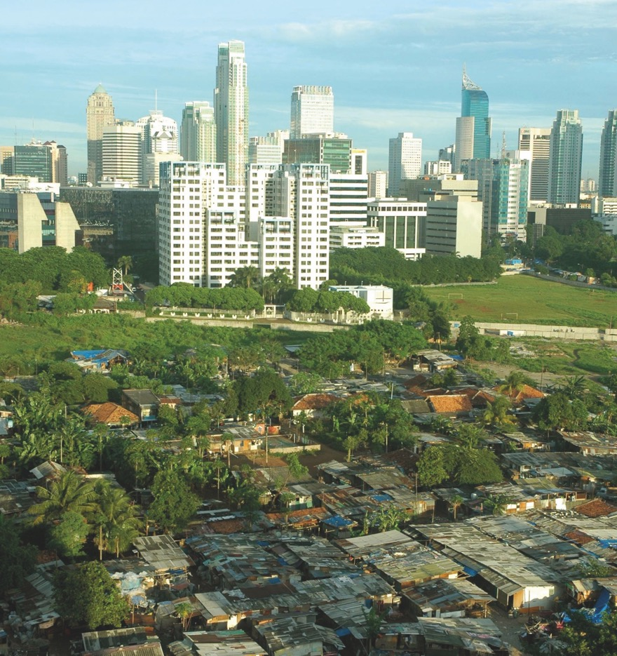


www.ctbi.org.uk/weekofprayer
Cyfiawnder yn Unig / Ceartas amháin
18-25 January
Welcome

St Antonius Padova Catholic Church, East Java

I am pleased to commend the materials for the Week of Prayer for Christian Unity 2019.

Last year we were invited to reflect upon the continuing impact of the Transatlantic Slave Trade upon Caribbean society and upon Christian unity and witness. This year we are reminded again that our prayer for unity is offered up amidst injustice and that Christian disunity is in so many ways related to the divisions in our world.

The Churches of Indonesia, from whom the material comes, speak out of a context of ethnic and religious diversity, and where there is a strong emphasis upon the need for a unity that is found in diversity, and one built on solidarity and collaboration. Yet they also highlight issues of economic injustice and how religious pluralism can face challenges in the face of radicalization.

This gives us an opportunity to reflect upon the context in which we pray for Christian unity. How do divisions in our society contribute to divisions in the Church? How does injustice in our British and Irish contexts create challenges in pursuit of our shared life together?

As in previous years the CTBI Writers Group has offered additional reflections and questions that I hope will enable a deepening prayer and reflection, along with suggestions for further action from Christian Aid.
Bob Fyffe, General Secretary,
Churches Together in Britain and Ireland
Only Justice

2
Introduction to this year’s theme
Our prayers for Christian unity are offered within a context of a world where corruption, greed and injustice bring about inequality and division. We ourselves are often complicit in injustice, and yet called together to form a united witness for justice and to be a means of Christ’s healing grace for a fractured world.

The Week of Prayer for Christian Unity 2019 material has been prepared by Christians from Indonesia, which is the largest country in South East Asia, made up of more than 17,000 islands, 1,340 different ethnic groups and over 740 local languages. It is united in its plurality by one national language Bahasa Indonesia. With some 86% of its 260 million people estimated to be Muslim, Indonesia has the largest Islamic population of any country. About 10% of Indonesians are Christian from various traditions, as well as Buddhist and Hindu communities. The nation is founded on five principles called Pancasila, with the motto Bhineka Tunggal Ika (Unity in Diversity). Across the diversity of ethnicity, language and religion, Indonesians have lived by the principle of gotong royong which is to live in “solidarity and by collaboration”. This means sharing in all aspects of life, regarding all Indonesians as brothers and sisters.

This harmony can be fragile at times and is threatened in particular ways. Gotong royong sits ill at ease with the neo-liberal approach to economics that has led to Indonesia’s economic growth - with that has come corruption that
Slums in Jakarta

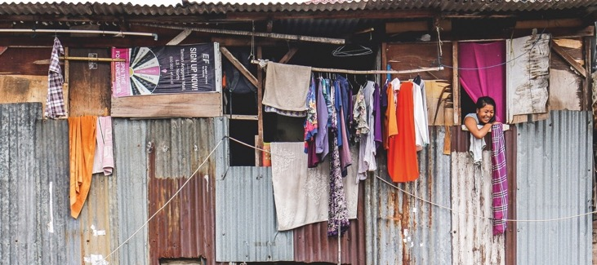

Week of Prayer for Christian Unity

3


Beautiful landscapes contrast with urban sprawl

infects politics and business, often with devastating effects on the environment. Meanwhile those who are supposed to promote justice and protect the weak fail to do so. As a consequence, a country rich in resources bears the burden of many people living in poverty. This is reflected in a traditional Indonesian saying, “A mouse dies of hunger in a barn full of rice”. Particular ethnic and religious groups are often associated with wealth in ways that have fed tensions. As a result the radicalization that pits one community against another has grown and is exacerbated by the misuse of social media to demonize particular communities.

A common Christian response to such a reality whilst acknowledging our own complicity, heeds Jesus’s prayer “that they all may be one”, and enables us to combat injustice.

Moved by these concerns the Christians of Indonesia found that the words of Deuteronomy, “Justice, and only justice, you shall pursue...” (see Deut. 16:18-20) spoke powerfully to their situation and needs. Before the people of God enter the promised land they renew their commitment to the Covenant. The passage comes in a chapter whose central theme is the festivities to be celebrated by the Covenant people. After each festival the people are instructed, “Rejoice during your festival, you and your sons and your daughters, your male and female slaves, as well as the Levites, the strangers, the orphans, and the
Only Justice

4

widows resident in your towns” (Deut. 16:14, see also 16:11). Indonesian Christians look to recover this same spirit of inclusive festivities across communities, which they previously enjoyed. This is rooted in justice, which is why we have a verse about appointing judges.
5

Jesus reaffirms this when he says that the Kingdom of Heaven belongs to those who hunger and thirst and are persecuted for justice (cf.Matt. 5:6, 10), and the Church is called to be a foretaste of this kingdom. However, in this disunity Christians fall short and fail to be a sign of God’s love for his people. Just as injustice has widened the divisions that have riven Indonesian society, so injustice has also fed the divisions of the Church. Indonesian Christians speak of the need to repent of the injustice that causes division, but also believe in the power of Christ to forgive and heal. They speak of finding themselves united under the cross of Christ, calling both for his grace to end injustice and for his mercy for the sin which has caused division.
Week of Prayer for Christian Unity

Surabaya, capital of East Java
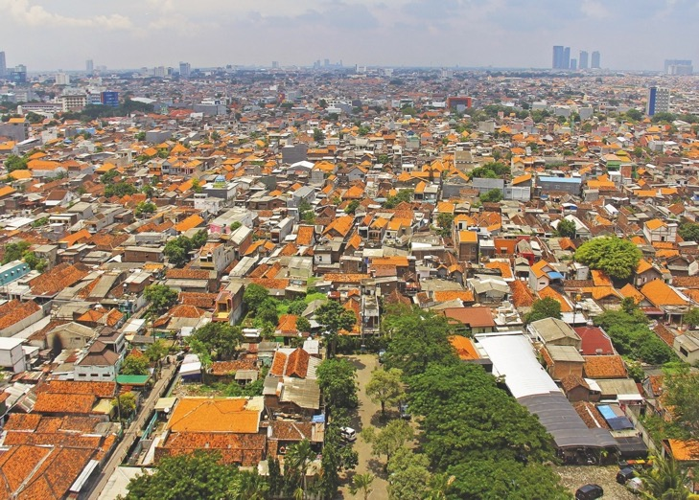

Amos 5:22-25
Luke 11:37-44


Dddd

Vvv

Starting Point
Christians in Indonesia recognize that in their land there are people who passionately try to practise their faith, but who oppress those of other beliefs. In the prophecy of Amos, God rejects the worship of those who neglect justice. In the Gospel of Luke, Jesus reminds us that the outward sign of true worship of God is acting justly. Christians can sometimes be very committed to prayer and worship, but less concerned for the poor and the marginalized. When, as Christians, we work together on justice issues we grow closer to one another and to God.
DAY 1
Only Justice

6


Reflection
At the table
we sit,
empty plates, but for a few crumbs.
Everyone’s had their fill again,
satiated,
at least for now.
Turning on the taps
we fill our bowls,
in the hope that the stains
will disappear.
The water cascades
over cup
and plate,
cleansing it
of any sign of human contact,
as if there had never been a meal.
In our polite conversation
and edgy discourse,
we fool ourselves
into thinking we are making
a difference.
We faithfully gather,
but are we just acting,
waiting,
for the others to speak up
as we wash our hands?

Let justice roll down like waters (Amos 5:24)

Prayer
God of all,
you have shown us the path
of justice.
You are the father of the orphan.
You are the constant companion of the widow.
You are the friend of the stranger.
In each of these,
may we meet you
and recognize the wind of
your Spirit,
moving us toward the need
for justice.
In all that we do,
may we know your grace and mercy
and offer healing and justice
in your name.

Questions
- How would you describe justice?
- Where have you recognized justice in action?
- Can we have unity without
justice?

Go and Do (see www.ctbi.org.uk/goanddo)
‘Charity is no substitute for justice withheld’.
Take time to reflect and remember campaign successes of the recent and distant past, e.g. the abolition of transatlantic slavery and the end of apartheid in South Africa. Visit Go and Do to read about recent successes in the campaign for tax justice.
Celebrate the successes and get together to discuss what action your community of churches could take to challenge injustice that is happening now. Visit Go and Do for some creative activism ideas.
7
Week of Prayer for Christian Unity

Ephesians 4:22-25

Matthew 5:33-37
Starting Point
The letter to the Ephesians presents a call for Christians to be honest and accountable to each other, so that we may grow in community. There is no place for deceitfulness, for it serves only to impair our relationships and so destroy that community. We are called
DAY 2

to live an authentic life of faith and stand up for the truth. Our yes must mean ‘yes’ and our no must mean ‘no’ – with no equivocal language or dishonest behaviour. Dishonesty disrupts the unity of the Church for which we are called to pray
and work.

Only Justice

8
Reflection
If I am to speak truth to power,
whose truth do I speak?
Whose justice do I seek
in the space between my
right-ness
and that of the ‘other’?
If I say ‘yes’ to justice,
does that make it all mine?
What of the grey between
the emphatics?
‘Let me declare boldly,
sure-footedly
that my yes is
a “yes-yes”, and my
no is “no”.’ Says Jesus.
‘Let me draw clarity
in the sand
that defines and refines knowledge, truth and tales

in such a way
that all are sure.
‘Let me dwell deep
in the place within
where, regardless of the
outward form
you know beyond doubt’s shadow,
that truth and justice,
peace and righteousness lie.
‘And let me,
in my boldness
turn widdershins
the hypocrisy of
those who confuse integrity
with fake-ness,
who obscure truth with falsehood
and call it news.
‘Let me boldly be good news.’

Prayer
God of justice,
grant me the wisdom to see
right from wrong.
Let my heart be guided by
honesty and my lips
speak truth.
In times of doubt, cloak me in
courage the colour of trust.
Birth in me the passion for unity
and peace
so that I may be a good news bearer for all.
In Jesus’ name I pray. Amen.

Let your word be ‘Yes, Yes’ or ‘No, No’ (Matthew 5:37)
Questions
- What does it feel like to have your words distorted?
- Look at on-line or paper
copies of current news items. Can you distinguish spin, or ‘fake news’ –
what are the markers of
such items?
- How, in our churches, do we
tell, or re-tell our own stories in order to set ourselves in a good light?

Go and Do (see www.ctbi.org.uk/goanddo)
Not everything we read or see in the news is true. ‘Fake news’ has become a catch-all term for stories that are deliberately made up and also those that have some truth to them but are not reported accurately.
Hold a newspaper reading breakfast for the churches in your area and take time to discuss the headlines and equip yourselves with the skills to discern what is true in this ‘post-truth’ age? Visit Go and Do to find out some steps for identifying fake news that you can discuss over breakfast.
Visit Go and Do to find out about and join the campaigns challenging the negative and scaremongering reporting in the media.
Week of Prayer for Christian Unity

9

Psalm 145:8-13
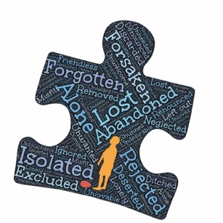
Matthew 1:1-17

Starting Point
Christians in Indonesia live within a context of great diversity. Indonesia is a nation of over 17000 islands and 1340 ethnic groups. The churches are often separated along ethnic lines, and some may wound the unity of the Church by regarding themselves as sole guardians of the truth. There are those who are excluded and pushed to the margins. The scripture passages for today remind us that the love of God transcends the boundaries of ethnicity, culture, race, and religion. God is broken with those who are broken. God stands outside with those who are excluded. God includes everyone in the plan of salvation and none are left out.
DAY 3
Only Justice

10

Reflection
Born
Endangered
Love - withheld misdirected
misused hidden from me
Broken
Untended
Self - withheld misdirected
misused hidden from me
Rejected
Cast away
Place - withheld misdirected
misused hidden from me
Found
Harboured
Love – offered whole healthy
including me
Broken
Tended
Self – offered whole healthy
including me
Accepted
Welcomed
Place – offered whole healthy
including me
Pain
Acknowledged
Love – chosen given
accepted returned

Healing
Started
Self – chosen given accepted
returned
Wholeness
Sometimes
Place – chosen given
accepted returned
God
born
broken
rejected
Life – restored remade
including me
The Lord is gracious and merciful to all (Psalm 145:8)

Questions
- Where do you see God’s grace and mercy in action?
- Who are those on the margins of your communities?
- What can you/we do to
engage those who feel beyond God’s reach?

Prayer
God of all humanity
your Son was born into a line
of men and women,
ordinary and extraordinary.
Some of them were remembered
for their great deeds,
others more for their sins.
Give us an open heart to share
your unbounded love,
and to embrace all who experience discrimination.
Help us to grow in love beyond prejudice and injustice.
Grant us the grace to respect the uniqueness of each person,
so that in our diversity we may
experience unity.
This prayer we make in your
holy name. Amen

Go and Do (see www.ctbi.org.uk/goanddo)
God stands with those who are most marginalized. Consider how your churches might join with those who are most marginalized in our societies. Contact local organizations working to support destitute asylum seekers and find out how you can help best. Visit Go and Do to find out more.
Take action to ensure those who are displaced but excluded from the UN resolutions on rights of refugees are included and given the support they need. Visit Go and Do to find out more.
Week of Prayer for Christian Unity

11

Dates
The Week of Prayer for Christian Unity is traditionally observed from 18th to 25th January (the octave of St Peter and St Paul). However, some groups choose other times of the year, particularly around Pentecost which is a symbolic date for the unity of the church. Do make your own decision, taking local factors into account. To allow for use at any time in the year, the Days material uses the notation 1-8.
Order of service
The order of service in the centre of the pamphlet can be pulled out and photocopied if you wish. Alternatively, all resources can be downloaded from the CTBI website and you are welcome to further edit or adapt them for local use. Please acknowledge the source of material as Churches Together in Britain and Ireland, Week of Prayer for Christian Unity resources.
Christian unity wall
Please add details and photos of your events, prayers and messages of unity to the Christian unity ‘wall’ at www.weekofprayer.org by posting to Twitter using #wpcuwall hashtag. Posts appear automatically (after a slight delay).
Photo credits
Grunge rule: based on Indonesian flag by Freestock.ca/Nicolas Raymond
p1/36/reflections: based on Indonesian flag by Freestock.ca/Nicolas Raymond
p1/13: Flickr /Argo Negoro
p3: Flickr /Abraham Arthemius
p27: Flickr / Mararie
p29: Flickr / Lavinia Elysia
p31: Flickr / Everyone Sinks Starco
p33: Flickr / Budi Nusyirwan
12



Order of Service

Justice and only justice you shall pursue
(Deuteronomy 16:18-20)
Week of Prayer for Christian Unity 2019

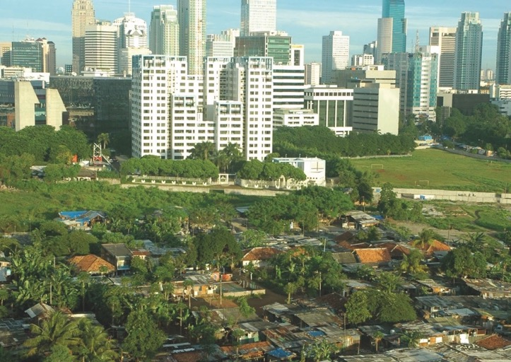

Photo: Flickr / Argo Negoro

© Churches Together in Britain and Ireland
Photo: Flickr /Argo Negoro



Call to worship
Only Justice

14

Leader Let us worship the Triune God.
God, our Father, you crown your creation with justice
and mercy.
Congregation We come to worship you.
Leader Jesus Christ, your cross brings new life and justice,
Congregation We come to worship you.
Leader Holy Spirit, you inspire our hearts to act justly,
Congregation We come to worship you.
Leader May the grace of the Lord Jesus Christ, and
the love of God, and the communion of the Holy Spirit
be with you all.
Congregation And also with you.

Gathering hymn of praise (chosen locally)
Introductory words
Leader As Christians from different churches, we gather here to pray
for unity. This year, we pray with the churches of Indonesia,
whose chosen theme is “Justice, and only justice,
you shall pursue”.



Prayer of repentance
Leader Beloved sisters and brothers, let us confess before God that we have sinned. We ask for forgiveness.
Reader 1 Compassionate God,
Jesus ate with outcasts and sinners. We confess that we
prioritize those of higher social status, that we ignore
strangers, the poor and the least in society and that we fear to defend the oppressed.
Lord, have mercy.
Congregation Lord, have mercy. (This response may be sung)
Reader 2 Righteous God,
you call us, the Church in every place, to act justly. We confess
that we misuse Church resources and power. This causes some
people to turn away.
Lord have mercy.
Reader 3 Loving God,
Jesus challenged us to love one another. We confess that we view
other churches as rivals and disregard those who do not share our point of view.
Week of Prayer for Christian Unity

15
Lord, have mercy.
Congregation Lord, have mercy.
Reader 4 Gracious God,

You call us all to love without discrimination. We confess that
we disrespect our neighbours, spread falsehood and gossip,
and participate in the disruption of social harmony.
Only Justice

16
Lord, have mercy.
Congregation Lord, have mercy.
Leader May almighty God have mercy on us, forgive us our sins and
lead us to eternal life.
Congregation Amen.
Hymn/Song
Proclamation of the Word of God
Let us listen for the word of God in the Old Testament
First reading: Deuteronomy 16:11-20
This is the word of the Lord
Thanks be to God
Responsorial Psalm: 82:1-8 (read or sung)
Rise up, O God, judge the earth.
Rise up, O God, judge the earth.
God has taken his place in the divine council;
in the midst of the gods he holds judgement:
‘How long will you judge unjustly


and show partiality to the wicked?’
Rise up, O God, judge the earth.
Give justice to the weak and the orphan;
maintain the right of the lowly and the destitute.
Rescue the weak and the needy;
deliver them from the hand of the wicked.
Rise up, O God, judge the earth.
They have neither knowledge nor understanding,
they walk around in darkness;
all the foundations of the earth are shaken.
Rise up, O God, judge the earth.
I say, ‘You are gods,
children of the Most High, all of you;
nevertheless, you shall die like mortals,
and fall like any prince.’
Rise up, O God, judge the earth;
for all the nations belong to you!
Rise up, O God, judge the earth.
Hear the Gospel according to St Luke.
(An Alleluia may be sung according to local custom)
Gospel reading: Luke 4:14-21
This is the Gospel of Christ.
Praise to Christ our Lord.
(An Alleluia may be sung according to local custom)
Week of Prayer for Christian Unity

17

Sermon on theme of our common commitment to justice
A sermon ‘starting point’ can be found at
https://ctbi.org.uk/week-of-prayer-for-christian-unity-resources
Commitment to Justice, Mercy and Unity
Leader Jesus Christ prayed for the unity of his disciples.
The gift of his life is justice for the world.
Reader 1 As members of the body of Christ, we are called to walk
humbly and act justly.
Let justice roll down like waters.
Congregation Holy Spirit, unite us in our prayers.
Reader 2 As members of the body of Christ, we are called to speak
out against injustice.
Let our word be ‘Yes, Yes’ or ‘No, No’.
Congregation Holy Spirit, unite us in our words.
Only Justice

18
Reader 3 As members of the body of Christ, we are called to lavish God’s grace and mercy on all.
Let us break through barriers of ethnicity, religion
and culture.
Congregation Holy Spirit, unite us in our humanity.
Reader 4 As members of the body of Christ, we are called to keep our lives free from the love of money, and be content with what we have.
Let us break the cycle of greed and live in simplicity.

Congregation Holy Spirit, unite us in our weakness.
Reader 5 As members of the body of Christ, we are called to bring good news to the poor.
Let us condemn exploitation and the systems that perpetuate it.
Congregation Holy Spirit, unite us in anger towards injustice.
Reader 6 As members of the body of Christ, we are called to care for the whole of creation.
Let us protect the life and beauty of all that God has made.
Congregation Holy Spirit, heal us and restore us.
Reader 7 As members of the body of Christ, we are called to treat all
with dignity.
Let us recognize discrimination, oppression and abuse.
Congregation Holy Spirit, open our ears to the cries for justice.
Reader 8 As members of the body of Christ, we are called to bring hope
to others.
Let us be salt and light.
Congregation Holy Spirit, unite us in hope for justice.
We have just asked the Holy Spirit to unite us in action. In a few moments we will have time to consider what commitment each one of us can make to justice. As you entered the church you were given two different coloured cards. Write your commitment on both of them. They will be collected in two baskets, one for each colour. One basket will be offered to God, the second basket is for our
Week of Prayer for Christian Unity

19

Churches Together group (or whichever group has organized this service) so that we can consider how to enable our congregations to carry out these commitments.
So take a moment now to consider. What step, however small, can you take to further God’s justice in our broken world?
(A song for unity and/or justice may be sung by the choir or music played as the congregants write their commitments.)
(Near the end of this song/music, ushers collect the cards in two baskets. One is
presented to a representative of the Churches Together group, and the other is put at the foot of the cross.)
Offering
Leader What does the Lord require of you but to do justice, and to
love kindness, and to walk humbly with your God?
(Micah 6:8) We commit ourselves to acts of justice.
Gracious God,
you have shown us your compassion and care for all creation.
Your love inspires us to offer these commitments to act justly
by loving others wholeheartedly regardless of their cultural, ethnic, and religious backgrounds. Accept now our offerings and transform them into action for the unity of your church. We ask this through your Son Jesus Christ, in the power of the Holy Spirit, who live with you as one God forever and ever.
Only Justice

20
Congregation Amen.

The Nicene Creed
We believe in one God,
the Father, the Almighty,
maker of heaven and earth,
of all that is, seen and unseen.
We believe in one Lord, Jesus Christ,
the only Son of God,
eternally begotten of the Father,
God from God, Light from Light,
true God from true God,
begotten, not made,
of one Being with the Father;
through him all things were made.
For us and for our salvation
he came down from heaven,
was incarnate of the Holy Spirit and the Virgin Mary
and became truly human.
For our sake he was crucified under Pontius Pilate;
he suffered death and was buried.
On the third day he rose again
in accordance with the Scriptures;
he ascended into heaven
and is seated at the right hand of the Father.
He will come again in glory to judge the living and the dead,
and his kingdom will have no end.
We believe in the Holy Spirit, the Lord, the giver of life,
who proceeds from the Father [and the Son],
who with the Father and the Son is worshiped and glorified,
who has spoken through the prophets.
We believe in one holy, catholic and apostolic Church.
Week of Prayer for Christian Unity

21

We acknowledge one baptism for the forgiveness of sins.
We look for the resurrection of the dead,
and the life of the world to come. Amen.
Prayers of intercession
Leader Let us raise to God our common prayer for the Church and for the needs of all humanity.
Reader From the islands and the oceans,
we worship you, O God, the Creator of life.
Throughout the mountains and the valleys,
we praise you, O God, the Saviour of the world.
With the tongues of all nations,
we thank you, O God, the Comforter of bodies and souls.
We come before you bearing our burdens and hopes.
Today we ask you:
Congregation O God, hear our prayer and grant us your love.
Reader We pray for those who live with injustice.
Encourage us to lift up their voices and strengthen their hope.
We pray for those who continue to perpetuate injustice.
May your kindness transform their hearts and make them agents of freedom and peace.
We pray for every institution and every person who stands
for justice.
Let us act justly according to your words.
Today we ask you:
Congregation O God, hear our prayer and grant us your justice.
Only Justice

22

Reader We pray for the visible unity of the Church.
We celebrate the rich diversity of your people.
May we be compelled to fulfil Jesus’ prayer that we may be one
and work together to live your Kingdom.
Today we ask you:
Congregation O God, hear our prayer and grant us a passion for unity.
Reader We thank you for the many colours, cultures, and customs of
our world.
In our differences, unite us by your love.
Enable us to act together to uphold life
and to make this world a just and peaceful household for
all humanity.
Today we ask you:
Congregation O God, hear our prayer and grant us your peace.
The Lord’s Prayer
Our Father in heaven,
hallowed be your name,
your kingdom come,
your will be done,
on earth as in heaven.
Give us today our daily bread.
Forgive us our sins
as we forgive those who sin against us.
Save us from the time of trial and deliver us from evil.
For the kingdom, the power, and the glory are yours now and for ever.
Week of Prayer for Christian Unity

23
Amen.



Hymn/Song
(during which the basket which is in front of the cross is taken to the door)
Sharing peace
The leader invites the assembly to exchange a sign of peace.
Leader As you leave this gathering you will be invited to take one
commitment card from the basket. We invite you to pray for the person who has made that commitment.
Blessing
Leader May God embrace you with love
and make kindness flow out from you.
May God ignite courage within you
and transform you into agents of justice and peace.
May God grant you humility
and give you perseverance to nurture unity.
Congregation Amen!
Invite people to take a card from the basket as they leave.
Bible verses from the New Revised Standard Version Bible: Anglicized Edition,
copyright 1989, 1995, Division of Christian Education of the National Council of
the Churches of Christ in the United States of America. Used by permission.
All rights reserved.
English translations of Lord’s Prayer and The Nicene Creed © 1988 English Language Liturgical Consultation (ELLC). www.englishtexts.org. Used by permission.
Only Justice

24

Acknowledgements
CTBI WPCU 2019 Writers

Each year Churches Together in Britain and Ireland (CTBI) works in collaboration with various writers from within the four nations to produce these materials for your use. In acknowledgment of this collaboration we have listed below the colleagues who have helped us accomplish this task for 2019:
Revd Dr Adrian Burdon (Moderator) - Superintendent Minister of the Shaw and Royton Circuit, Manchester
Jenny Bond - Churches Together in England
Revd Peter Colwell - Deputy General Secretary, Churches Together in Britain and Ireland
Ruth Harvey - Director of Place for Hope, Church of Scotland Minister and a member of the Religious Society of Friends
Doral Hayes - Executive Development Officer, Association of
Interchurch Families
Phillip Mellstrom - Worship Development Worker, Church of Scotland
Dr Siôn Aled Owen - Geirda Language Services
Denise Tapfumaneyi - Office Administrator, Churches Together in Britain and Ireland
Wendy Young - Church Resources Officer, Christian Aid
Week of Prayer for Christian Unity

25

Hebrews 13:1-5
DAY 4
Matthew 6:25-34
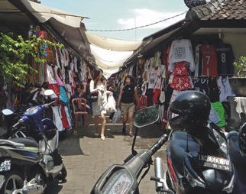

Shopping in Bali

Starting Point
God’s goodness has provided ample food and fresh water to sustain life for all and yet many people lack these necessities. Human greed frequently leads to corruption, injustice, poverty and hunger. Jesus teaches us not to be concerned about accumulating more material things than we need. We should, rather, be concerned with proclaiming the Kingdom of equity and announcing God’s reign of justice. Christians are called to live lives which enable the waters of justice to flow.
Only Justice

26

Reflection
I scrape together
the crumbs of my excess,
perhaps enough to feed
the sparrows?

I soak up
the spilling over of my cup,
perhaps enough to drown
my sorrows?

I ask myself,
when is enough
ever going to be enough?

You ask me
if I can spare any change
and I worry
that I do not have enough

enough good reason
enough good will
enough compassion
enough empathy
enough humanity
enough energy
enough desire
enough courage
to make the change that is
sorely needed

Prayer
God of the seasons,
whether in bountiful harvest,
or when there is no yield for what
we have sown;
let us be content,
that your grace is sufficient.
Help us to have the generosity
of spirit,
to share what we have
with those who have not.
May we all be blessed
with love, grace, compassion
and mercy,
as we seek to walk humbly
and do justly,
for your name’s sake. Amen.

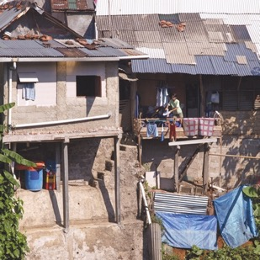

Be content with what you have (Hebrews 13:5)

Slums in Bogor

Questions
- Share a story of a time when
you did not have enough – how did you feel?
- What do you find the most difficult thing to share?
- What do you find the most difficult thing to receive?

Go and Do (see www.ctbi.org.uk/goanddo)
Pay attention to the advertising messages you receive, on buses, billboards, TV, newspapers, online. Reflect on the messages that we are absorbing everyday about what we supposedly need.

Reflect on your identity as a consumer and consider the steps we can take as individuals and as a community of churches to live simply so others can simply live?

Plan a Lent journey between the churches in your area that involves a fast from buying and how we might count and share our blessings instead. Visit Go and do to find out more.
Week of Prayer for Christian Unity

27

Amos 8:4-8
Luke 4:16-21
DAY 5

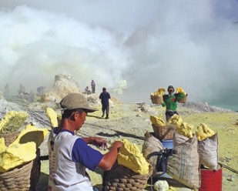

Starting Point
The prophet Amos criticized traders who practiced deceit and exploited the poor. God, who sides with the victims of injustice, will not forget such wrongdoing. In a globalized world, such marginalization, exploitation and injustice is rampant. The gap between rich and poor is becoming wider. Economic demands become the deciding factor in our relationships and the demands of justice are more and more pushed to the side-lines. Christians are called to challenge the prevailing attitudes and to work for justice.
Only Justice

28

Reflection
I’ll believe it when I see it!
I’ve heard it all before!
‘Things can only get better’
‘Audacity of hope’
Promises of something new!
Good news?
They are just bus-slogans when
the poor remain poor,
the vulnerable abused and no-one speaks out!
Do you think I can jump up
and dance
when my hands and feet are made
heavy with the anger from broken promises?
And so I stare at you,
because to stare is all I can do.

But
if ‘good news’ means
rising up against power,
overturning the tables down the
road in the big city,
walking, talking and eating with
people like us,
going the whole way with us,
not departing when things get
too tough,
even when the suffering becomes
too great to endure,
this would truly be something new. It would be good news fulfilled.
Then I could be tempted to trust
one more time.

To bring good news to the poor (Luke 4:18)

Prayer
God, the bringer of good news,
forgive our lust for power
and free us from the temptation
to oppress others.
Instil in us the determination
to see your good news made real
in us and those around us,
as we share in the mission of
your Son Jesus
to fulfil your promise of freedom
from poverty and oppression.
We pray in his name. Amen.

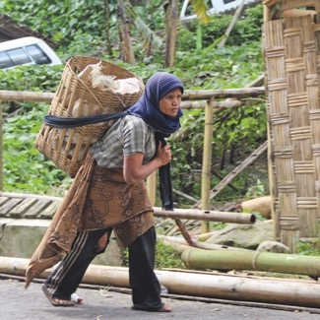

Questions
- Where do you see deceit and false promises?
- Who are the poor and the powerful in your community?
- What can we do to bring the good news of the gospel to both the powerful and the poor?

Go and Do (see www.ctbi.org.uk/goanddo)
The World Economic Forum meets from 22nd – 25th January 2019 in Davos, coinciding with when many churches mark the Week of Prayer for Christian Unity. It is a moment that highlights the extreme disunity and inequality across the world. 42 people own the same wealth as the poorest 50 percent (Oxfam 2018).

Take time this week to work together for a world where there is unity not just between Christians but where we as human beings can flourish together. Renew your commitment to trade that is fair and ethical and to continue to campaign for taxes to be paid. Visit Go and Do for more information.
Week of Prayer for Christian Unity

29

DAY 6

Jeremiah 10:12-16
Mark 16:14-15

Starting Point
We are, today, facing a serious global ecological crisis and the survival of the planet is threatened. The passage from Mark’s Gospel reminds us that, after his resurrection, Jesus commissioned the disciples to proclaim the good news to the whole creation. No part of creation is outside God’s plan to make all things new. So, Christians are called to promote values which reconcile humankind with all creation. When we join with other people in defence of our common earthly home, we are not just engaging in activism, but we are fulfilling the Lord’s command to proclaim to all creation the good news of God’s healing and restoring love.
Only Justice

30
Reflection
Proclaim the good news to all
of creation,
not just to my small part.

Oh God, who made the world,
both body and gift.
Your creation groans.
What have we done?
Land and sea polluted,
death and destruction,
communities gone,
families displaced.
While we sit in comfort.

Your creation groans.
What have we done?
A damaged world,
a broken system.
Upheld by stupidity, destruction, neglect and greed.
An abuse of God’s gift,
while we disconnect.

Where is God’s voice,
God’s rolling waves of justice?
We too are God’s body,
thinking beyond ourselves,
seeing consequences,
listening for the still small voice,
swimming against the tide.

Asking what shall I do?

The Lord of hosts is his name (Jeremiah 10:16)

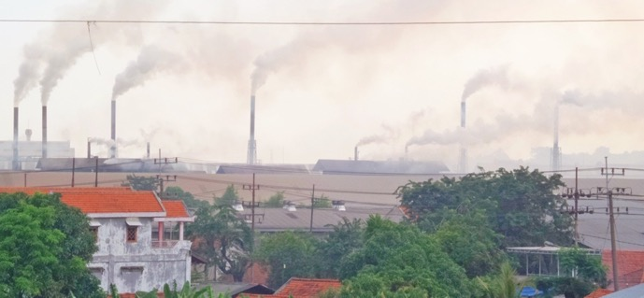

Prayer
Loving God,
by whose breath all things came
to be,
we thank you for the world
which manifests your glory,
diversity and beauty.
Grant us the wisdom to walk gently upon the earth
and to share together your good news with all creation. Amen

Air pollution at the edge of Surabaya

Questions
- Where do you see an abuse of human power, leading to destruction or neglect?
- Where do you see God’s justice in the created world?
- Where can we make a difference?

Go and Do (see www.ctbi.org.uk/goanddo)
Wrap up warm, pack a flask and organize a nature walk with the churches in your area. Take it as time to journey together and to reconnect with the natural world of which we are all a part. You could go to a park if you are in the city, or step outdoors if you are in the countryside.

Pray for another way for the world and that we as humanity might work with creation rather than against it. Visit Go and Do to take action in the next stage of the climate justice campaign.
Week of Prayer for Christian Unity

31

DAY 7

1 Samuel 1:13-17 Matthew 15:21-28

Starting Point
The marginalization and dismissal of women’s voices continues in our own times and in our own culture. Within our own churches we are often complicit with attitudes and actions that devalue women. As we become more aware of the issues, so we begin to recognize the many ways in which women are subjected to violence and injustice. Human trafficking, exploitation of women and children, and sexual abuse continue to be the reality for many women. In the scripture readings
Only Justice

32

both Hannah and the Canaanite woman are dismissed as ‘worthless’ nuisances. But they stand up for themselves, change the perceptions of Eli and Jesus, and achieve their deepest desire. Many women are unable to challenge marginalization and exploitation. As Christians unite in prayer and the study of the Scriptures, truly listening for God’s voice, we discover that God also speaks today through the cries of the most abused in society.

Reflection
Hannah

Weeping silently,
praying from the heart before
the Lord,
why does Eli think she is drunk?
Quiet, dignified, refuting her accuser,
she is promised her heart’s desire.

The Canaanite woman

Nameless,
fierce and canny on behalf of
her daughter,

turning insult to advantage,
rejection to praise resounding throughout centuries.
Great is your persistent faith!

The ‘worthless’ woman

Belittled, discounted, invisible,
why won’t you hear my story?
Why won’t you believe what they are doing to me?
Desperate worm turning,
speaking out, #MeToo,
a tsunami of testimony, standing strong together,
mountains pushed aside.
Nothing is impossible with God.

Prayer
Gracious God,
you are the source of human dignity.
By your grace and power
the words of Hannah, from the midst of her tears,
challenged and turned the heart of Eli the Priest.
By your grace and power
the Canaanite woman was emboldened to reject rejection
and move Jesus to heal her daughter.
As we strive for a Church which unites all humanity,
grant us the courage to reject all forms of violence against women

and to celebrate the gifts
Woman, great is your faith!(Matthew 15:28)
that women bring to the Church.
This we pray through Jesus Christ our Lord,
in whom all may find their true worth and calling. Amen.

Questions
- How would you describe a person of great faith? Think
of someone you know.
- Can you remember a time
when you felt marginalized
or dismissed?
- What can we do to
empower women, children
and other marginalized people in our community?

Go and Do (see www.ctbi.org.uk/goanddo)
Visit Go and Do to find out how the Side by Side faith movement for gender justice is making great progress across the world.

Organize a local event with the churches in your area to mark and celebrate International Women’s Day on Friday 8th March. Visit Go and Do for resources and ideas.

Wear black each Thursday in solidarity with all across the world who are working and longing for the day when there is an end to violence against women. Find out more at Go and Do.

g
Week of Prayer for Christian Unity

33

DAY 8


Psalm 27:1-4
John 8:12-20

Starting Point
Over the past eight days the churches of Indonesia have helped us consider difficult situations facing the world. Many of these have raised questions of justice. The Church has been complicit in many instances of injustice and, through that complicity, we have damaged our unity and diminished the effectiveness of our witness to the world. Christians gather for common prayer, professing common faith and to listen for God’s voice. Although the many injustices wound us, we do not lose hope, but are called to action. The Lord is our light and salvation, the stronghold of our lives. We do not fear.
Only Justice

34

Reflection
Hope
Forgive us how we’ve devalued you:
‘We live in hope’ and yet don’t hope to live,
‘Hope so’, when we have none in
our hearts.

Show us who you really are:
disturb the deathly ease of
our despair
and give us the courage to embrace your pain:
impudent in the face of hate,
unrelenting under oppression,
daring to resist the entropy
of division.

Goad us to take up that felon’s cross
whose agony
laid empty the grave.

Prayer
God our hope,
we praise you for your
loving kindness.
Uphold us when we are about to
give up,
show us your light when all around seems dark.
Transform our lives that we may bring hope to others.
Help us to live united in our diversity as a witness to your communion,
Father, Son and Holy Spirit,
one God now and forever. Amen.



Questions
The Lord is my light and my salvation (Psalm 27:1)
- How has Jesus empowered you to witness to what is right?
- Where in the life of your church or group of churches do you most need the gift of hope?
- What is your best hope for
your community?

Go and Do (see www.ctbi.org.uk/goanddo)
Generate hope by sharing your actions and prayers for justice on the CTBI prayer wall using the #wpcuwall hashtag on Twitter and visit www.weekofprayer.org to see the actions others have taken.

The Christian Aid Week 2019 packs for organizers will be landing on doormats across the UK and Ireland this week. Plan to get involved in this other week of the year that witnesses Christian unity across the UK and Ireland. Visit Go and Do to find out more.
Week of Prayer for Christian Unity

35

Week of Prayer for Christian Unity 2019



Twitter: #wpcu2019
#wpcuwall
Printed copies available from
Norwich Books and Music
Order line: 01603 785925
Original version published by:
Churches Together in
Britain and Ireland
Interchurch House,
35 Lower Marsh, London SE1 7RL
Registered charity no. 1113299
Company limited by guarantee,
registered no. 5661787
Note: this version may have been adapted for local use.
www.ctbi.org.uk/weekofprayer
Fax: 01603 785915
orders@norwichbooksandmusic.co.uk
online:https://chbookshop.hymnsam.co.uk/

www.ctbi.org.uk/weekofprayer
www.weekofprayer.org



