Liberation And entrapment project: Trafficking and Human Slavery - resources
Mission Theology Advisory Group

Table of Contents

Introduction 3
What exactly is Human Trafficking? 4
What are these resources about? 5
Meet Jenny 8
Meet Peter 10
Meet Andy 12
Photographs 15
Numbers 19
People who help 24
Indicators of Trafficking 27
Engaging with the Bible 36
Prayers 41
Reflections 45
Safe Spaces 48
Acknowledging Complicity 51
Being Vigilant 53
Being Responsible 56
Final Thoughts 59

The Mission Theology Advisory Group is an ecumenical group formed in partnership between Churches Together in Britain and Ireland and the Church of England



We provide resources in the areas of Spirituality, Theology, Reconciliation, Evangelism and Mission

This resource adds practical things to do to the paper ‘Trafficking and Modern Day Slavery’ in our Theology series. A plain text version is also available.

Please print and share.

Exploring Human Trafficking and Modern-Day Slavery – Resources

Introduction
‘Human trafficking is an open wound on the body of contemporary society, a scourge upon the body of Christ. It is a crime against humanity. The very fact of our being here to combine our efforts means that we want our strategies and areas of expertise to be accompanied and reinforced by the mercy of the Gospel, by closeness to the men and women who are victims of this crime.’
Pope Francis, 10th April 2014



In a message to Anglicans from across the Communion who gathered in Rome in November 2014, the Archbishop of Canterbury said tackling trafficking and modern slavery was ‘a huge and daunting challenge’ but one that churches must face.
Church leaders such as Pope Francis and the Archbishop of Canterbury have joined together to urge churches to do whatever they can to tackle issues of trafficking and human slavery.

What exactly is Human Trafficking?

The United Nations’ Protocol to prevent, suppress and punish trafficking in persons (2000) defines trafficking as follows:
(a) “Trafficking in persons” shall mean the recruitment, transportation, transfer, harbouring or receipt of persons, by means of threat or use of force or other forms of coercion, of abduction, of fraud, of deception, of the abuse of power or of a position of vulnerability or of the giving or receiving of payments or benefits to achieve the consent of a person having control over another person, for the purpose of exploitation. Exploitation shall include, at a minimum, the exploitation of the prostitution of others or other forms of sexual exploitation, forced labour or services, slavery or practices similar to slavery, servitude or the removal of organs;
(b) The consent of a victim of trafficking in persons to the intended exploitation set forth in subparagraph (a) of this article shall be irrelevant where any of the means set forth in subparagraph (a) have been used;
(c) The recruitment, transportation, transfer, harbouring or receipt of a child for the purpose of exploitation shall be considered “trafficking in persons” even if this does not involve any of the means set forth in subparagraph (a) of this article;
(d) “Child” shall mean any person under eighteen years of age.
http://www.osce.org/odihr/19223
Basically, this means that around us in our own society, men, women and children are being deceived by others, often believing that they are being offered a better life. When they fall prey to traffickers they are often forced to use their bodies for sex, pornography, labour, begging, forced marriage, or organ donation against their will. They may also be frightened into handing over money or personal documents and unable or too afraid to ask for help. They may not trust, or know how to access, health or police services. Some may have been economic migrants or illegal immigrants in the first place, believing that their captors will help them travel to another country or get them jobs. News stories in 2015 about the numbers of migrants drowning in the Mediterranean have highlighted the desperate plight of trafficked people and how often they are at risk of death.

What are these resources about?

We invite you to use these different resources to learn about and think about the crimes of human trafficking and modern day slavery. While these resources contain plenty of information about trafficking to help you find out more about it, they also invite you to think about what our own roles and responsibilities are in a world in which human trafficking is big business.
These resources introduce you to a number of people’s stories, not those who have been trafficked, but people who have encountered situations where people may have been trafficked. Their stories will help us all understand what we need to look out for and what we might do to be more vigilant in the places where we live, travel, and meet others.
You can use these resources as individuals or as part of a group. You might like to use a notebook to jot down ideas or a flipchart if you are in a group.
These resources are divided into four sections:
Yellow resources: introduce you to people’s stories and indicators for trafficking. Each section comes with questions for reflection or discussion.
Green resources: pictures to look at and reflect on; websites to explore to find out more about trafficking.
Blue resources: bible study, prayers, reflections which can use as part of your exploration or as an event in church.
Pink resources: examining what we can do individually and together to be more vigilant, more observant and to be part of the movement for change.
You can choose which resources to work with and mix and match among them as you like. This grid will help you choose:

STORIES | Introduction  YOU ARE HERE | Meet Jenny | Meet Peter | Meet Andy
INFORMATION | Photographs | Numbers:  Statistics to think about | People who Help:  Charities which help victims or trafficking or campaign for awareness and change | Indicators of Trafficking
PRAYER AND  REFLECTION | Engaging with the Bible | Prayers | Reflections | Safe spaces
DOING SOMETHING | Acknowledging Complicity | Being Vigilant | Being Responsible | Final Thoughts

These resources accompany a paper from the Mission Theology Advisory Group (MTAG) on mission, theology and human trafficking which has been widely shared and disseminated through the Christian denominations of the UK, through the Anglican Communion and through the Vatican. You can find this paper in the Church Resources section of the Church of England website. In this paper there are more stories about human trafficking and modern day slavery and an in-depth enquiry about why Christians should care about these issues. You can also find out more about what the Church of England in particular is doing to engage with issues around human trafficking through Dr Charles Reed and the Clewer initiative on the Church of England website.
You can find out more about MTAG and what we do from our page on the Church of England website.
If you would prefer to print a plain text version of these resources for downloading and sharing, please contact Anne Richards anne.richards@churchofengland.org.

Meet Jenny

This is Jenny’s story (all names have been changed).
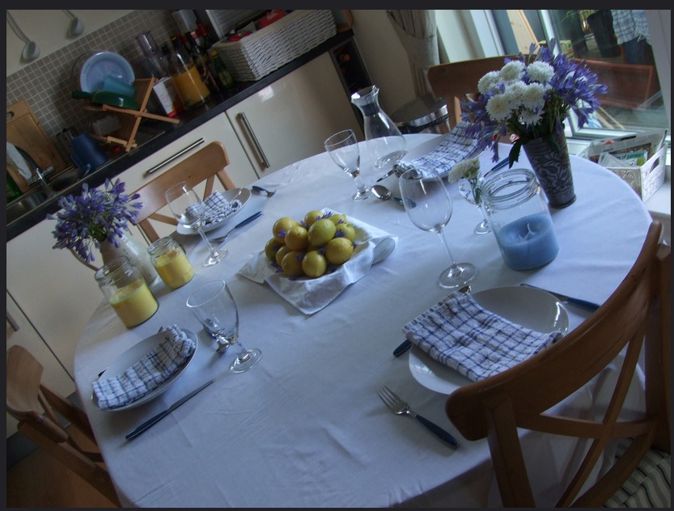
Photo by Elin B on Flickr
Jenny met Shana at work, and they were assigned to work on a project together. She liked Shana and after a few weeks, Shana asked if Jenny would like to go to a dinner party at her house. Jenny readily accepted.
Jenny was impressed by Shana’s house and by her wealthy and successful husband Deep. A number of people had come to the dinner party and she enjoyed meeting them and talking to them. When they sat down for dinner however, she was surprised to see a small, very thin, young Asian woman bringing in the food and serving it. There was something ‘off’ about the woman’s behaviour. Deep seemed annoyed at her presence and tutted loudly when she put the serving dish down noisily. As soon as the food was served, the woman disappeared very quickly, keeping her head down, not looking at Shana or Deep. Jenny was surprised and asked Shana if the woman was a relative. Shana shook her head, ‘servant’.
‘You mean she works for you? Like a housekeeper?’
Shana nodded carelessly and turned to her neighbour to talk about something else. Jenny wouldn’t let it go. ‘That woman lives here, or she has her own place?’
Deep overheard, ‘That’s really none of your business’
Jenny said sorry and got on with her food, but the woman still bothered her, although she really couldn’t say why.
A little later, Jenny decided to visit the loo. On the way, she caught sight of the serving woman again. She thought the woman was getting a mop out of a cupboard opposite the lavatory, but as she passed the woman quickly shut the door. In the small glimpse she had, Jenny thought she saw clothes and something like a bed. She smiled at the woman, but she fled back to the kitchen.
Jenny said nothing more about it, but she was still bothered by the woman and what she was doing in Shana’s house. At work, a couple of weeks later, Shana told Jenny she was going on holiday and was worried about the security of the house. Jenny asked whether the woman would be looking after the house. Shana suddenly became annoyed and said that the woman was a relative with mental health issues whom they had taken in as an act of kindness and that Jenny really should stop obsessing about her. Jenny was offended and the relationship between them cooled. After their project ended, she and Shana didn’t really speak any more.

Some questions:
- How would you have felt in Jenny’s position?
- What would you have said to Shana or to Deep?
- Do you think Jenny was right to be concerned or was she just sticking her nose in?
- What do you think Jenny should have done about the woman, if anything?
- How do you think Jenny would feel if the woman turned out to be trafficked or if it turned out Shana was telling the truth?

Meet Peter

This is Peter’s story (names have been changed)
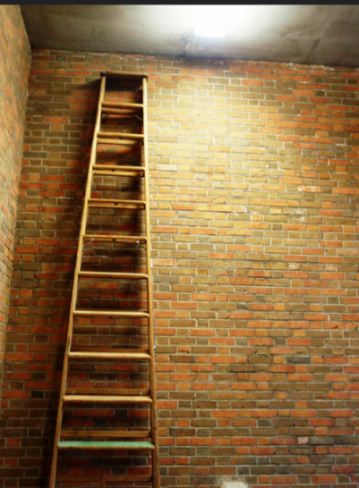

Photo by Joel Kramer on Flickr

Peter needed some work doing on the gables of his house which were peeling and flaking and some of the wood had rotted and needed replacing. He decided to get some quotes for the cost of the work from three different companies he found through advertisements in the local press. The first two were quite expensive, explaining that there would have to be scaffolding put in place to create safe access to the high gables and explaining how many people would be needed to remove the material safely and tidily. The third was ridiculously cheap. Peter was not well off, and, having been assured that the work could be done quickly, hired the third for cash.
However Peter was surprised when two men arrived with just a ladder. Neither spoke English, and neither seemed to know anything about scaffolding. Peter was also alarmed to see that they had only a few damaged tools and were dressed in thin T shirts and plimsolls, despite the light rain that was falling. Peter was even more alarmed when one of them slipped on the ladder and cut his hand. He offered to take the man to hospital, but the man waved him away and wrapped his hand in a cloth. The men worked on the gables all day, taking turns to go up the ladder and refusing the offer of tea or a break. They carried on working even when it began to get dark. When Peter asked about this, they indicated that they had to get the job done ‘today’. When they had finished, Peter gave them a few pounds as a thank you. They looked at each other and one put a finger to his lips at the other. Then the boss turned up and Peter gave him the cash and they all left. Peter thought the whole thing was very odd. A few months later he tried to contact the same firm again for another job, but the phone number no longer worked.

Some questions:
- How would you have felt in Peter’s position?
- What would you have said to the two men?
- Do you think Peter was right to be concerned or was he overreacting?
- Do you think Peter should have done anything else?
- How do you think Peter would feel if the men turned out to have been trafficked for their labour?

Meet Andy

This is Andy’s story (names have been changed)

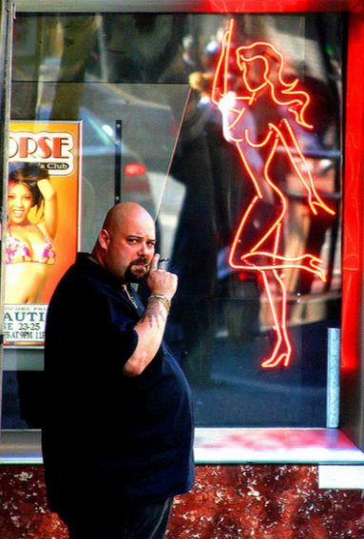
‘Strip Club Bouncer’ Photo by Thomas Hawk on Flickr

‘When I was a student I badly needed money so I applied to do bar work. I’d never done it before so I got taken on by a pub not far from my student house and then for more money at one of the local nightclubs all my friends went to. After that a friend recommended me to a club that was starting up on the other side of the city. They wanted an experienced bar person and it was a lot more money for fewer hours. I had a lot of essays to write so it seemed like a good idea. What I didn’t know when I went for the interview was that it wasn’t a nightclub like I’d been working at before but a strip club.
Obviously I realised straight away that it was a strip club, when the girls came out on the first night and started dancing. At first I was embarrassed and then frankly, couldn’t believe my luck, especially when I told my friends. They all wanted to come along and have a look and kept congratulating me on finding a job with good money and all the half-naked girls I could want. But after a couple of weeks I realised that I just felt uncomfortable – I didn’t like the atmosphere or the way some of the people talked about the girls. But I told myself, I need the money and I’m not doing anything, just serving drinks.
After a little while I started to get to know some of the girls. All of the ones who were willing to tell me a bit about themselves were in need of money – one or two had a fairly serious drug habit, but most had families to support: children or elderly parents, and the evening hours were easier to manage. One of the dancers had even been a student like me! They got quite well paid and the clients weren’t allowed to touch them. After a while I didn’t really notice them dancing any more, I just knew them by their names, people to say ‘hi’ to in the supermarket. There were two, though, who didn’t speak any English, and seemed very wary of speaking to me, although I just assumed that was the language barrier. They drank a lot and often seemed depressed.
One night I went out back to get ice and saw one of the foreign girls in the corridor struggling with a man. I ran up to him and pulled him off her and shouted in his face. He shouted back at me that he’d paid for her and she was going to have to do what he wanted. He slapped her and I punched him. My boss turned up and to my surprise and indignation fired me on the spot. But that was the first time that it had actually occurred to me that more was going on at that club than just dancing. I told my friends and they were amazed that I could have been that naïve. After a week or so I told the police about it. I was so bothered about the girls who couldn’t speak English. I don’t know what the police did about it, if anything. They never came back to me but shortly after the club closed.’

How would you have felt in Andy’s position?
• How would you have connected with the girls who didn’t speak English?
• Do you think Andy was right to be concerned or was it not his business to intervene?
• Do you think Andy should have done anything else?
• How do you think Andy would feel if the girls had turned out to have been trafficked?

Photographs

In this section, we invite you to look at some pictures and imagine the stories that could be behind them.
Photographers notice things and have a keen eye for people and situations that other people do not see. Their photographs can often tell stories.
For example: imagine a beach at sunset. Two people are silhouetted walking together at the end of the shore. The scene looks romantic, idyllic. But in the foreground is a large object wrapped in shining plastic, glittering in the sun. It is the drowned body of a person desperate to leave Africa and to get to Europe, who had, quite probably, given his or her identity documents and all their money to gangs of people traffickers. These tragedies have been documented by the photographer Juan Medina http://www.bbc.co.uk/news/magazine-32433547 (warning – the images are distressing). In April 2015 more than 1000 people died this way, so Medina captures in one image the suffering of so many unknown.
Each of the three photos came with some information which is included with the photo. We ask to you to go further and imagine what else you might have done in the same situation to find out the story behind the photo. What might the photographer of the first picture have found out if he wasn’t in a rush? What do you think the second photographer found out about the woman back at the studio? Was the woman in the third photograph really working for free in return for bed and board?
We are not suggesting that any of the subjects were indeed victims of trafficking. But how can you tell? How can you find out the truth about people’s lives?

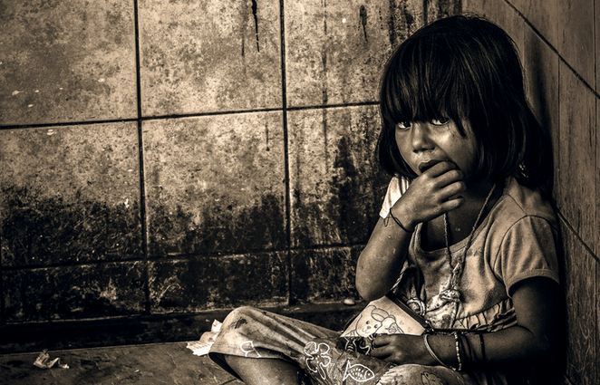
Photo by KamrenB Photography on Flickr
This was taken during a border town visit. My dad and I were in a rush to get back into Thai territory when this girl appeared. I had a 75-300 zoom on my 600D and this was snapped while walking by. This shot almost didn't happen. I'm glad it did because many people I show this to have an emotional response.
- Have a look at this picture
- Give the child a name
- Imagine her story. Why is she there? What is the cup for?
- What would you say to her?
- Who could you talk to about her situation?
- What future would you like her to have?


Photo by alessandro isnotaurello √on Flickr
we bought the hooker and took her to our studio...
- Have a look at this picture
- Give the woman a name
- Imagine what her story might be: where is she going? Who is she meeting?
- How would you feel about talking to her?
- How could you find out about whether she was a victim of trafficking?
- Whatever her story, what sort of future would you like her to have?

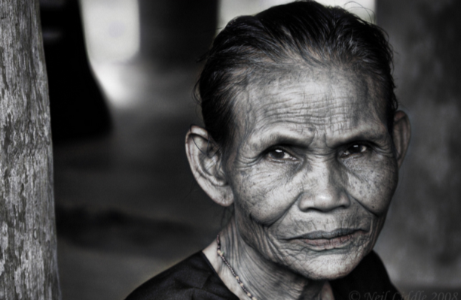
Photo by Neils Photography on Flickr
This lovely lady is forever indebted to the family I stayed with in Toraja. Many years ago, she found herself in serious trouble. Without a home and without a job, she begged to have a place to stay and food. In return, she promised she would help the family in home duties for the rest of her life. This lady was doing the cooking, cleaning and shoving away of children for the family funeral house.
- Have a look at this picture
- Give the woman a name
- Imagine you found her working for nothing in someone’s home. What do think her story might be?
- How would you feel about talking to her?
- How could you find out about whether she was a victim of human slavery?
- Whatever her story, what sort of future would you like her to have?

Numbers
In this section, you will find some statistics about trafficking illustrated with photographs to help you think about the sheer numbers.
The statistics have been collected by the charity Stop the Traffik and can be found on their website at www.stopthetraffik.org.

You might like to look at each statistic and illustration and think about what this means for the world in which we all live. What would it take to change things? You might like to write down:
- Thoughts and impressions
- Ideas for action
- Pointers for prayer

People trafficking is the fastest growing means by which people are enslaved, the fastest growing international crime, and one of the largest sources of income for organised crime.
— The UN Office on Drugs and Crime

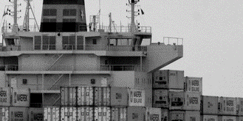
Photo by Glen on Flickr
In August 2014 35 adults and children were discovered in a shipping container at Tilbury docks in Essex. One man died.

1.2 million children are trafficked every year
— Estimate by UNICEF
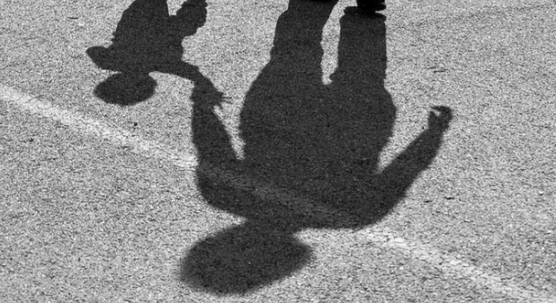
Photo by David Amsler on Flickr

Human trafficking is the second largest source of illegal income worldwide exceeded only by drugs trafficking. — Belser 2005

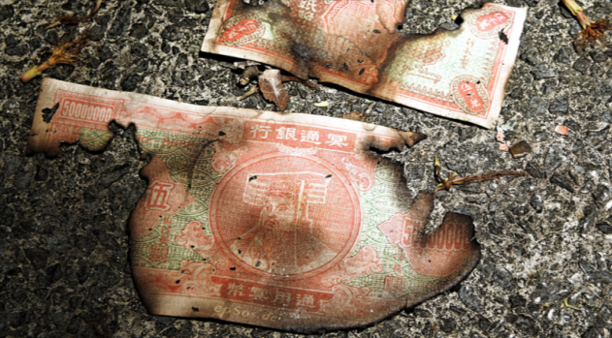
Photo by epSos.de on Flickr
600,000-800,000 men, women and children are trafficked across international borders each year. Approximately 80 per cent are women and girls. Up to 50% are minors.
— US Department of State Trafficking in Persons Report 2007

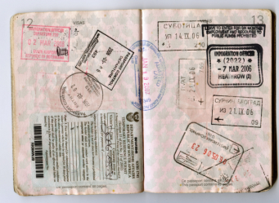
Photo by Jon Rawlinson on Flickr
At least 20.9 million people are victims of forced labour worldwide. While it is difficult to establish a precise amount, conservative 2012 research estimated trafficking victims as comprising some 44 per cent of this figure.
—ILO 2012 Global Estimate of Forced Labour

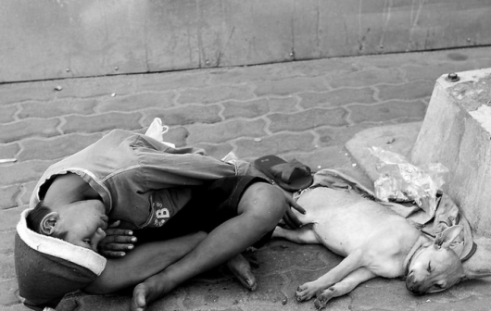
Photo by Transformer 18 on Flickr
There are even reports that some trafficking groups are switching their cargo from drugs to human beings, in a search of high profits at lower risk.
— The UN Office on Drugs and Crime

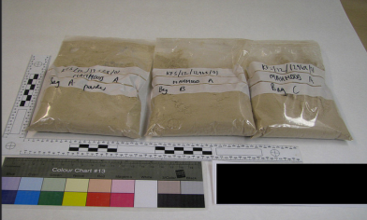
Photo by ukhomeoffice on Flickr

The majority of trafficked victims arguably come from the poorest countries and poorest strata of the national population.
— A global alliance against forced labor, International Labor Organisation, 2005

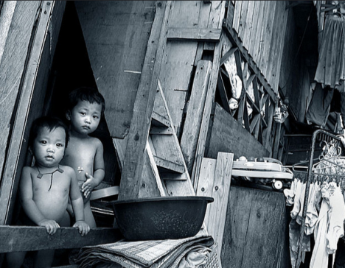
Photo by Roger Alcantara on Flickr

People who help
In this section you can find a number of suggestions for charities which are actively engaged in helping people who have been trafficked or which are working to combat trafficking.
What you might like to do is visit one or two of these websites and read about what they are doing to fight against trafficking. Since websites sometimes come and go, you can find more sites using the Wikipedia link at the bottom.
Which of these charities might help our friends? How do you think their stories might change or develop because of the work of people who are trying to stop trafficking?

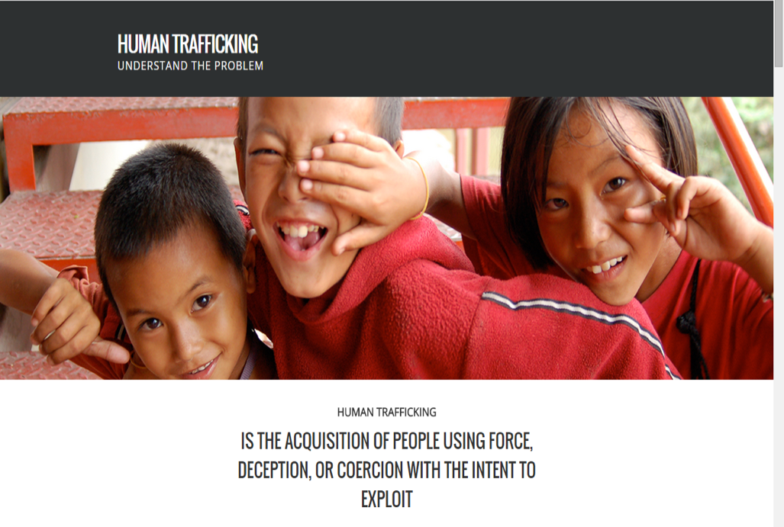
http://notforsalecampaign.org
http://www.barnardos.org.uk/what_we_do/our_work/trafficked_children.htm
http://www.tearfund.org/en/nochildtaken
http://www.unseenuk.org/
http://hopeforjustice.org/
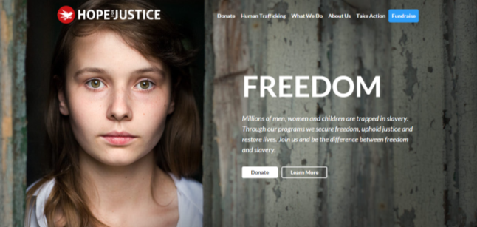
http://www.humantraffickingfoundation.org/
http://www.stopthetraffik.org/
http://www.antislavery.org/
http://www.eavesforwomen.org.uk/about-eaves/our-projects/the-poppy-project
http://www.enterprisingspirit.org/
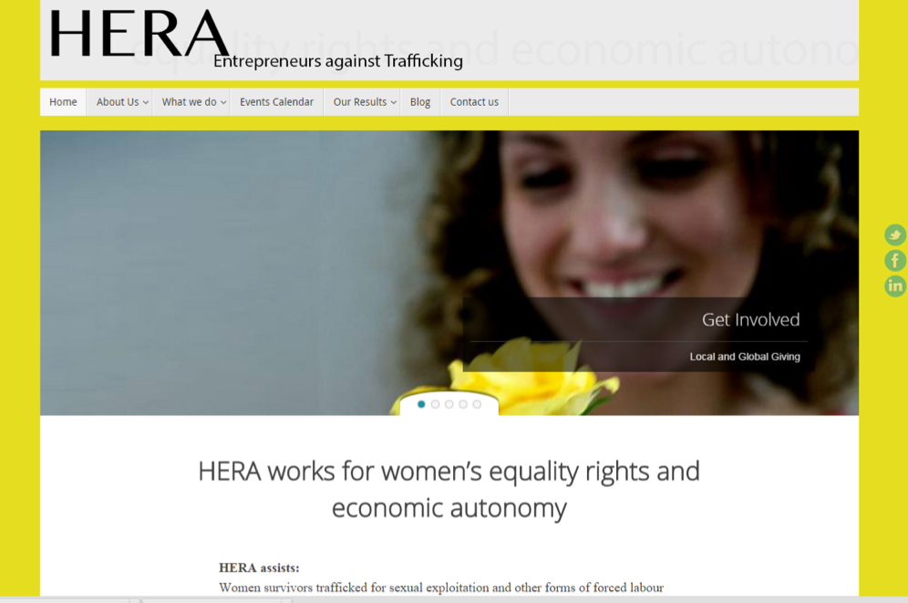
http://www.ecpat.org.uk/
http://www.beyondthestreets.org.uk/
http://combattrafficking.eu/content/anti-trafficking-organisations
http://www.charistiwala.com
http://en.wikipedia.org/wiki/List_of_organizations_that_combat_human_trafficking

Indicators of Trafficking
The following indicators come from http://www.unodc.org/pdf/HT_indicators_E_LOWRES.pdf
If you have looked at Jenny, Peter and Andy’s stories, you might like to see how many of these indicators were present in their experiences.

People who have been trafficked may:


• Believe that they must work against their will
• Be unable to leave their work environment
• Show signs that their movements are being controlled
• Feel that they cannot leave
• Show fear or anxiety
• Be subjected to violence or threats of violence against themselves or against their family members and loved ones
• Suffer injuries that appear to be the result of an assault
• Suffer injuries or impairments typical of certain jobs or control measures
• Suffer injuries that appear to be the result of the application of control measures
• Be distrustful of the authorities
• Be threatened with being handed over to the authorities
• Be afraid of revealing their immigration status
• Not be in possession of their passports or other travel or identity documents, as those documents are being held by someone else
• Have false identity or travel documents
• Be found in or connected to a type of location likely to be used for exploiting people
• Be unfamiliar with the local language
• Not know their home or work address
• Allow others to speak for them when addressed directly
• Act as if they were instructed by someone else
• Be forced to work under certain conditions
• Be disciplined through punishment
• Be unable to negotiate working conditions
• Receive little or no payment
• Have no access to their earnings
• Work excessively long hours over long periods
• Not have any days off
• Live in poor or substandard accommodations
• Have no access to medical care
• Have limited or no social interaction
• Have limited contact with their families or with people outside of their immediate environment
• Be unable to communicate freely with others
• Be under the perception that they are bonded by debt
• Be in a situation of dependence
• Come from a place known to be a source of human trafficking
• Have had the fees for their transport to the country of destination paid for by facilitators, whom they must payback by working or providing services in the destination
• Have acted on the basis of false promises

CHILDREN
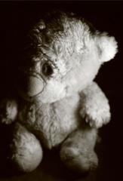

Children who have been trafficked may:
• Have no access to their parents or guardians
• Look intimidated and behave in a way that does not correspond with behaviour typical of children their age
• Have no friends of their own age outside of work
• Have no access to education
• Have no time for playing
• Live apart from other children and in substandard accommodations
• Eat apart from other members of the “family"
• Be given only leftovers to eat
• Be engaged in work that is not suitable for children
• Travel unaccompanied by adults
• Travel in groups with persons who are not relatives
The following might also indicate that children have been trafficked:
• The presence of child-sized clothing typically worn for doing manual or sex work
• The presence of toys, beds and children's clothing in inappropriate places such as brothels and factories
• The claim made by an adult that he or she has “found” an unaccompanied child
• The finding of unaccompanied children carrying telephone numbers for calling taxis
• The discovery of cases involving illegal adoption

DOMESTIC SERVITUDE
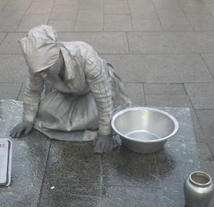

People who have been trafficked for the purpose of domestic servitude may:
• Live with a family
• Not eat with the rest of the family
• Have no private space
• Sleep in a shared or inappropriate space
• Be reported missing by their employer even though they are still living in their employer's house
• Never or rarely leave the house for social reasons
• Never leave the house without their employer
• Be given only leftovers to eat
• Be subjected to insults, abuse, threats or violence
People who have been trafficked for the purpose of sexual exploitation may:
• Be of any age, although the age may vary according to the location and the market
• Move from one brothel to the next or work in various locations
• Be escorted whenever they go to and return from work and other outside activities
• Have tattoos or other marks indicating “ownership” by their exploiters
• Work long hours or have few if any days off
• Sleep where they work
• Live or travel in a group, sometimes with other women who do not speak the same language
• Have very few items of clothing
• Have clothes that are mostly the kind typically worn for doing sex work
• Only know how to say sex-related words in the local language or in the language of the client group
• Have no cash of their own
• Be unable to show an identity document
The following might also indicate that children have been trafficked:
• There is evidence that suspected victims have had unprotected and/or violent sex.
• There is evidence that suspected victims cannot refuse unprotected and/or violent sex.
• There is evidence that a person has been bought and sold.
• There is evidence that groups of women are under the control of others.
• Advertisements are placed for brothels or similar places offering the services of women of a particular ethnicity or nationality.
• It is reported that sex workers provide services to a clientele of a particular ethnicity or nationality.
• It is reported by clients that sex workers do not smile.

LABOUR EXPLOITATION
People who have been trafficked for the purpose of labour exploitation are typically made to work in sectors such as the following: agriculture, construction, entertainment, service industry and manufacturing (in sweatshops).
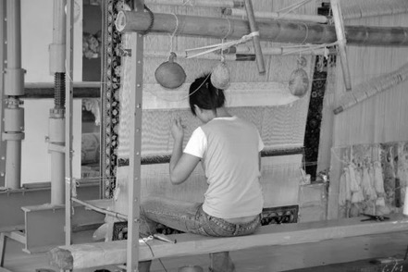

People who have been trafficked for labour exploitation may:
• Live in groups in the same place where they work and leave those premises infrequently, if at all
• Live in degraded, unsuitable places, such as in agricultural or industrial buildings
• Not be dressed adequately for the work they do: for example, they may lack protective equipment or warm clothing
• Be given only leftovers to eat
• Have no access to their earnings
• Have no labour contract
Work excessively long hours
• Depend on their employer for a number of services, including work, transportation and accommodation
• Have no choice of accommodation
• Never leave the work premises without their employer
• Be unable to move freely
• Be subject to security measures designed to keep them on the work premises
• Be disciplined through fines
• Be subjected to insults, abuse, threats or violence
• Lack basic training and professional licences
The following might also indicate that people have been trafficked for labour exploitation:
• Notices have been posted in languages other than the local language.
• There are no health and safety notices.
• The employer or manager is unable to show the documents required for employing workers from other countries.
• The employer or manager is unable to show records of wages paid to workers.
• The health and safety equipment is of poor quality or is missing.
• Equipment is designed or has been modified so that it can be operated by children.
• There is evidence that labour laws are being breached.
• There is evidence that workers must pay for tools, food or accommodation or that those costs are being deducted from their wages.

BEGGING AND PETTY CRIME
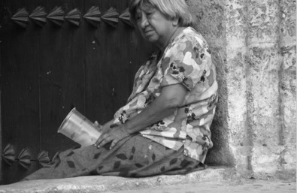
People who have been trafficked for the purpose of begging or committing petty crimes may:
• Be children, elderly persons or disabled migrants who tend to beg in public places and on public transport
• Be children carrying and/or selling illicit drugs
• Have physical impairments that appear to be the result of mutilation
• Be children of the same nationality or ethnicity who move in large groups with only a few adults
• Be unaccompanied minors who have been “found” by an adult of the same nationality or ethnicity
• Move in groups while travelling on public transport: for example, they may walk up and down the length of trains
• Participate in the activities of organized criminal gangs
• Be part of large groups of children who have the same adult guardian
• Be punished if they do not collect or steal enough
• Live with members of their gang
• Travel with members of their gang to the country of destination
• Live, as gang members, with adults who are not their parents
• Move daily in large groups and over considerable distances
The following might also indicate that people have been trafficked for begging or for committing petty crimes:
• New forms of gang-related crime appear.
• There is evidence that the group of suspected victims has moved, over a period of time, through a number of countries.
• There is evidence that suspected victims have been involved in crime.

Engaging with the Bible
Below are three passages from the Bible which contain stories which can help us reflect on issues of human trafficking today. Each passage is followed by some suggested questions for discussion.
Genesis 37: 23-24

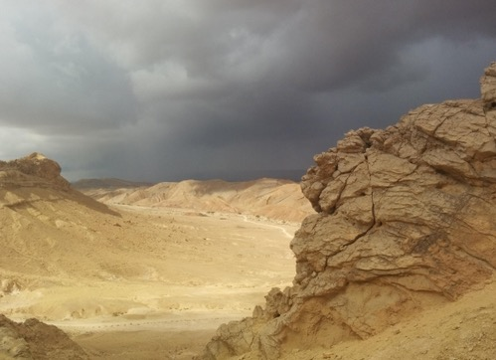
So when Joseph came to his brothers, they stripped him of his robe, the long robe with sleeves that he wore; and they took him and threw him into a pit. The pit was empty; there was no water in it.
Then they sat down to eat; and looking up they saw a caravan of Ishmaelites coming from Gilead, with their camels carrying gum, balm, and resin, on their way to carry it down to Egypt. Then Judah said to his brothers, ‘What profit is there if we kill our brother and conceal his blood? Come, let us sell him to the Ishmaelites, and not lay our hands on him, for he is our brother, our own flesh.’ And his brothers agreed. When some Midianite traders passed by, they drew Joseph up, lifting him out of the pit, and sold him to the Ishmaelites for twenty pieces of silver. And they took Joseph to Egypt.
When Reuben returned to the pit and saw that Joseph was not in the pit, he tore his clothes. He returned to his brothers, and said, ‘The boy is gone; and I, where can I turn?’ Then they took Joseph’s robe, slaughtered a goat, and dipped the robe in the blood. They had the long robe with sleeves taken to their father, and they said, ‘This we have found; see now whether it is your son’s robe or not.’ He recognized it, and said, ‘It is my son’s robe! A wild animal has devoured him; Joseph is without doubt torn to pieces.’ Then Jacob tore his garments, and put sackcloth on his loins, and mourned for his son for many days.

Some things to think about:
- What of motives do the brothers have for selling Joseph into slavery? (You could also read the rest of the story in context if you wanted to explore this more deeply)
- What do you think about the role of lies and deceit in human slavery?
- How do you think Joseph felt about what was happening to him?
- How you think Reuben and Jacob felt about the story they were told?
- Imagine re-telling this story from the point of view of the traders.
- How might this story help us engage with issues of human trafficking today?

Judges 19. 22; 25-28


While they were enjoying themselves, the men of the city, a depraved lot, surrounded the house, and started pounding on the door.... So the man seized his concubine, and put her out to them. They wantonly raped her, and abused her all through the night until the morning. And as the dawn began to break, they let her go. As morning appeared, the woman came and fell down at the door of the man’s house where her master was, until it was light.
In the morning her master got up, opened the doors of the house, and when he went out to go on his way, there was his concubine lying at the door of the house, with her hands on the threshold. ‘Get up,’ he said to her, ‘we are going.’ But there was no answer.

Some things to think about:
- Why do you think the man gave his concubine to the men?
- What issues of power and responsibility are laid out in this story?
- What do you feel about the acts of violence in this story?
- How might this story help us engage with issues of human trafficking today?
Philemon 1.8-21


For this reason, though I am bold enough in Christ to command you to do your duty, yet I would rather appeal to you on the basis of love—and I, Paul, do this as an old man, and now also as a prisoner of Christ Jesus. I am appealing to you for my child, Onesimus, whose father I have become during my imprisonment. Formerly he was useless to you, but now he is indeed useful both to you and to me. I am sending him, that is, my own heart, back to you. I wanted to keep him with me, so that he might be of service to me in your place during my imprisonment for the gospel; but I preferred to do nothing without your consent, in order that your good deed might be voluntary and not something forced. Perhaps this is the reason he was separated from you for a while, so that you might have him back for ever, no longer as a slave but as more than a slave, a beloved brother—especially to me but how much more to you, both in the flesh and in the Lord.
So if you consider me your partner, welcome him as you would welcome me. If he has wronged you in any way, or owes you anything, charge that to my account. I, Paul, am writing this with my own hand: I will repay it. I say nothing about your owing me even your own self. Yes, brother, let me have this benefit from you in the Lord! Refresh my heart in Christ. Confident of your obedience, I am writing to you, knowing that you will do even more than I say.

Some things to think about:
- What is Paul saying about Onesimus?
- What difference might this change make to the Christian community?
- How do you think Onesimus felt about what Paul was trying to do?
- How might this story help us engage with issues of modern day slavery today?

Prayers



For Jenny...
Lord of Compassion, we pray for Jenny and all like her, who are concerned about how people are treated, who try to find out the stories of those frightened into silence.
Help us always to ask the awkward questions, to seek out truth and not to take the easy path.
Amen


For Peter...
Lord of hope, we thank you for people like Peter, who look after those who work for them, who seek to make sure people are paid and cared for at work.
Help us to care about those we employ, to be interested in their stories, to make sure they come to work freely, work safely and are paid fairly.
Amen


For Andy...
Lord of love, we thank you for people like Andy, who care about how people are treated who will intervene to prevent violence and coercion towards those who are vulnerable.
Open our eyes to what goes on around us, help us to speak for those who cannot, help us to look into the dark places and let in your healing light.
Amen
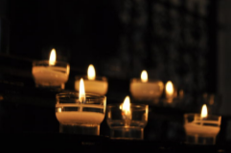
For victims of trafficking.....
Lord of the lost, we pray today for all those who are victims of human trafficking: people lured from their homes and families; people deceived while trying to find a better life; people who are desperate to trust anyone.
Help us to be more vigilant and watchful; to be aware of those who may need our help those who do not know where help may lie.
Amen


For traffickers...
Lord of changed hearts, we pray today for those involved in trafficking and human slavery. We pray that in their heart of hearts they know that what they do is evil. We pray that they will give up the lures of money, greed, control and repent the harm they have done and the suffering they have caused.
Amen


For all who work against human trafficking...
Lord of creation, we thank you for all who are working to combat human trafficking: for governments and agencies, for Church and other faith leaders, for charities and individuals.
Help us to be part of love’s movement to work for a world where human beings are valued, free to come and go, where no one is enslaved, no one used against their will for other’s pleasure, or other’s need.
Amen

Reflections

“Modern slavery is an appalling crime that has no place in today's society. Yet these figures show it is taking place here – often out of sight – in shops, fields, building sites and behind the curtains of houses on ordinary streets.”
Modern Slavery and Organised Crime Minister, Karen Bradley 2014

What does it take to get behind the locked doors and the curtains? Below is a story of Christian love, care and befriending from a charity involved in helping victims of trafficking for you to think about:

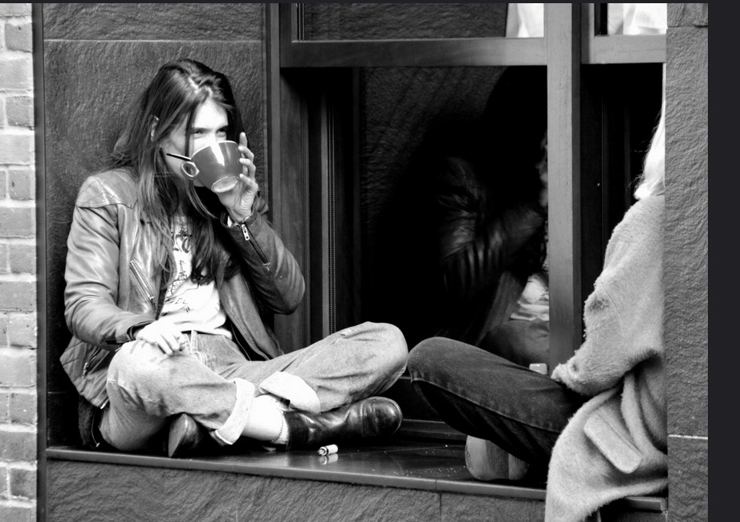
Photo by Sam Carpenter
In 2008, as a group of friends we felt prompted by God to respond to the issue of sexual exploitation in the sex industry and human trafficking. Having no experience or expertise in the area we did the only thing that we knew how to do; pray! So we began prayer walking around the area of our town where the brothels and saunas were each week; praying for the people that they represented. After a few months we knocked on the door of one of the saunas, introduced ourselves and explained we were from the local church and that we pray for them each week and asked if they had anything specifically that we could pray for. The lady who answered the door seemed quite confused, but once she worked out that we weren't joking, she told us how dangerous it had been recently in the sauna and asked if we could pray for their safety. We have come to learn that most people in the sex industry will face a daily risk of violence and exploitation. The woman then encouraged us to knock again the next week to see what they'd like prayer for! So we began to build relationships with some of the women in the different saunas, after a while they invited us in for a cup of tea each week and we spend an hour or so talking about anything and everything - from the big issues in life to what brand of nail varnish we prefer to wear! We have learnt that the people behind the labels are people just like us; with hopes and dreams, shame and pride, fear and pain. As we have become friends with people in the saunas I think that they have also realised that behind our labels of 'Christian" or "middle class" we are also people just like them! We have shared in the ups and the downs of our lives together, and our lives are all the more richer for it. No child dreams of working in the sex industry when they grow up. People enter the sex industry for many different reasons. In our experience the minority would say that they enter it freely. For many they enter the sex industry as a matter of survival; often due to financial need, to sustain an addiction, homelessness, lack of opportunity, or complex vulnerabilities, and others are coerced or forced. Whatever the entry route there is a very real story behind every single person. There are many tales of tragic loss, lack, abuse and pain; and it has been heart-breaking to hear some of these first hand. The majority of people that we have met fear being judged or labelled for their involvement in the sex industry, and this sense of shame can prevent them from building friendships with people in the community and seeking help from statutory services. For people who have been trafficked, the lack of personal freedom makes them even more 'invisible', inaccessible and isolated. So it really does feel like a privilege that God has opened the door for us to get to know people in the sex industry. Some of the women remain working in the sex industry and we've also had the joy of supporting some women to exit it; but our friendship is not conditional and is not based on the choices they make, or whether someone chooses to remain in the sex industry or not. The people that we have had the privilege of becoming friends with in the sex industry display incredible strength, dignity and courage, and they have each taught us so much as they have dared to believe that there is hope and that "nothing is impossible".

Some things to think about:
What do you think this story tells us about the importance and relevance of prayer?
How important is it that friendships come without judgement on people’s choices, mistakes or lifestyles?
What do you think are the risks in such relationships – on both sides?

Safe Spaces


Photo by Valerie Everett
Imagine what it is that makes you feel safe. What does ‘feeling safe’ mean? Who do you trust to keep you safe and who would you trust to save your life? Who would you trust to help you if you were lost or frightened?
Where do you feel most safe? What sort of place is it? What makes it reassuring?
Victims of trafficking have often lost everything they once trusted or which made them feel safe. Often, they do not ask for help, even if they have an opportunity, because they do not know who to trust or whether asking for help would make their situation worse.
People who have been trafficked need places where they can feel safe and they need people they can trust. But many do not feel safe anywhere and may not feel they can trust anyone. This might be because they have come from countries or places where they have been persecuted or have been at risk of being killed, or from places where the authorities are corrupt. Many will have experienced betrayal, not least at the hands of the traffickers, and many will have lost all their savings and property, even their passports and identity documents. Some will have been told that anyone offering to help in fact wants to deport them or hurt them. For this reason, some victims of trafficking become dependent on their traffickers, and will be reluctant to accept help or to leave them.
Some will have been damaged physically and mentally by their treatment and this may make them even more suspicious and afraid.

Churches were traditionally places of sanctuary, where people who were in trouble could seek safety and seek help. What would it take for your church or your Christian community to be a safe space for victims of trafficking, either as a first place to ask for help, or as a place to begin recovery?

Three things to think about:
Trust: what can you do to show your charity/organisation/church is trustworthy?
Friendship: how can you befriend someone who is friendless?
Safety: how can you help to make a person feel safe?

Imagine you have been given the task of designing a safe space for someone who is recovering after having been trafficked.
- What sort of issues will you need to consider?
- How will you design the space?
- What will you put in it?
- Who will be there?
- What might happen there?

Acknowledging Complicity
In telling their stories, Jenny, Peter and Andy all acknowledged the uncomfortable feeling that they could have done more. They sensed something wasn’t right, but they weren’t really sure what they could do.
They were also aware that it was possible that they were part of the problem. In Jenny’s case, she felt that by accepting the dinner invitation, she was tacitly becoming part of a set in which it was usual to expect to be cooked for and waited on. In Peter’s story he was aware that he was looking for the cheapest deal and that a cheap job for cash was probably what brought him into contact with the workers. In Andy’s case, while he needed the money, he was also willing to become inured to the strip club atmosphere and not think about what it might mean in terms of pressure on the girls.
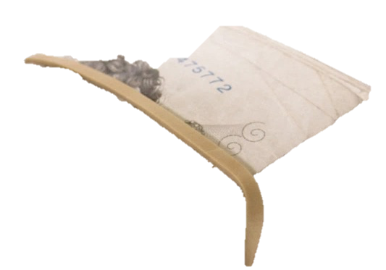
Photo by taxrebate.org.uk
In all three scenarios, money is a factor and leads to the possibility of people’s bodies being exploited by others for material gain. The problem is, we all have a relationship with money and it can lead us into situations where our own needs eclipse the exploitation of others. So we have to be aware that we can actually create conditions where people are more likely to be trafficked.
Another thing to reflect on is the fact that the Jenny, Peter and Andy’s stories didn’t really end very well. Jenny’s relationship with her work colleague soured, Peter was left feeling worried and with unfinished business and Andy lost his much-needed job. This shows that confronting the evil of human trafficking and modern slavery may come with costs. Many people may feel it is simply less trouble to say and do nothing.
Yet Christians are called to work not for our comfort but for God’s world and that can be difficult and come with personal costs. Are we prepared for that? At the very least we need to be aware of how we can make it less easy for the traffickers.

Some things to think about:
‘There are thousands of migrants here [in Calais] now. No-one's quite sure how many - 2,000 or 3,000 perhaps. The numbers are growing daily and all have their hearts set on a new life in the UK, which they appear to believe is a kind of wonderland that will answer all their problems.’
http://www.bbc.co.uk/news/magazine-31008193
People become vulnerable to trafficking when:
- They are offered the expectation of employment and financial reward
- In the sex industry, expectation of high financial rewards
- They believe they can get access to material benefits associated with “the West”
- They believe they will achieve an improved social position and treatment
- They are brought in because of the demand for “exotic” women as prostitutes
- They are brought in to service a growing pornography industry
- Employers’ demand for cheap labour and unwillingness of other people to work in unskilled, low wage jobs
- Consumers’ demand for cheap goods and services
- Strict migration regimes making legal migration difficult
What do you think has to change to make the conditions for trafficking non-existent?

Being Vigilant
It is easy enough to learn about the problems of human trafficking, but how do we have to change to meet the challenges of identifying and stopping trafficking in our own communities?
The first issue is one of awareness. What sixth sense do we possess that tells us that something is not quite right or that things are not as they should be?
All of us perhaps need to become more aware of the communities around us. That doesn’t mean we should spy on people or intrude into their business, but just to make a little more time to know what is going on in our vicinity. Many people today spend a lot of their time talking on mobiles, listening to music or talking on phones, even when they are travelling around. That makes it more difficult for people who are in trouble to make themselves known, even when they are in plain sight.

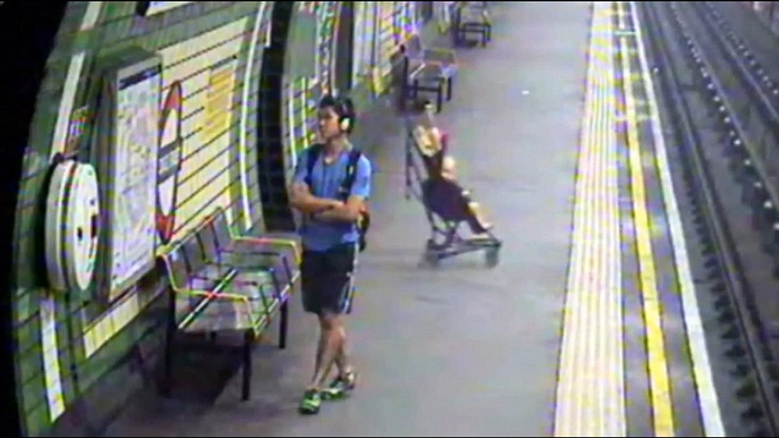
http://www.dailymail.co.uk/news/article-2721963/Heartstopping-moment-child-pushchair-falls-TRACKS-London-Tube-train-rescued-mother-just-seconds-spare.html
For example, this baby in a stroller fell on to the tracks while the man in the photo was entirely unaware that anything was happening. Fortunately the baby was rescued, but it seems amazing that this could happen while the man, a couple of yards away, was entirely oblivious. But sometimes we can be just as oblivious to what’s around us too.
So how can we become more aware? Here are some ideas:
Who is my neighbour?
Have a stroll around where you live. How many neighbours do you know by name, or by sight? How many people do you feel comfortable saying hello to, or smiling at when you meet them?
When you are out and about in your area, have a look at the buildings you pass by. Do you know what they are all for? Are there any with bars on the windows or locked doors?

Who is travelling with me?
If you’re on a train or bus, ferry crossing or at an airport, are there young people or groups of people who seem lost, frightened, or wondering what to do next?
If you work with lorries or containers, it might be especially important to be vigilant. For example, in August 2014, workers at Tilbury Docks in Essex heard shouting coming from one of the containers that came in off a ship and discovered 35 terrified people trapped inside, one of whom had died. http://www.independent.co.uk/news/uk/home-news/tilbury-docks-man-dies-after-over-30-adults-and-children-are-found-in-container-9673137.html

Being safe:
If you suspect someone is a victim of trafficking don’t try and tackle the matter just on your own. Get help: call the local police (101) or any other authorised agency
Crimestoppers – 0800 555 111
The Salvation Army – 0300 303 8151
UKHTC – 0844 778 2406
NSPCC CTAC – 0808 800 5000

For a list of all contact numbers please visit:
http://www.nationalcrimeagency.gov.uk/about-us/what-we-do/specialist-capabilities/uk-human-trafficking-centre/national-referral-mechanism
Another important matter is to make sure that if you discover trafficking happening that you don’t do something to make matters worse: it is very important that a victim of trafficking is not put in more danger due to the actions of a person trying to assist them. So make sure:
- The person consents to be helped and understands what you’re offering to do to help.
- Tell them about their rights to assistance and protection
- Refer them to responsible agencies

Being Responsible
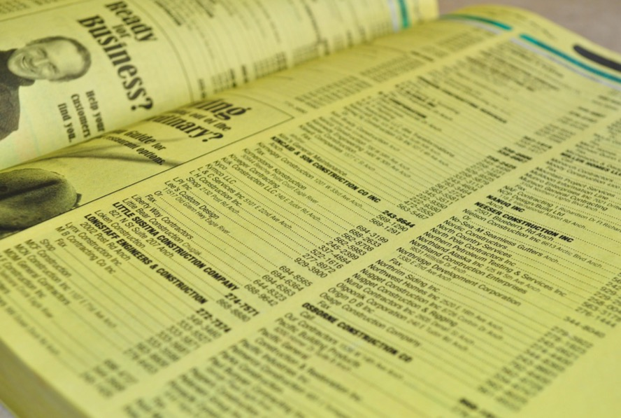

There are a number of things we can all do in our own lives which can change the conditions in which traffickers flourish. For example:

Sex
The journalist A J Jacobs, in The Year of Living Biblically, tried to address the issue of living a pure life by banishing from his life all temptations to lust. This was difficult as he works for Esquire, a magazine which interviews celebrities about their sex lives and publishes pictures of women and men in alluring poses.
A J Jacobs started by covering up all photographs and images which he thought might inspire lustful thoughts but then discovered something odd. Having previously been previously inured to billboards, magazines, scenes in film and TV, by trying to avoid them he discovered he could not think of anything else. Covering up photos just made him think about what was underneath and the more he tried to avoid sex in our western culture the more he found himself faced with it. This showed that we are so surrounded by sexual images and ideas in our culture that for the most time we neither notice nor are aroused by it: it is just there, playing into our subconscious all the time and we never notice how we are affected by it. When we become consciously aware of it, it affects us and makes us more uncomfortable.
The fact of sex work is a bit like this. Most of the time we never think about it. We read about or hear on the news about child sex abuse, child sex tourism and other crimes with horror and distaste without recognising the sexualisation of our culture all around us.
Many of us would feel deeply uncomfortable about walking through a red light district or finding out what goes on in strip clubs. But that can also mean that the victims of trafficking can be hidden in plain sight.
One of the things we can do is to become more aware of the sex industry all around us.

Asylum seekers and refugees
People trafficking often occurs when people are desperate to get away from persecution or the murderous intent of others. Gangs take advantage of people, often demanding money or identity documents and then stranding people or leaving them in dangerous situations.

Some people believe asylum seekers, refugees and illegal immigrants are only in the UK to sponge off our benefits system and to receive healthcare. So it is up to us to work in the ‘gap’ between the plight of people who may be stranded after being deceived and those who see them as a menace. It may help if we are willing to listen and to hear their stories without judgement in order to determine what kind of help they require.

Labour
Another thing we can do is be responsible when we employ people’s labour, whether that’s some work being done on our houses and gardens or if we run a business. Make sure that people are properly employed, paid, have proper equipment and breaks and are not coerced into what they are doing.
Money
Some people, especially children, may be trafficked for begging. While Christians may wish to help people who are homeless and in need it is worth considering what else a young person or child asking for money may be experiencing. Perhaps food and drink would be a better gift, or a bit of time to talk to them and see if they will trust you with their story.

Organ donation
If more people carry an organ donation card then there would be more organs available for transplant and the temptation to traffick organs would be reduced.

Prayer
It is important always to hold all those involved in trafficking in prayer. By regularly praying for them, we will not forget them, and our prayer habits will make us more aware of those out there who need help.

Final Thoughts

These resources are just an introduction to what goes on in human trafficking and what we can do to make a difference. Sadly, there is a great deal more to the issue, as human trafficking encompasses a spectrum of fast-growing and international crimes.
You can read more stories and think about a theological response to human trafficking at https://www.churchofengland.org/media/1982544/human%20trafficking%20and%20modern-day%20slavery.pdf
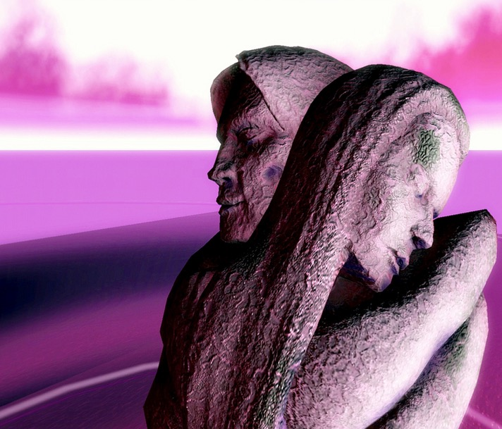
Photo by αndrΩ
If you have used some or all of the resources here are a few things you might like to think about:
- What have I learned?
- What else would it be good to find out?
- What assumptions or prejudices should I leave behind?
- How can I make a difference in my own local community?
- How can I support those helping victims of trafficking?
- Where does Christian faith come into all this?
If you want to know more or if you would like to start a conversation about human trafficking and modern day slavery, get in touch with the Mission Theology Advisory Group and tell us your stories.
A Powerpoint presentation is available for information and training.
Or if you would like to be put in touch with charities or groups working to combat trafficking,
Contact: anne.richards@churchofengland .org
Facebook: Mission Theology Advisory Group
Twitter Mission Theology Advisory Group @mtagmembers

Find out more about us and what we do at the Church of England website and at www.ctbi.org.uk

‎

