LIBERation and entrapment project: flooding
Mission Theology Advisory Group

Table of Contents
Liberation and Entrapment Project 3
Flooding 3
Introduction 3
What caused the bad weather? 6
Was the bad weather related to climate change? 9
Reacting to disaster 10
The Role of the Church 15
Resources 17
Practical action: a short checklist for churches in times of flooding 17
Advising people about flooding 17
Sources of help: 18
Advice from the UK government about flooding 19
Appendix 1 23
Theological reflection: can the story of Noah shape our thinking? 23
References 25

The Mission Theology Advisory Group is an ecumenical group formed in partnership between Churches Together in Britain and Ireland and the Church of England



We provide resources in the areas of Spirituality, Theology, Reconciliation, Evangelism and Mission

This resource belongs to our Theology series. Please print and share.

Liberation and Entrapment Project

Flooding
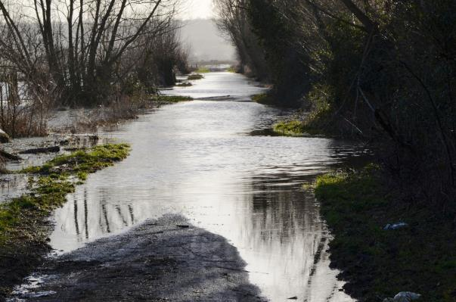
The Somerset Levels.
Photo: Nick Sarebi

Introduction

On 28th October 2013, the UK was hit by a storm, nicknamed ‘St Jude’. Driven by the jet stream, powerful winds killed four people, left more than 600,000 people without power, blew 100 trees on railway lines creating significant travel disruption and triggered 137 flood alerts. While not as powerful or as destructive as the great storm of 1987, many people felt the impact of a severe weather event.
However the St Jude’s storm proved to be only the first in a series of winter storms which lasted into Spring 2014. This resulted in the 2013-3014 winter becoming the wettest on record. Many rivers reached their highest ever recorded levels and caused flooding to thousands of homes, while a storm surge caused both coastal erosion and damage to sea fronts and promenades. In West Wales, Aberystwyth was particularly badly hit and in Dawlish in Devon, a section of track from the main railway line into Cornwall was damaged when the sea wall was swept away, severing the important rail link. As rain continued to fall, the ground became so saturated that flood water had nowhere to go, meaning low-lying areas such as the Somerset Levels were very badly affected, and leaving some villages, such as Moorland in Somerset, completely cut off and under water. Power outages and rail and road problems affected domestic lives and businesses alike, leaving some places like ghost towns in an eerie silence except for the lapping of the floodwater. Livestock and wildlife were also in trouble as fields disappeared under water. Abandoned homes and shops were also preyed upon by looters in a few cases. Many people in the south-east and other parts of the country had no power on Christmas Day.
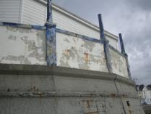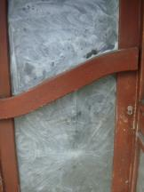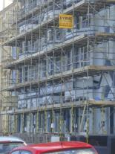
After the storm: damage, closed businesses, and reparations in Aberystwyth
These pictures show that flooding has immediate human and economic costs. Some businesses are so sensitive to tourism that transport interruption and bad weather mean immediate failure. This meant that enormous efforts were put into restoring the Dawlish line before the Easter holidays. In addition, flooding, with the possibility that it could recur, has an impact on property, insurance and resale prices.
In February 2014 Price Waterhouse Cooper projected that the clear-up cost could reach £1 billion while the governor of the Bank of England expressed concern that the flooding could have an effect on future output in a time of pre-existing economic strain.
Beyond damage and loss to the country as a whole however, are many individual stories of fear, loss and heartbreak, as well as other stories of communities coming together, individuals travelling from other parts of the country to help out and the unstinting service of firefighters and lifeboat services in helping people in trouble.

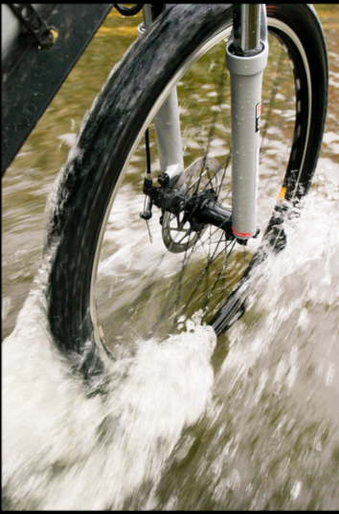
Cycling through a shallow part of Botley Road, Oxford Photo: John Barker
In addition, questions have arisen: what causes prolonged bad weather? Is God punishing us for something? Have human beings affected the climate? How do people cope with feelings of anxiety and entrapment? Who will help when the waters are lapping at your door? Where do we put our anger and distress? Why doesn’t the Government do something? What are we going to do about the future?
These questions all have a spiritual element, about our place in the world and our sense of displacement when that world gets interrupted.
In the next sections we look at the flooding as a spiritual issue, inviting reflection and testing our understanding of our place in the world and care for each other. The purpose of this reflection is to allow churches to plan for the effects of future bad weather in the communities where they are situated.
Such planning is a mission issue. In the five marks of mission, Christians are called to give loving service to others, to challenge unjust structures and to be responsible carers of creation. All these marks are tested by flooding and storms.

What caused the bad weather?

The ‘jet stream’ consists of very strong winds at very high altitudes which move weather around the planet. Waves and ripples can occur in the jet stream creating depressions over the Atlantic which bring storms to the UK. The jet stream’s position and ‘waviness’ are affected by both cold air at the poles and hot air from the tropics which means that the global climate and environment are all involved in what happens to the jet stream. The British Meteorological Office reminds us that ‘the atmosphere is a complete environment with numerous connections’.
The weather system which produced the St Jude’s storm and the prolonged rainfall was caused by an unusual positioning of the jet stream. This meant that the polar vortex which normally sits over the North Pole, shifted downwards over North America, leading to freezing temperatures in every US state and extreme snowfall in many northern and eastern areas. Many Americans were advised not to leave their homes and many businesses, schools and roads were closed and flights cancelled. More than 200 million people were affected by the weather.
On the other side of the world, Australia experienced soaring temperatures and a prolonged and extreme heat wave, shattering records for temperature. It was so hot through 2013 – 2014 that the Australian Bureau of Meteorology had to add another colour to its temperature map to denote areas with record heat.
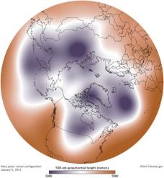
NAOC photograph
The jet stream travels from west to east but when it becomes especially wavy in a north and south direction, hot and cold air is dragged into regions which would not expect to experience the temperatures or weather conditions associated with them. The same ‘wavy’ behaviour of the jet stream also kept the UK locked into a weather pattern in which rainstorm after rainstorm swept across the country. Science gives us tools to try to understand our weather, although weather is a tremendously complex system. Accurate forecasting is difficult and unusual weather events can arise quickly and remain in place longer than can be predicted.
The British are often said to be obsessed with weather and that we love talking about it. Our changeable weather has seeped deep into both our culture and temperament. Perhaps though, we aren’t talking about it enough or in the right way. Most of us like to watch the weather forecast or may ‘religiously’ look up the weather online before we venture out. The Poet Laureate, Carol Ann Duffy, rightly includes a recitation of the shipping forecast in her poem called Prayer. We’re also aware that we can often be caught out. A warm sunny morning can turn into wet, cold and windy conditions. On other occasions taking an umbrella can seem foolish when we end up needing the sunscreen. Many people were furious when BBC weatherman Michael Fish assured people that a storm was not coming just before they woke up to find a million trees on the ground. But this should surely teach us just how mysterious and complex weather really is and that we should always be prepared for unusual weather events as well as expected ones.
Is weather a spiritual issue? It is interesting that a number of people contacting the Church of England asked whether God was behind the bad weather and the terrible effects on human beings. A politician, David Silvester, tried to make capital out of this question by criticising the government’s legislation for same-sex marriage in terms of retribution through natural disasters, citing scriptural precedent. This highlights a problem: it shows us that in some people’s minds, a God ‘up there’ uses the natural forces of the planet to punish human beings and causes us misery to teach us all a lesson. If we change our minds, mend our ways, make the appropriate sacrifices or otherwise conform to God’s mysterious rules, then the sun will shine again. Some people have asked whether the Biblical story of Noah tells us that God intends to destroy sinful human beings with rain and others have asked about whether insurance ‘Acts of God’ mean that would should ascribe flooding to divine action. In fact the phrase ‘act of God’ in relation to insurance matters is a bit of a myth in the sense that insurers do not behave as if God has anything to do with it. A biblical reflection on the Noah story for people who want to use this as an aid to reflection on the 2014 storms is given at Appendix 1.
We can see that this kind of thinking does nothing to allay the anxiety which lies behind it. It creates a picture of a vengeful, merciless God, whose actions on the world are demonstrations of power and destruction, bringing fear and misery. It tempts us to single out the scapegoats (eg same-sex marriage legislation) and pass on the blame and punishment to others in order to escape ourselves. This kind of thinking benefits neither our understanding of weather nor our theology. This is made clear in the Book of Job in which Job’s friends talk about a causative relationship between human behaviour and God’s punishment in terms of calamity. However, God’s words to Job ask him whether he has the deep understanding of the way creation works:
‘Who has cut a channel for the torrents of rain, and a way for the thunderbolt, to bring rain on a land where no one lives, on the desert, which is empty of human life, to satisfy the waste and desolate land, and to make the ground put forth grass?’
Job 38. 25-27.
Weather is not just about human beings, but part of the order of creation which enables and sustains life on this planet. When we start to think of extreme weather events as just affecting human populations or somehow being ‘about’ us, then we forget both the good intention of God as Creator and anthropomorphise God into our own destructive image. The book of Job teaches us that this is a false view, or as Jesus says in Matthew 5.45: ‘he makes his sun rise on the evil and on the good, and sends rain on the righteous and on the unrighteous’.

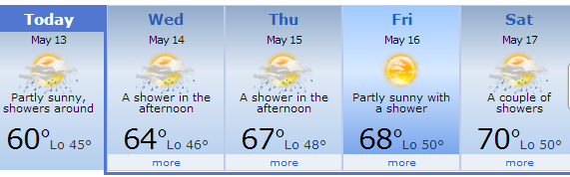
We should think more deeply about the weather than just watching the forecast. In particular we should all of us think about not just about whether we need a raincoat this morning, but about the impact of future weather on our bodies, our homes, our pets and livestock, our families, our businesses. Weather is a spiritual issue because it affects how we live, grow and flourish as Christians and church communities. Meetings of our own Mission Theology Advisory Group (MTAG) which has members who come from all over the country have been disrupted in the past by snow and ice, wind and rain as well as by the more recent flooding and we are ourselves aware of the need to maintain communication, exchange work and care for each other when travel is a problem. Weather is a spiritual issue because it can affect how and when people meet together for prayer and worship; it can become part of the memory of baptisms, funerals and weddings. Weather can affect people’s mood or even drive an already depressed person into suicide.
In terms of liberation and entrapment, weather plays its own part. We can be ‘trapped’ inside by strong winds or heavy rain, while a sunny weekend brings people flocking to the seaside or to the shops for barbecue stuff. Weather is therefore a deeply entrenched part of both our human experience and our spirituality and requires our attention and reflection.

Was the bad weather related to climate change?

The Teacher in Ecclesiastes 9. 11-12 notes that:
‘Again I saw that under the sun the race is not to the swift, nor the battle to the strong, nor bread to the wise, nor riches to the intelligent, nor favour to the skilful; but time and chance happen to them all. For no one can anticipate the time of disaster. Like fish taken in a cruel net, and like birds caught in a snare, so mortals are snared at a time of calamity, when it suddenly falls upon them’.
We ought to be better at anticipating disaster in a technologically proficient world. Yet it still proves difficult to know exactly what is happening with our shifting, changing planet. This means that the question about the relationship between the recent extreme weather events and human-initiated climate change is still being debated and questioned.
At a meeting on Arctic Change at the American Association for the Advancement of Science in Chicago, Professor Jennifer Francis from Rutgers University's Institute of Marine and Coastal Sciences reported that warming Arctic air may have caused the jet stream to weaken and become more ‘wavy’. This may also be linked to melting sea ice, because the sea ice acts as a lid keeping warmth from getting into the atmosphere. On the other side of the world, Karly Braganza, manager of climate monitoring at the Australian Bureau of Meteorology, has also suggested that human behaviour may be behind the climate change leading to the scorching temperatures in Australia. While such experts cannot predict whether such weather patterns are likely to be repeated, there is the possibility that we can expect more of them and when they arrive, they will last longer.
Climate scientists are therefore working hard to understand the processes involved in extreme weather, but find it difficult to evaluate the amount of impact our own behaviour has on how these processes come about. However, we should not sit back and wait for some definitive conclusion.
The fifth mark of mission requires that we respect our planet and treat it with care and appropriate stewardship. So no matter what the extent of our own role in climate change, we can all act with more awareness, more care and more attention to our carbon footprint and contribution to greenhouse gases.
Further, beyond the big picture there is a requirement to address how we manage local environments and especially our water. Attention has been drawn to how we manage ditch digging and maintenance and how we manage soil so that it does not become sterile and wash into rivers, silting them up and making them more prone to flooding. This is not just a matter for farmers and land owners. Every one of us can be more careful about water management and drainage, including not clogging sewers by throwing everything we want out of sight down the lavatory. Farming and land management is itself part of a complex economic web driven by our shopping habits and demands, so it is not enough to place blame on poor practice without considering how we as consumers drive such practices. If we want to reduce the impact of flooding we should not rely on the introduction of beavers to manage our rivers effectively but consider how we ourselves can do more to make sure rivers are kept clean and free of silt. We can also manage the water table more effectively by considering how to reduce the amount of domestic rubbish sent to landfill which affects the water table as it rots.
MTAG has a resource for exploring the fifth mark of mission and making changes through its Eco House at www.dispossessionproject.org. We suggest using these resources to explore environmental issues to raise awareness, change lifestyles and exercise responsibility for the way our planet develops in the future. Other resources and help are available at http://www.churchcare.co.uk/shrinking-the-footprint .
Some simple ideas for being more responsible about water include:
- Recycle where possible. Send as little as possible to landfill
- Don’t throw anything except proper toilet tissue into the lavatory (and especially not baby wipes)
- Don’t throw rubbish into streams, rivers or ditches
- Clear drain openings outside your home of leaves or rubbish
- Find out about farming and river/land management in your area and press for responsible practices
- Support farmers who farm responsibly and care for the environment

Reacting to disaster

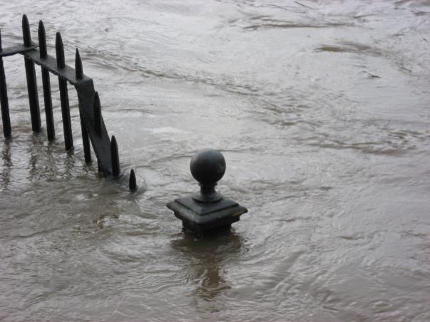
Flood at York
Photo by Claudio Mazzetti
‘When the water started coming into my garden I literally couldn’t believe it. I just stood there and said to my husband, “Look at this”. He was sensible and started moving things and turning off the electricity. I said “What are you doing that for?” He said “It’s going to come in the house”. I didn’t believe it. My mind went blank and then I thought “this is what happens in other countries, like you see on the news. Like India. It can’t happen here.... But it did.”’
‘Jane’ from Pangbourne, talking to MTAG
Jane also reiterated her feelings of disbelief when people were advised not to drink tap water because of possible contamination by sewage. She felt that ‘dirty water’ was a ‘foreign’ issue and not something that could happen in the UK. Yet as the flood waters rose more concerns were expressed about contaminants and the possibility of water-borne disease, including worries about buried bodies and ashes in flooded cemeteries where the water reached over the top of the gravestones. When the water level receded in Jane’s house, she was most struck by the smell of the dirty water as being not only upsetting but somehow deeply shameful, making her feel like a failure. It is natural to feel threatened and unsafe by an unstoppable force of nature invading your home.
Many people reacted with anger at the prolonged flooding and wanted to find someone to blame. Government ministers came under fire for not acting quickly enough or for making highly publicised but otherwise token visits to flooded areas without registering the real distress of residents, or having the expertise to know how to mobilise appropriate help: ‘The feeling that rural life was simply not understood by those with power’. It was also argued that government only became really motivated to send organised aid when the Thames flooded at Chertsey, flooding wealthy people’s houses much nearer to London. In terms of liberation and entrapment there was a question about whether people who are geographically and economically furthest from sight and out of mind are in fact the last to be ‘remembered’ and helped by those in authority when disaster strikes, so that relatively unpopulated areas were ‘allowed’ to flood in order to preserve major conurbations. As Taylor et al noted in their report on the Somerset flooding, people asked: ‘Why has it taken as long to get help to us as it did to the Philippines after the tsunami?’ and ‘This would never have been allowed to happen in a town or city. Even if it had we would have been helped far more quickly there’. A row erupted about apparent criticism of the Environment Agency. Some cartoons even joked that developing countries were thinking about sending aid to flooded Britain, while outrage was provoked by a suggestion in the Daily Mail that the British overseas aid budget should be diverted to help people at home. A front page headline for the 11th February 2014 in that newspaper read ‘Put UK flood victims first’.
This last issue was interesting in that it highlighted a moral question about whether people felt they were more worthy or deserving of help than others in need and whether governance morally obligates those in authority to consider British people first and to divert resource from other expressed need. It was therefore interesting that the Prime Minister, David Cameron, claimed that the resources of the army and ‘unlimited’ funds would be made available to help people affected by the flooding.
What was also interesting about the debate was the observed need to blame an external agency and the idea that disasters usually happen to someone else. It should be remembered that in many countries flooding is simply a part of life. One of MTAG’s members, who grew up in Brazil, recalled regularly moving the family piano to higher ground so that the water would not damage it.

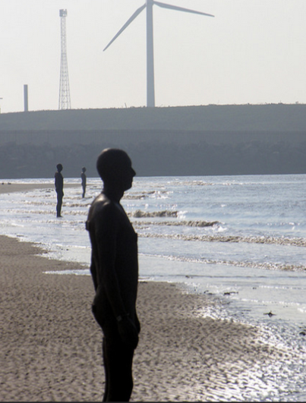
Photo: Phillip Capper
Yet when flooding is a comparatively rare event, other matters, which impact on spirituality, come into play. The photo above is of Anthony Gormley’s Another Place, installed in 2005 at Waterloo Beach, Crosby, Merseyside, in which cast iron figures stand impassively to be submerged or revealed by the rise and fall of the tide. This installation asks us to consider the psychological effect of being trapped by a flood, as the water comes up inexorably and the figures can do nothing as it rises and covers them. At first, like Jane, people may not believe that it is really going to happen to them, then, when the water is actually coming in, people panic or dissociate from the event and do nothing, waiting for it to go away. The experience of unexpected flooding can be traumatic, leaving people with complex feelings of fear, loss and uncertainty which persist after the water has gone.
Fr Philip Knights, a member of MTAG, shared his own experience of having a Chapel of Ease flooded:
‘Our Chapel of Ease, dedicated to St Thomas More, in the Village of Welham Green was flooded with approximately 7” of dirty water on Friday 7th February. The usual 9:30am Mass on the Sunday morning was moved to our main Church in Hatfield but by the following weekend the waters had been pumped out and all was more or less dry. We had a work party on the Saturday which removed sodden carpets and underlay and then had the Herculean task of cleaning (I think that is the literal use of ‘Herculean’ as the Augean Stables certainly came to mind as we removed mud and whatever else had washed in from the surrounding farms.) The Mass was offered again in the building on the Sunday. The loss adjuster has agreed to replace the carpets and normality should soon return.
There is a visceral but almost guilty feeling about being flooded. No lives were lost, no serious injuries, it was just inanimate objects such as carpets that were damaged and yes, seeing the news, many people were far far worse off than we were. However, whilst putting things into a perspective may be objective wisdom, it felt a subjective violation. There is something about the nature of flooding that muddies the soul and dampens the spirit. The language of entrapment is very apposite.’

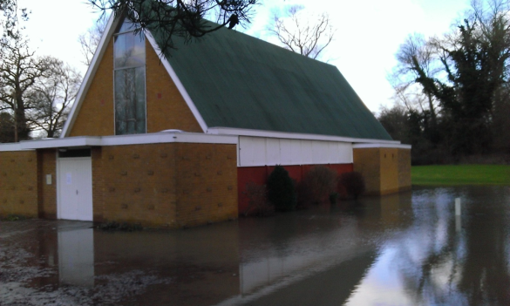

As with Jane from Pangborne, Fr Philip notes the experience leaves a gut feeling of guilt and violation which is unrelated to the amount of actual damage. This psychological sense of loss and intrusion caused by flood water is itself a spiritual experience and one which needs more than money to heal.
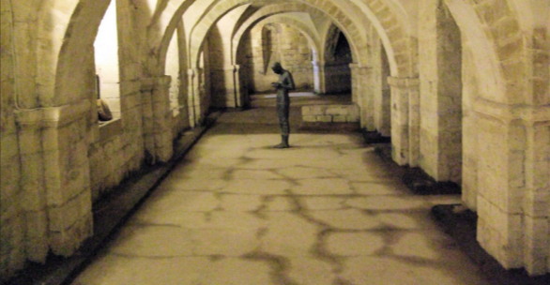
Photo: Jim Linwood
Anthony Gormley, Sound II : a statue in the crypt of Winchester Cathedral which regularly floods.

The Role of the Church

In reflecting on the experience of being flooded, Fr Philip also noted another side of things:
‘Within adversity there is an opportunity of service and community building. People were neighbourly. Church people and non-church people assisted with the clean up and there was a feeling of solidarity in suffering and well-wishing for recovery. People could see a problem to whose solution they were eager to contribute.’
Churches are at the heart of communities and therefore have a much better idea in times of difficulty as to who is in need and who needs to be checked up on to see if they are all right. Taylor et al point to the possibility of churches becoming community ‘hubs’ providing food from their kitchens, toilet facilities and Wi-Fi. Not only can this help people cut off from their home facilities but simultaneously can create a missionally significant service. The provision of such ‘hub’ activities is not something governments can manage, so churches can have a vital role to play, especially in carrying out the third mark of mission in providing loving service to others. Taylor et al quote a member of the clergy saying ‘I joined in filling sandbags, helping people move items, witnessing the movement of 550 cattle. That was very sobering. There is something about being a witness and then a voice for people, even if it involves a lot of tears. Getting my hands dirty was probably the best thing I could do’.
To be prepared is important. Jesus exhorts us to be prepared for the unexpected and warns what happens to people who are unprepared. If it is a matter of faith that we expect the Lord’s coming again, then surely we ought to also spend time in practising preparedness. How we learn lessons from the past and look forward and anticipate the needs of others is also a part of the missionary purpose and a way in which we anticipate the full realisation of God’s kingdom. Such preparation requires not only the resources of church buildings and facilities but to be clear about what clergy and lay people are available in times of emergency to respond to the needs of the community and to be prepared to check on the vulnerable and elderly.
In the resources section which follows, we offer a short checklist for churches to use in times of flooding in addition to the government’s advice about flooding and end with this prayer, specially written for those affected by flooding:
Gracious God,
We commit to you all who are affected by flooding and the severe weather.
We pray for those who are suffering through loss of their homes and everyday lives. We remember those whose livelihoods have been damaged, whose businesses cannot operate and farmers whose crops have been destroyed and livestock evacuated.
We give thanks for the many people who have worked together to help one another. We remember the physical hardships, stress and distress of all those working in difficult conditions and pray for the perseverance and stamina required to carry on.
We ask your blessing on the work of all organisations and initiatives that are seeking to provide relief to people, prevent further flooding and ensure livestock are well cared for.
Bless the work of all those who caught up in this severe weather and its aftermath.
All this we ask through your Son, Jesus Christ our Lord. Amen.
http://www.arthurrankcentre.org.uk/communities-and-farming/community-resources/item/9344-how-to-support-those-affected-by-flooding

Resources

To help with being prepared for the future, we offer below some pointers for practical action:

Practical action: a short checklist for churches in times of flooding

- Will the church be flooded? Where else can services and occasional offices be held?
- Who do you know who is housebound/frail/elderly/pregnant/living with small children who might have difficulty getting access to goods and services if roads are flooded?
- Who might need help to get to hospital appointments or services?
- Who might need help to get to Jobcentres or interviews or who are at risk of losing benefits if they cannot travel?
- Can someone check on danger points such as bridges or promenades if people come to ‘look at’ the flooding or storm surges?
- Do you have good contacts throughout the community so that you can alert police and other emergency services as necessary?
- What can your church do to provide emergency shelter/food/ clothing/ advice for people affected by flooding?
- What skills and resources does your church community have do to help with clean-up, and redecoration?

Advising people about flooding

Churches can be at the forefront of providing advice and support for people whose homes may be at risk from further episodes of severe weather.
Further detailed advice and help and how to get it is reproduced from the government’s website in the Resources section below.
A leaflet handout could be provided with bullet points like those below:
Before it happens:
- Make a plan for a flood emergency well beforehand. Don’t wait and see.
- Get good insurance cover. If you’re not sure about how to get suitable insurance contact a Citizen’s Advice Bureau for help.
- People: where are elderly people or children going to stay? If they are going to leave how will they get there? Decide this in advance and make sure everyone knows where they will be going and what to take. Will you have food, water, medication and other important supplies if you get cut off from shops or the doctor?
- Animals: who will look after family pets or any livestock? How will they be transferred? Decide this in advance.
- Decide where you are going to store important and precious belongings, especially papers and documents. Clear an area for storage upstairs or in the loft.
- Clear a space upstairs big enough for removable ground floor furniture.
- Buy plastic boxes with close fitting lids for safe storage of items.

If flooding threatens
- If the emergency services give you instructions, follow them without delay.
- Outside: if you can, tape plastic sheeting to the bottom walls of your house.
- Use sandbags to protect access points to the house.
- Move cars and vehicles to higher ground
- Move irreplaceable items to safety.
- Move ground floor items upstairs
- Tie up curtains away from the floor

If water comes in
- Turn off all gas and electric and move electrical items away from the water

Afterwards
- Photograph all damage for insurers before and after the water levels drop.
- Check with authorities that drinking water has not been contaminated.
- Dispose of sandbags responsibly (see help for this in the further resources section).
- Make a list of items that need replacement and tasks that need to be done for repair, restoration and redecoration.
- Clean away mud and dirt and check for mould growth as this is a health hazard.
- Don’t sleep in damp areas.
- Don’t reconnect electric or gas devices until they have been checked by a competent electrician.
- Expect a long period for complete drying out. Don’t redecorate until you are sure this process is complete.

Sources of help:

Farming Community Network www.fcn.org.uk See www.fcn.org.uk/events/detail/83 for FCN’s role in the 2014 flood relief
Royal Agricultural Benevolent Institution www.rabi.org.uk See http://www.rabi.org.uk/seeking_help/Flooding2014.html for information about the RABI’s role in the 2014 flood relief.
County Community Foundations: these will often manage grants and resources for those flooded out.
FLAG: Flooding on the Levels Action Group for better water management: www.FLAGsomerset.org.uk
Farming and Wildlife Advisory Group (FWAG) www.fwag.org.uk

Advice from the UK government about flooding

https://www.gov.uk/browse/environment-countryside/flooding-extreme-weather

Prepare for a flood and get help during and after
- Find out if you’re at risk
- Make a flood plan
- Improve your property's flood protection
- Get insurance
- Get help during a flood
- Get help after a flood

1. Find out if you’re at risk
To plan for a flood, check your risk from:
- rivers or the sea
- surface water
- reservoirs
You can get the flooding history of a property. This is a free service unless it’s for a business or takes more than 18 hours to complete.
Email: enquiries@environment-agency.gov.uk
You must include:
- the property’s address
- a map showing the property’s location
- your address and phone number
Use the Land Registry’s Flood Risk Indicator service if you want to buy a report on the risk of flooding from rivers and seas for a specific property in England or Wales.

Get flood warnings
If you’re in an area at risk sign up for flood warnings online or call Floodline.
Floodline
Telephone: 0345 988 1188
Telephone: 0845 988 1188
24-hour service
Find out about call charges
The service is free. You can get warnings by phone, email or text message.

Wales, Scotland and Northern Ireland
You can get advice on flooding in:
- Wales from Natural Resources Wales
- Scotland from the Scottish Environment Protection Agency
- Northern Ireland from Northern Ireland Direct

2. Make a flood plan
You should make a written plan of how you’ll respond to a flood if you run a business in an area at risk of flooding. It should include how you’ll:
- protect staff
- deal with hazardous equipment
- reduce the risk from polluting materials
Download guidance on how to prepare your business for flooding.
Download guidance and a flood plan template if you’re responsible for making a flood plan for a school, hospital, care home or other community group.
You can make a flood plan if your home is at risk of flooding and find outhow to use sandbags.

If you have a disability or need extra help
Ask your local council if they keep lists of people who need extra support during a flood.
Contact Floodline to ask for a friend or relative to get flood warnings on your behalf.

3. Improve your property's flood protection
Ask a building surveyor, architect or other independent professional for advice on permanent flood protection measures.
Use the flood protection advisor to find out how much it could cost to protect your home.
Contact the Environment Agency if your plans will affect the flow of a river or will divert flood water to other properties.
Environment Agency
Email: enquiries@environment-agency.gov.uk
Telephone: 03708 506 506
Minicom: 03702 422 549
Monday to Friday, 8am to 6pm
Find out about call charges
Environment Agency
National Customer Contact Centre
PO Box 544
Rotherham
S60 1BY
Read guidance on how to protect your home or small business from a flood.
Read advice from English Heritage if you live in a historic building.

If you own a riverside property
If you own property next to a watercourse, eg river, culvert, brook or mill stream, you must:
- manage your own flood risk
- maintain river beds and banks
- not obstruct the water flow
Read guidance on the rights and responsibilities of owning a riverside property.
Contact the Environment Agency if you have questions about your responsibilities.

Find flood protection products and suppliers
Contact the Flood Protection Association for suppliers or search the National Flood Forum directory.
Look for the Kitemark when buying flood protection products.

4. Get insurance
Contact the National Flood Forum for advice on how to get insurance and reduce your premium or excess.
Contact the British Insurance Brokers’ Association to find a broker that specialises in properties that are difficult to insure.
Read guidance on getting insurance in high flood risk areas if you can’t get insurance.

Get evidence of flood risk
An insurance company may ask you for an Insurance Related Request Letter if your property is at risk of flooding. The insurer will use the letter to decide if they’ll insure you and how much it will cost.
Contact the Environment Agency to get the letter.
The letter states:
- if your property is in a flood risk area
- how likely the area is to flood
- the protection given by local flood defences
- if there are any planned flood defences
You’ll get the letter within 20 working days. It’s free for individuals and £60 for businesses.
If you’ve done flood protection work on your property, you or a surveyor can complete a Flood Risk Report to tell insurers or buyers how the work affects the flood risk.

5. Get help during a flood
You can ask your local Fire and Rescue Service for help pumping out water but you may be charged a fee.
You must contact:
- your local Environment Agency office to pump water into rivers or boreholes
- your local authority to pump water into ditches or watercourses
- your water company to pump water into public sewers
- the Highways Agency to pump water into street drains

Report a gas, electricity or sewage hazard
Contact National Grid on 0800 111 999 to report a gas leak or 0800 404 090 to report a problem with overhead electricity lines.
Contact your local council to report an overflowing drain or sewer.

Get emergency accommodation or money
Contact your local council for help getting temporary accommodation.
Contact Citizens Advice for help getting emergency money.

Plan a journey
If you need to travel look at the latest:
- weather forecast
- road travel information

Further information
The National Flood Forum has advice on what to do if you’re about to be flooded.

6. Get help after a flood
Public Health England has advice on how to clear up after a flood.
Contact your local council if they haven’t provided skips or extra rubbish collections.

What to do with used sandbags
Dispose of used sandbags at your local civic amenity and recycling site.
Sandbags contaminated with hazardous substances, eg sewage, must be disposed of as hazardous waste - contact your council environmental health department for advice.

Find repairers
Contact the Construction Industry Research and Information Association (CIRIA) for advice on restoring buildings.
Contact the British Damage Management Association or the Construction Centre for companies that can repair your property.

Appendix 1

Theological reflection: can the story of Noah shape our thinking?

The story of Noah (Genesis 5.32 – 10.1) is one of the best loved and best known stories of the Bible and many people remember the basics of the flood part of the story from childhood.
With the severe weather and flooding in 2014 some people have asked whether we should pay more attention to the story of Noah. Most such enquirers ask the question from what they remember from the story – is this God’s punishment?
The problem in answering the question is that the biblical narrative is much more complex and intricate than people’s memories of ‘the animals went in two by two’ or God making it ‘rain and rain and rain and rain and rain’. That having been said, there are some elements of the narrative which can help us understand the spiritual effects on us of extreme weather.
It has been well documented that the biblical flood story is not the only ancient story of this kind and that not only does the biblical narrative echo and call on other flood narratives but that this interconnection with other stories may help to explain some of its unusual features. What this tells us is that people of many times and places have struggled to make sense of extreme weather events and disasters. They have struggled to find meaning and purpose in natural disaster and asked themselves what there is to learn from survival in such circumstances. In this sense, Jane from Pangborne, Fr Philip in Hatfield, and everyone who has been affected by the floods, has contributed to an ongoing ‘Noah’ narrative being re-told in our own contexts and cultures.
The Noah narrative is intimately related to the creation stories in the earlier chapters of Genesis. God delights in and blesses what is good, and desires that the living things of the planet ‘be fruitful and multiply’. At the outer edge of the Noah narrative then, is the understanding that what has multiplied along with the human population is human evil and this proliferation has broken God’s heart. Robert Alter points out that the word for ‘heart’ is repeated for both human evil and God’s grief. Because human beings have twisted and damaged the creation, God must effectively rewind and recreate it to undo the damage.
This faces us with two questions. First, what role have we as human beings had in climate change and in what ways are we continuing to break God’s heart with what we are doing to the precious planet? Secondly, what is God doing today to restore the world and how do we aid that process? These are significant and relevant questions and much more useful than the ‘punishment’ concerns. Such questions require us to acquire information about our role in climate change and to pay attention to research and discussion about how our weather is changing and what such changed weather patterns mean for living things on our planet. They press us to identify the harm we have done and find good and effective ways to redress our mistakes and our damage. Similarly, we are called, as God’s people, to search out what God desires for the creation, to find out what God is doing and to work for those purposes. If we say that God loves the world, then we must love it too.
We can also learn more about the second question from the Noah story. For God actively gives Noah instructions on the preparation of the ark. Alter draws our attention to the sheer length and depth of God’s narrative intervention; we cannot doubt that God is here, guiding Noah not just to the big picture, ‘build an ark’, but the smallest significant details, ‘make a skylight’. Noah’s attention to God, faith in God’s purposes, and his considerable skills in constructing the ark, provide us with a picture of our own tasks in mission and how these are relevant not just to general mission aims, but to making a difference in providing loving and dedicated service to our own communities.
A fundamental aspect of the narrative is that Noah must seek to care for and preserve the creation. The taking of pairs of animals and birds into the ark as well as his human family impresses upon us the importance of thinking beyond ourselves to care for our families, neighbours, communities, pets, livestock and animals and plants affected by the weather. In severe weather, we are all called on to make and provide arks, by being properly prepared and knowing what skills we have or can share to give food, protection and shelter to others in times of hazard. Churches are arks, whether their architecture reminds us of it or not, and perhaps we should not need flooding to remind us that our churches should be places of care for creation and places of sanctuary and love.
During the flood, creation is reduced to its primordial state. Just as in the creation stories, the Spirit moved over the face of the waters, so the ark now bears its precious cargo of created beings into God’s future. The Spirit is with them. Remember the detail of the skylight? The dove brings back to Noah evidence that God has restored the creation. After the flood, creation effectively begins again. God makes a solemn oath to the divine self about the rightness and goodness of the restless cycle of the seasons and goes on tell Noah to be ‘fruitful and multiply’ in the restored creation. Noah responds with thanksgiving. As we all know, that restoration of relationship, goodness and blessing between God and human beings is sealed with the sign of the rainbow. After the rain comes the sun.
This part of the narrative can help us understand why we feel violated and guilty if the flood water comes in. There is an unmaking taking place – of our homes, our places where we feel safe, so that we have to retreat with whatever is most precious to us. While the actual damage may be relatively little, the sense of unmaking is linked right back to whatever we most fear about the precariousness of our own existence and that of our world. Even a damp carpet can spark in us the fears we carry of some apocalyptic event. In some ways, that is a good thing, if it reminds us not to be complacent and to consider what is to us of real value. It might also make us more mindful of those in other countries whose experiences are more dangerous and more extreme than ours. Further, the narrative reminds us that we can start again, can renew a right relationship with God and creation and that we should be thankful for the chance. There is resurrection. But if we are going to count our blessings, then it is with gratitude for all who work to deliver us. The rainbow is not an excuse for complacency; the rainbow requires that we make the most of a chance to re-make creation as God would have it.

References

Alter, R., (2004) The Five Books of Moses, (New York. W W Norton)

BBC News (2013) ‘Big Storms compared’ http://www.bbc.co.uk/news/uk-24708614 29th October 2013 accessed 14/05/2014.

BBC News (2014) ’10 key moments of the UK winter storms’ http://www.bbc.co.uk/news/uk-26170904 17th February 2014 accessed 13/05/2014

BBC News online, (2014) ‘UKIP councillor blames storms and floods on gay marriage’ http://www.bbc.co.uk/news/uk-england-oxfordshire-25793358 18th January 2014 accessed 13/04/2014

Five Marks of Mission http://www.anglicancommunion.org/ministry/mission/fivemarks.cfm accessed 15/05/2014

Kahn, B., (2014) ‘Australia’s 2014 Heat Wave Picks Up Where 2013 Left Off’ online at http://www.climatecentral.org/news/australia-2014-heat-wave-picks-up-where-2013-left-off-16938

Met Office Uk http://www.metoffice.gov.uk/learning/wind/what-is-the-jet-stream accessed 14/05/2014

Neuman, S., (2014) ‘Warming Arctic May Be Causing Jet Stream To Lose Its Way’ online at http://www.npr.org/blogs/thetwo-way/2014/02/16/277911739/warming-arctic-may-be-causing-jet-stream-to-lose-its-way accessed 14/05/2014

Osbourne, H., (2014) ‘UK flood clean-up costs could hit £1bn, insurance expert warns’ The Guardian online 10th February 2014 http://www.theguardian.com/business/2014/feb/10/flooding-costs-one-billion-pounds-insurance-expert-warns-rising-premiums accessed 14/05/2014

Pickford, J., (2014) ’Mark Carney warns on economic impact of UK flooding’ (2014), Financial Times online 12th February 2014 http://www.ft.com/cms/s/0/56ea3d9c-9411-11e3-a0e1-00144feab7de.html#axzz31bAu7IaX accessed 14/05/2014

Shipman, T., Ellicott, C., (2014) ‘Spend our foreign aid on British victims of flooding: MP's impassioned call as crisis deepens’ 7th February 2014 online at http://www.dailymail.co.uk/news/article-2554324/Spend-foreign-aid-British-victims-flooding-MPs-impassioned-call-crisis-deepens.html accessed 14/05/2014

Sky News (2014) ‘Flood Victims helped by “Best of British”’ http://news.sky.com/story/1209889/flood-victims-helped-by-best-of-british accessed 15/05/2014

Taylor, S., Walrond, R., Gurner, A., (2014) Fact, Feeling and Future, A Report following the Somerset Winter Floods of 2013 and 2014 for the Bishop of Taunton. Online at http://www.bathandwells.org.uk/faithandmission/fact-feeling-and-future/.
UK government (2014) https://www.gov.uk/browse/environment-countryside/flooding-extreme-weather accessed 14/05/2014
Wintour, P., Booth, R., (2014) ‘UK floods: David Cameron pledges unlimited public funds’ 11th February 2014 The Guardian online at http://www.theguardian.com/environment/2014/feb/11/uk-floods-david-cameron-unlimited-public-funds accessed 14/05/2014

Wintour, P., and Mason, R., (2014) ‘UK floods: government has got a grip on this, minister insists’ The Guardian online 11th February 2014
http://www.theguardian.com/environment/2014/feb/11/uk-floods-government-got-grip-minister accessed 14/05/2014

28th October is the feast day of Saint Simon and Saint Jude.
BBC News (2013) ‘Big Storms compared’ http://www.bbc.co.uk/news/uk-24708614 29th October 2013.
BBC News (2014) ’10 key moments of the UK winter storms’ http://www.bbc.co.uk/news/uk-26170904 17th February 2014.
Osbourne, H., (2014) ‘UK flood clean-up costs could hit £1bn, insurance expert warns’ The Guardian online 10th February 2014 http://www.theguardian.com/business/2014/feb/10/flooding-costs-one-billion-pounds-insurance-expert-warns-rising-premiums
Pickford, J., (2014) ’Mark Carney warns on economic impact of UK flooding’ (2014), Financial Times online 12th February 2014 http://www.ft.com/cms/s/0/56ea3d9c-9411-11e3-a0e1-00144feab7de.html#axzz31bAu7IaX
Sky News (2014) ‘Flood Victims helped by “Best of British”’ http://news.sky.com/story/1209889/flood-victims-helped-by-best-of-british
See http://www.anglicancommunion.org/ministry/mission/fivemarks.cfm
http://www.metoffice.gov.uk/learning/wind/what-is-the-jet-stream
Kahn, B., (2014) ‘Australia’s 2014 Heat Wave Picks Up Where 2013 Left Off’ online at http://www.climatecentral.org/news/australia-2014-heat-wave-picks-up-where-2013-left-off-16938
BBC News online, ‘UKIP councillor blames storms and floods on gay marriage’ http://www.bbc.co.uk/news/uk-england-oxfordshire-25793358
Neuman, S., (2014) ‘Warming Arctic May Be Causing Jet Stream To Lose Its Way’ online at http://www.npr.org/blogs/thetwo-way/2014/02/16/277911739/warming-arctic-may-be-causing-jet-stream-to-lose-its-way
Taylor, S., Walrond, R.,Gurner, A., (2014) Fact, Feeling and Future: A Report following the Somerset Winter Floods of 2013 and 2014 for the Bishop of Taunton, p.2. Online at http://www.bathandwells.org.uk/faithandmission/fact-feeling-and-future.
Ibid. pp. 4; 12.
Wintour, P., and Mason, R., (2014) ‘UK floods: government has got a grip on this, minister insists’ The Guardian online 11th February 2014 http://www.theguardian.com/environment/2014/feb/11/uk-floods-government-got-grip-minister
Shipman, T., Ellicott, C., (2014) ‘Spend our foreign aid on British victims of flooding: MP's impassioned call as crisis deepens’ 7th February 2014 online at http://www.dailymail.co.uk/news/article-2554324/Spend-foreign-aid-British-victims-flooding-MPs-impassioned-call-crisis-deepens.html
Wintour, P., Booth, R., (2014) ‘UK floods: David Cameron pledges unlimited public funds’ 11th February 2014 The Guardian online at http://www.theguardian.com/environment/2014/feb/11/uk-floods-david-cameron-unlimited-public-funds
Taylor, S., et al, op.cit. p 12.
Ibid. p. 6.
Taylor, S., et al, have a number of important recommendations in their report suggesting ways in which dioceses could make preparations, op.cit., pp 21-24.
Alter, R., (2004) The Five Books of Moses, (New York. W W Norton) p. 40.
Alter, R., (2004) The Five Books of Moses, p. 41.

