Advent journey with the magi
Mission Theology Advisory Group

Table of Contents

1: STARS 3
2: TRAVELS 8
3: GIFTS 14
4: MEETING HEROD 18
5: MEETING JESUS 22

The Mission Theology Advisory Group is an ecumenical group formed in partnership between Churches Together in Britain and Ireland and the Church of England



We provide resources in the areas of Spirituality, Theology, Reconciliation, Evangelism and Mission

This resource belongs to our Spirituality series. Please print and share.

Advent Journey

1: STARS
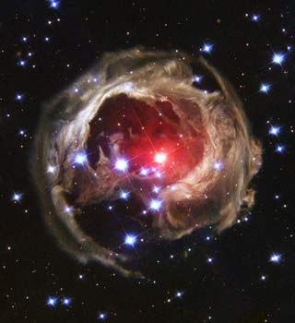
When I have a terrible need of - shall I say the word - religion. Then I go out and paint the stars.
Vincent Van Gogh
Starting Out: Something to Think About
Alone of the gospels, St Matthew tells us that before the journey even began the Magi looked up and out. Two thousand and more years ago there was none of the light pollution that has dimmed the stars for us, nor any artificial light beyond flickering fires and oil lamps. No one had ever ventured into the sky, the home only of birds, bats and insects. Night came with its great bowl of stars and moonlight and when darkness fell, earth-bound people looked up, and out.
Looking up and out is fundamental to Christian mission. When we imagine people engaged in prayer and reflection we often think of the search for stillness and silence, closing our eyes and folding our hands, becoming inward looking and focused as we dig down inside ourselves for God. Yet prayer and reflection can be the opposite as well, an opening of our eyes to become more aware, more connected with the universe around us, more aware of the needs of our fellow human beings in our communities and neighbourhoods and of our place in a stupendous creation.
Ancient peoples looked up at the stars and sought to make sense of what they saw there. Moving stars they called planetes, the wanderers, because they seemed to be moving about among the fixed stars. Now we know these are the planets of the solar system. People used their eyes to distinguish the brighter from the dimmer stars and joined their dots of brightness to imagine them as images, people, animals and things: the names of constellations. The seemingly random arrangement of lights became accessible, nameable, so that any new thing could be noticed. And if they saw something new, those people, the ones who looked up and out, would ask: what is that doing there?
In the time of Jesus, new and unusual phenomena in the night sky could be understood as signs from God. After all, God created the heavens as well as the earth, so that any new thing, - a supernova, a comet, would be noticed and interpreted as something God wanted his people to see. Such rare but marvellous and wonderful sights must surely, those people thought, be signs of something really extraordinary happening, something we would really want to know about. So heavenly signs must have correspondingly amazing events associated with them: a birth of a king perhaps, a change in earthly power relations, something new, exciting or frightening. And those who looked up and out would talk about this among themselves, and they would say: we need to find out what God is doing.
We now know so much more about the moon and the stars, even about the exact composition of stars and their distance from us. And they are no less marvellous for all that. But for Christians, knowing more about the heavens does not lessen the impact of the creation for us. The quest is still relevant: we need to find out what God is doing. In Advent this question of what God is doing is especially important. What is new in our world?

Journeying through Scripture
If the stars should appear but one night every thousand years how man would marvel and stare.
Ralph Waldo Emerson
Matthew 24. 42-44
42 ‘Therefore keep watch, because you do not know on what day your Lord will come. 43 But understand this: if the owner of the house had known at what time of night the thief was coming, he would have kept watch and would not have let his house be broken into. 44 So you also must be ready, because the Son of Man will come at an hour when you do not expect him’.
The Magi in Matthew’s gospel were the sort of people Jesus was talking about in this passage of Scripture. They were good at keeping their eyes open and keeping watch.
No one really knows who the Magi were. Theologians have argued about whether the Magi could have been Zoroastrian priests who were astronomers (those who study the stars) or astrologers (those who interpret the stars) or whether they were a mixture of both. But whatever or whoever they might have been, the worldview of people like the Magi would have had little in common with the sort of astrologers who write your horoscope in the paper or offer to create charts of astral influences which tell you what your life will be like.
The Magi of St Matthew’s gospel, the ones who kept watch, were ready. They had heard their own prophecies and had their own expectations and when they saw the sign they decided to go on a journey, a spiritual quest or pilgrimage to get beyond portents and guesswork but to see and experience what God was doing for themselves.
Christian mission is like this. It’s not about talking and guessing, but about keeping our eyes open for what God is doing, which needs a spiritual attentiveness created by prayer and reflection. And when we see God at work, we are called to be in that place too.
This Advent, we can journey with the Magi to find God at work, in giving his son, Jesus Christ to be born in a manger at Bethlehem in Judaea.

Something to Read
I see him, but not now; I behold him, but not near— a star shall come out of Jacob, and a sceptre shall rise out of Israel
Numbers 24.17

Something to Do

http://hubblesite.org/newscenter/archive/releases/2004/06/image/a/format/web/
On the next cloudless night, go outside and look up at the stars. See if you can find the constellation Cassiopeia (which looks like a big W in the sky). How many other constellations can you name?
Jesus himself looked up at the same moon and stars. What do you imagine he felt when he looked at the night sky? What else can you see in today’s night sky that Jesus would not have been able to see? What impact have human beings made on the map of the night sky?
If the weather is bad, find an online map of the constellations in the northern hemisphere and look at the stars that way.
The chances are that you know a great deal less about what you can see than the Magi did. So that reminds us that as seekers after God, trying to encounter others in mission, we need to do some catching up. To journey with the Magi we need to look up, and out.

Something to Pray About
God is the friend of silence. See how nature - trees, flowers, grass- grows in silence; see the stars, the moon and the sun, how they move in silence...
Mother Teresa
God of the created cosmos, We look up and out towards your universe We marvel at its beauty We thank you for all those who work to understand the stars and planets We look always for signs of your love for us We listen for the signs of your call to us
Help us always to be alert to your will for us And be ready to continue the journey with joy
Amen.
A Spiritual Exercise
If you can, turn the lights and any sounds down or off. Sit quietly and imagine you are looking out over a desert at the night sky. You feel the need to embark on a journey, a journey towards God. Where will you find God? How will you get to meet God?
Or:
What kind of feelings do the stars invoke in you, - a scientific curiosity, a desire to paint or draw, photograph, write or simply watch and marvel? Are you the sort of person who stays up to watch an eclipse of the moon?
Prof Brian Cox on stars (GCSE level) http://www.youtube.com/watch?v=PsRvxQzIDNU
God writes the Gospel not in the Bible alone, but also on trees, and in the flowers and clouds and stars.
Martin Luther

Advent Journey

2: TRAVELS


All journeys have secret destinations of which the traveller is unaware.
Martin Buber

Starting Out: Something to Think About
Why does anyone begin a journey? Some people will just set out into the unknown, buy a ticket to anywhere, just for fun and adventure, but most people have a motive, an idea where they will be going and why and what they will find when they reach their journey’s end. Since the time of Jesus many map-makers have given us intricate and exciting pictures of where we could go, where we could explore, and today we live in the era of the GPS and the Satnav where journeys are plotted out for us. Human beings have even made the journey to the moon.
The ability to journey is a remarkable feat of the human imagination; an ability to project into the future and aim for a vision of something which has not yet come to pass: a meeting, a holiday, a new place to live or work or settle a family. Many journeys are anticipated with pleasure and excitement; others are the forced result of natural disaster, war, or persecution.
That ability to imagine a future is an important part of Christian mission. Without it, we are stuck dealing only with our current context, what we see and experience around us. But God calls us into our own future, to be prophetic about what the world could be and look like.
The Magi then, looked up and out and imagined that what they might find at journey’s end would be worth the trouble and toil of those travels. But they didn’t just decide on a whim. In St Matthew’s gospel they come to ask for ‘he that has been born King of the Jews’. They already have in their minds a hope and an expectation. That is why some commentators have suggested that the Magi were priests, because the Zoroastrian religion in Persia had a tradition that a Messiah would be born in Judea. So this tells us that God’s mission, the missio Dei, involves not only the vision of a new future for human beings, but that that vision is for all human beings, even those outside the faithful. Indeed, it may even be those outsiders who hear and respond to God’s call most effectively, - an uncomfortable point Jesus makes to his hearers in Luke 4.
So the Magi began a journey, a spiritual journey, to find the person of their religious prophecy, a person born to be a king, a person who would change the world.
In Advent, we too are on this journey. God continues to call us to set out to meet him in Jesus Christ. How will we prepare for and set out on this journey?
Something to Read
But you, O Bethlehem of Ephrathah, who are one of the little clans of Judah, from you shall come forth for me one who is to rule in Israel, whose origin is from of old, from ancient days.
Micah 5.2
You might also like to read and reflect on T S Eliot: The Journey of the Magi http://allpoetry.com/poem/8453741-The-Journey-Of-The-Magi-by-T_S__Eliot

Journeying through Scripture
If you wish to travel far and fast, travel light. Take off all your envies, jealousies, unforgiveness, selfishness and fears.
Cesare Pavese
Isaiah 30. 6; 8.
⁶ An oracle concerning the animals of the Negeb.
Through a land of trouble and distress,
of lioness and roaring lion,
of viper and flying serpent,
they carry their riches on the backs of donkeys,
and their treasures on the humps of camels,
to a people that cannot profit them.
⁸ Go now, write it before them on a tablet,
and inscribe it in a book,
so that it may be for the time to come
as a witness for ever.

In our churches and fellowships, the journey of the Magi is often all too brief. Perhaps they travel from one side of the church to the other to join the figures at the crib, or maybe they hide behind the stable for a little while. But it’s hard to get across the sheer scale of the journey St Matthew hints at.
Christian traditions have tried to give us a sense of this vast undertaking. St. Matthew only tells us that the Magi came from the ‘east’, from the direction of the sun rising. One tradition has it that the Magi were scholars and that their names were Caspar (or Gaspar), Melchior and Balthazar and that they came from India, Persia, and Arabia. Imagine coming to Jerusalem all the way from India!
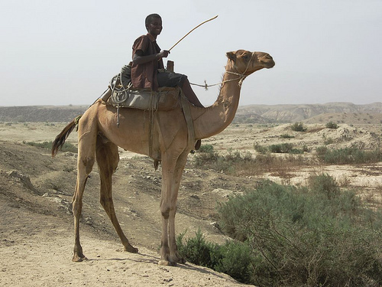
Photo: David Stanley
Christmas cards give us a very unrealistic picture of the journey of the Magi as we see them happily swinging across a smooth sandy vista lit by starlight where all is calm. Isaiah however, gives us a much clearer picture of the hazards of travel. The Magi would almost certainly have had to use camels to cross the desert and would have needed access to water. They would have had to carry and to find food, perhaps from traders on the desert routes or in towns and villages. Perhaps they were seasoned travellers, used to carrying articles for trade, but even if they were, the journey would likely have taken months, through uncertain weather and difficult terrain, so they must have been very determined and very driven. The journey was hard and dangerous and anyone crossing such a distance must have been aware that it could cost them their lives.
Yet St Matthew says that they continued on their journey inspired by a star.
As we journey through Advent towards the birth of Christ the Saviour, perhaps we can find some of this determination and vision. Yet we cannot sugar-coat what it might cost us to make the journey, what it might mean to find Christ. The journey in Advent, as in the journey of life, asks us the uncomfortable question: are we ready to meet God?

Something to Do
Like all great travellers, I have seen more than I remember, and remember more than I have seen.
Benjamin Disraeli
If you have a photograph album of a holiday in the UK or abroad, have a look through the photos you took. Make a list of the things you did to prepare for that holiday. Then write down what you needed to do beforehand. How did you get there and what happened on the way?
Now imagine you are a camel driver in the Magi’s party. What will you need to prepare for this journey? What must you take with you and what will you do if you run out of supplies?
Something to Pray About
It is not fit that every man should travel; it makes a wise man better, and a fool worse.
William Hazlitt
God of the sea and desert, You have made us travellers, explorers Wonderers and wanderers. You have made us restless Till we rest in you.
Walk with us in our journey this Advent Guarding and guiding us, Until we find the miracle you promised, The Son you sent us. Amen.
A Spiritual Exercise
Do not go where the path may lead, go instead where there is no path and leave a trail.
Ralph Waldo Emerson
Imagine your life as a spiritual journey. Who have been your most important travelling companions? What resources have you had with you and what things have you had to find along the way? What helps you find out if you are on the right path and what do you think your future path looks like? What do you think you will find at the end of your journey?
Or:
The Magi are usually shown as riding camels. Travellers of that time had to take animals with them to carry loads and provide transport and they too needed food and water along the way. How important is it that both human beings and animals together made the journey to find Jesus? Are there animals which have been important in your life’s journey? How have they helped you?

Advent Journey

3: GIFTS
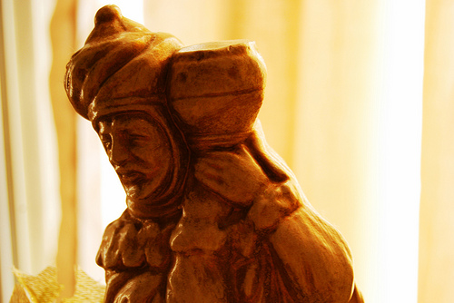
Photo: Seth Sawyers
Each day provides its own gifts.
Marcus Aurelius
Starting Out: something to think about
Middle Eastern hospitality required that journeys and visits were marked by the giving or exchange of gifts. Monarchs, statesmen and religious leaders still bring and receive gifts when they meet other leaders in other countries. If you are invited to a party or to a friend’s house it is usual to bring a gift and perhaps to take one away. But if we are to accompany the Magi on their journey towards Jesus, we have to stop and wonder: what does gift-giving really involve?
Gifts are words and emotions in concrete form. They embody the idea that you have thought about the other person and your friendship, love, esteem or gratitude for them is reflected in the form of gift you offer. You might take something you have cooked round to a new neighbour, to show you recognise that they might need something while they get their kitchen up and running; you might take flowers and wine to a dinner party to thank the hosts for the effort they have taken to feed you; you might take magazines or soap or fruit to a sick person to show care for them and to embody the hope that they will get well.
Most people today visiting a relative with a new baby will bring gifts of clothes, nappies, cradle linen or toys. Yet the Magi come, St Matthew tells us, with gold, frankincense and myrrh. These are expensive, costly gifts, but besides their cost, they also come laden with spiritual significance. Just as you might give a godchild a cross, a Bible or a St Christopher, so frankincense offers the idea of sacrifice and worship pleasing to God and myrrh with the idea of purification and perhaps death. It’s also worth wondering whether St Matthew would like us to think about what might have happened to those gifts. Did Jesus grow up remembering or being told about exotic strangers who brought him symbolic treasures? What might his parents have told him about the people who journeyed so far to find him?
Something to Read
‘There is nothing in the true believer's power which he would not do for his Lord: nothing in our substance which we would not give to him, nothing in ourselves which we would not devote to his service.’ C H Spurgeon, Sermon, December 24th, 1882.
Read more http://www.spurgeon.org/sermons/1698.htm
Journeying through Scripture
I thank fate for having made me born poor. Poverty taught me the true value of the gifts useful to life.
Anatole France
Malachi 3:1-4
3 ‘I will send my messenger, who will prepare the way before me. Then suddenly the Lord you are seeking will come to his temple; the messenger of the covenant, whom you desire, will come,’ says the Lord Almighty.
² But who can endure the day of his coming? Who can stand when he appears? For he will be like a refiner’s fire or a launderer’s soap. ³ He will sit as a refiner and purifier of silver; he will purify the Levites and refine them like gold and silver. Then the Lord will have men who will bring offerings in righteousness, ⁴ and the offerings of Judah and Jerusalem will be acceptable to the Lord, as in days gone by, as in former years.
What has Christian mission got to do with gifts? If we journey with the Magi to encounter Jesus what are we bringing with us to offer to him? What, these days, is acceptable to the Lord?
At the induction of her husband into a new Church of England parish, Wendy looked round at all the people who had turned out to greet (or perhaps just get a look at) the new vicar. She reflected afterwards that it was sad to say goodbye to all the people from the old parish but it was also an odd feeling that these many strangers would soon become familiar and new relationships would emerge – and that was exciting. Every time we meet a new person, in church, down the shops, in work, in school, college or university, the opportunity is there to meet Jesus in them, whether they are Christians or not. Like the Magi, sometimes we don’t know the details of the journey to encounter them; sometimes those people turn up in unlikely or unexpected places. Yet in every encounter, whatever it is, there is an exchange of gifts: gifts of conversation, of learning new things, of discovering something about oneself and about others. Journeys create stories and stories are gifts of imagination and experience which we give to one another.

Something to Do
I don't want expensive gifts; I don't want to be bought. I have everything I want. I just want someone to be there for me, to make me feel safe and secure.
Princess Diana
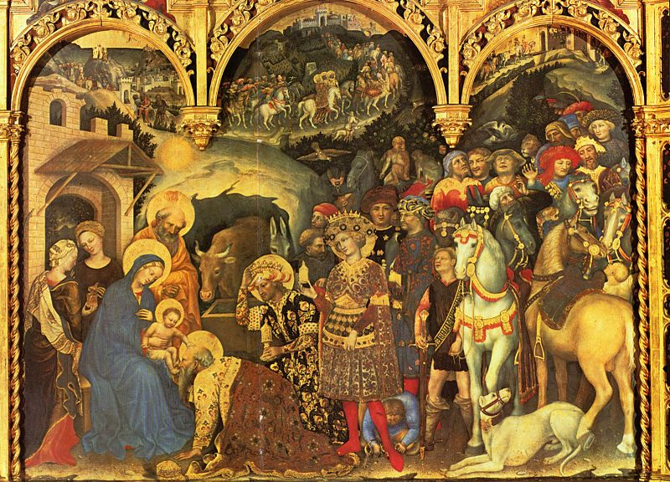
Gentile da Fabbriano, Yorck Project.
Have you started thinking about what you might give people for Christmas? Have you bought any presents? These days it can be difficult to find the time and space to put effort into finding presents and people sometimes opt for things like gift cards when they can’t think of anything for that ‘awkward’ teenage niece or nephew they don’t really know that well. Next time you think about finding a gift for someone see if you can put more of yourself into the gift. Maybe it is something you could make; maybe it could come with a special message; maybe it could be wrapped in a more thoughtful way? What about giving the gift? Is there a way it could be given which captures your relationship with the recipient? What could you do, to spend less, love more?
Something to Pray about
What you are is God's gift to you, what you become is your gift to God
Hans Urs von Balthasar
Lord,
We thank you for all the gifts you have given us; All the gifts we have received from others. Help us be good stewards of all entrusted to us That we may become new gifts of love and hope To all who need us.
Amen
A Spiritual Exercise
A wonderful gift may not be wrapped as you expect
Jonathan Lockwood Huie
Lay out a pound coin, a scented candle and a cosmetic cream of any kind. Pick up each one in turn and handle it and/or smell it. What do these things mean to you?
Or
What kind of gifts has God blessed your life with? Spend some time reflecting on and giving thanks for those blessings.
Advent Journey

4: MEETING HEROD
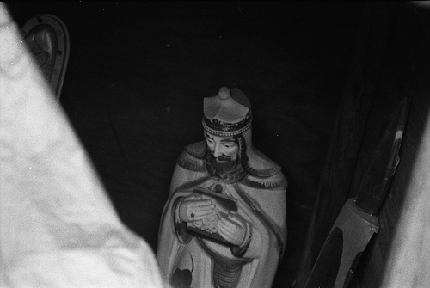
Photo: Steve Snodgrass
Starting Out: Something to Think About
Not brute force but only persuasion and faith are the kings of this world.
Thomas Carlyle
On any pilgrimage or spiritual journey we need guides and guidance. Mission doesn’t happen in a vacuum. If we seek to do God’s will, how do we find out where God wants us to go?
St Matthew tells us that the Magi made for Jerusalem, the holy city. If a Messiah was to arise, it was surely in Jerusalem that they would find people who knew the details. So the Magi arrive and start to ask for information about the star they have followed and directions to the new-born ‘King of the Jews’.
It is not surprising that Herod the Great was bothered by this. He was the local ruler and his authority came from the Romans. But any Messiah, arising as a powerful religious leader could supplant him and take away his power. And Herod enjoyed his power very much. Now some foreigners have arrived and are starting talk about a prophecy. So Herod seeks out information and a secret meeting with these people who have made such an extraordinary journey.
Herod is clever. He has narrowed down the end point of the journey through the prophecy in Micah and he has some willing visitors who can get him the information he needs. He lies to them, saying that he wants to find out where Jesus is so that he can worship him.
Something to Read
‘Herod...collected an army and set out for Jerusalem to dethrone Hyrcanus...his father and brother...calmed him down , urging him to confine his revenge to threats and ferocity...Thus advised Herod gave way, satisfied that he had made his future secure by giving his people a demonstration of his power.’
Josephus, The Jewish War
Journeying through Scripture
My crown is called content: a crown it is that seldom kings enjoy.
William Shakespeare
After Jesus was born in Bethlehem in Judea, during the time of King Herod, Magi from the east came to Jerusalem² and asked, ‘Where is the one who has been born king of the Jews? We saw his star when it rose and have come to worship him.’
³ When King Herod heard this he was disturbed, and all Jerusalem with him. ⁴ When he had called together all the people’s chief priests and teachers of the law, he asked them where the Messiah was to be born. ⁵ ‘In Bethlehem in Judea,’ they replied, ‘for this is what the prophet has written:
⁶ ‘“But you, Bethlehem, in the land of Judah,
are by no means least among the rulers of Judah;
for out of you will come a ruler
who will shepherd my people Israel.”^{[b]}’
⁷ Then Herod called the Magi secretly and found out from them the exact time the star had appeared. ⁸ He sent them to Bethlehem and said, ‘Go and search carefully for the child. As soon as you find him, report to me, so that I too may go and worship him.’
⁹ After they had heard the king, they went on their way, and the star they had seen when it rose went ahead of them until it stopped over the place where the child was. ¹⁰ When they saw the star, they were overjoyed.
Christian life is a spiritual journey in which we both learn and grow, but if we are to journey with the Magi we have to realise that life is not plain sailing. The Magi had a star to follow but it led them initially to a dangerous and wily leader who tried to use them as agents in his own pursuit of power. The Magi walked into a world of political scheming, violence and conspiracy. We are so used to the awe, wonder and miracle side of the nativity, that we forget that Jesus was born among many dangers, even danger from those who wanted to find him and worship him.
At this point in St Matthew’s story, the fate of Jesus is in the hands of the Magi. Suppose they had found Jesus and gone straight back to Herod? What chance would that family have had, if the Magi had given Herod the information he wanted? We are told that even without the Magi’s information, Herod decides to act. As the story unfolds, we see the presence of his power, fear and rage. This sends the Magi in one direction and Mary, Joseph and the child Jesus in another.
To journey with the Magi is to act with discernment. To bear witness to Christ is not only good news, but can be dangerous news. It’s true today too. There are people in the world today who will be killed if they tell the authorities that they have found Jesus. There are people who stand before him in worship in awe and wonder and return to their homes secretly without letting others know, lest they be arrested or murdered. One of the tasks of Christian mission is to support such people, to let them know that they are not alone, to remember them in prayer, to help them in trouble and to work for a world where faith can be open and shared freely.
This Advent we stand with all people seeking Jesus whose journey brings them face to face with Herod and pray that they may always return safely to their homes
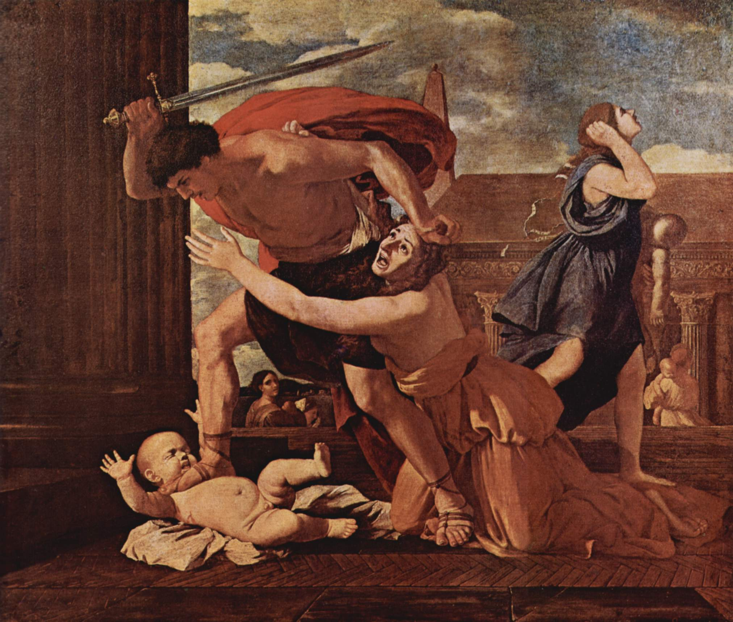
Poussin, Massacre of the Innocents, Yorck Project
Something to Do
So the people will pay the penalty for their kings' presumption, who, by devising evil, turn justice from her path with tortuous speech.
Hesiod
Next time you are out and about in your local community, have a look for things like the police station, law courts, council offices or town hall. Say a prayer for all who work there, that they may do their work fairly and with justice for all.
Something to Pray About
The welfare of the people in particular has always been the alibi of tyrants.
Albert Camus
Lord,
We pray for all who come before the courts of the King, Who are tested and questioned, Whose purpose is interrogated. We pray for all who profess the Christian faith Knowing that it may cost them their homes, their churches, Their livelihoods or their lives. We give thanks for those who protect and nurture them And pray for a time When all people can worship in peace and safety
Amen
A Spiritual Exercise
I remember that all through history, the way of truth and love has always won. There have been murderers and tyrants, and for a time they can seem invincible. But in the end they always fall. Think of it always.
Andre Malraux
St Matthew tells us that the Magi were guided by a star to find Jesus and tells us that the Magi were warned in a dream not to go back to Herod but to find a different way home. Having found Jesus, what do you suppose guided them back to their homes? Who or what has helped you on your spiritual journey in the darker and more difficult times of life?
Or: Reflect on a time when you had to stand up to someone for the sake of your principles or your faith. What did that feel like? How do you think we can stand up to oppressive power today?
CHRISTMAS

5: MEETING JESUS
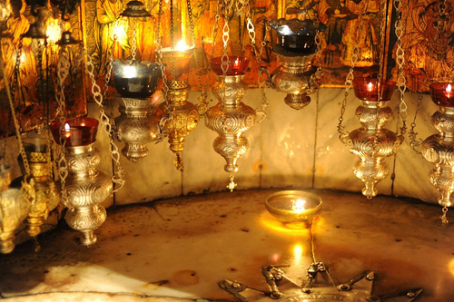
Grotto of the Nativity in Bethlehem
Photo: Guillaume Paumier
Starting Out: Something to Think About
We may have our private opinions but why should they be a bar to the meeting of hearts?
Mahatma Gandhi
What did the Magi really expect to find? What are miracles supposed to look like? Do you suppose they might have been disappointed when they tracked down the child that had been born to be the Messiah, the King of the Jews? Is this what the star was all about, this young woman, this carpenter husband, the poverty of their lives?
For many people the journey through Advent to Christmas ends up feeling a bit like this. Christmas is all anticipation: putting up decorations, looking forward to being off work or school, hoping for presents, getting together with family. But when it comes to it, there’s a flat feeling: is this it? Maybe what you were hoping for didn’t materialise or the sheer effort of buying and wrapping presents and cooking for the family just wore you out.
St Matthew doesn’t tell us specifically what the Magi thought or felt, but that on finding the child Jesus they worshipped him. And that suggests that St Matthew wants us to understand that when they found him, when they met Jesus face to face, they knew they were in the presence of God. And that takes the Christmas moment to a whole new level; that’s the moment that people are searching for and sometimes miss. It is the encounter with the Christ child that transfigures Christmas, that gives Christmas meaning. That is what Advent leads up to, something utterly awe-inspiring; meeting with God not in some distant, heavenly domain, but right now, right here, in our own world. That’s right at the heart of Christian mission, not endless words about Jesus, but ways of meeting Jesus, for real, right here among us, right now.
Something to Read
‘He will come like child’.
Have a look at former Archbishop Rowan Williams’ poem ‘Advent Calendar’ from After Silent Centuries, 1994.
http://rowanwilliams.archbishopofcanterbury.org/articles.php/2280/
Journeying through Scripture
Yesterday we obeyed kings and bent our necks before emperors. But today we kneel only to truth, follow only beauty, and obey only love.
Khalil Gibran
¹¹ On coming to the house, they saw the child with his mother Mary, and they bowed down and worshipped him. Then they opened their treasures and presented him with gifts of gold, frankincense and myrrh. ¹² And having been warned in a dream not to go back to Herod, they returned to their country by another route.
This is the journey’s end. A journey of walking, riding, striding, covering ground. But at journey’s end the Magi halt before the child and bow down. In many paintings and crib-sets, we find the Magi kneeling in the straw and the dirt of the child’s dwelling.
Have you ever thought about kneeling? Kneeling in the course of worship is traditional in some churches, but in others people prefer to sit or stand. Sometimes it’s just not practicable when you’re squashed into a pew with a lot of other people with coats and handbags and you’re trying to hold your book and service sheets as well. It can be distracting if your knees or back hurt and you have to struggle to get up again. It’s not something we do all that much in daily life, except perhaps for housework or gardening. So why should anyone kneel at all in worship? Yet, the Magi are so often depicted as great and powerful men bowing or kneeling before the tiny child. What is so significant about the act of kneeling?
If you kneel, you give away your power. As with bowing the head, you make yourself shorter, and kneeling, you cannot run away. So to kneel down is to become vulnerable, to submit to the will of another, to show, physically, in your body, that you give up your strength and autonomy. So kneeling is a mark of obedience (not my will but yours), and also of humility and supplication – asking for compassion and mercy. It is also a mark of recognition, and veneration and all these things can be combined in the action of kneeling during worship. Kneeling presupposes the presence an Other, of one who is deemed greater and so when we kneel in worship we create the understanding that God, in Jesus, is among us.
Not everyone can, or wants to, kneel in worship. But there is something about those figures humbling themselves, casting down their crowns, which reminds us that we worship God with our whole being, bodies as well as minds and spirits. To meet the Christ-child, to offer the gift of ourselves, means to kneel before him in order to meet him face to face. And as we kneel before him, Christ raises us up. On their rising, the Magi learn a new truth, the truth about Herod, and begin their return journey by turning their backs on his evil, for they have met God and seen his truth.
Something to Do
Christmas in Bethlehem. The ancient dream: a cold, clear night made brilliant by a glorious star, the smell of incense, shepherds and wise men falling to their knees in adoration of the sweet baby, the incarnation of perfect love.
Lucinda Franks
Imagine a ‘photo collection’ of the journey of the Magi. What would they tell their friends and family when they got back? What would they tell their own people about their journey, about meeting and then keeping away from Herod and about finding Jesus?
How can we be more like the Magi telling people about Jesus for the first time?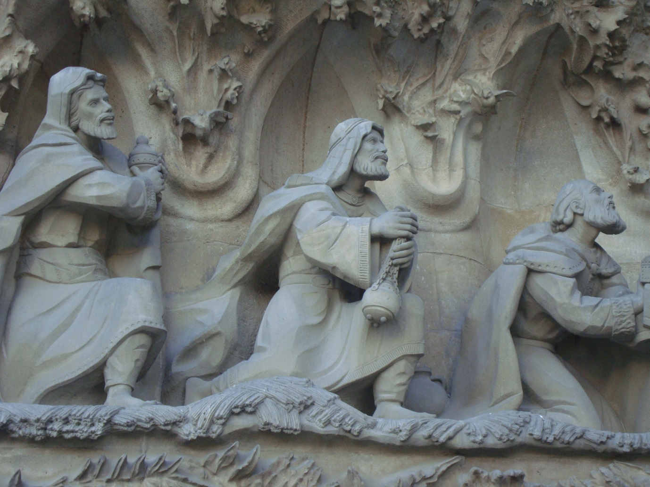
Something to Pray About
If the only prayer you ever say in your entire life is thank you, it will be enough.
Meister Eckhart
Lord,
As the Magi came to you, into the place where you lived, they knew they were at journey’s end. This Christmas, after the journey through Advent, may we come before you in awe and wonder at your birth and be filled with wonder, thanks, and praise.
Amen

A Spiritual Exercise
Wisdom begins in wonder.
Socrates
Take some time this Christmas to look back at the journey we have made with the Magi. Stay with them through Epiphany season and make some spiritual New Year’s resolutions to take their story of meeting Jesus into your own work and witness. Some of those resolutions could include:
Find a guiding star that will strengthen you in your Christian life. It might be a person, Bible study, a book, an activity or time spent in prayer.
Be better prepared for your spiritual journey. What is going to help your faith to grow this year?
Who will you meet and talk to on the way? Perhaps you could befriend a new person at church, at work or at school?
How will you share the gospel with others? Who else will you tell about your story and journey?

