95 Missional Theses For the 500th Anniversary of the reformation 31st October 2017 based around the five marks of mission
Mission Theology Advisory Group

The Mission Theology Advisory Group is an ecumenical group formed in partnership between Churches Together in Britain and Ireland and the Church of England



We provide resources in the areas of Spirituality, Theology, Reconciliation, Evangelism and Mission

This resource belongs to our Mission series. Please print and share.

95 Missional Theses

For the 500th anniversary of the Reformation
31st October 2017
Based around the Five Marks of Mission

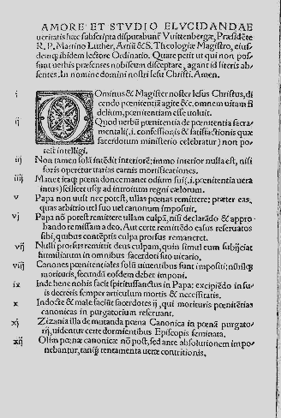
#webelieve

To proclaim the Good News of the Kingdom



1 We believe in a Church that tells the world: “God is love” (1 John 4:8)

2 We believe in a Church that acknowledges all people to be of great value, “made in the image of God, male and female” together (Genesis 1:27)

3 We believe in a Church inspired by the Son of God, born of flawed, fallen people, offering transformation to our own flawed humanity (Mt.1)

4 We believe in a Church that can recognise the hand of God in the midst of life’s uncertainties (Psalm 46)

5 We believe in a Church that reaches out to all people in all times and in all places (Malachi 1. 11)

6 We believe in a Church which places Jesus at the centre, as Word of God and the model of God’s intention for all humankind (John 1.1-14)

7 We believe in a Church which is committed to evangelisation of our world (Matthew 28.19-20)

8 We believe in a Church which is inspired by the Holy Spirit in mission (Luke 4. 1-22)

9 We believe in a Church where mission is an environment rather than an event (John 4. 39-42)

10 We believe in a Church which has a coherent theology of creation (Luke 12.27-28)

11 We believe in a Church which grows from pilgrims walking together (Luke 24.28-35)

12 We believe in a Church which helps doubters cope with doubt (John 20.24-28)

13 We believe in a Church that can laugh at itself, learn from its foolishness, where fun is a key spiritual discipline (Zechariah 8.4-5)

14 We believe in a Church which confesses failings and shows the world how to do better (1 John 8-9)

15 We believe in a Church with a good account of human sinfulness (Matthew 9.2-7)

16 We believe in a Church which is challenged and changed by its own evangelism (Acts 11.22-30)

17 We believe in a Church that is more concerned with the mystery that is God than with its own success (Hebrews 2. 1-11)

18 We believe in a Church that loves sharing God’s word (Acts 8.26-40)

19 We believe in a Church which knows it is the instrument and not the end of God’s mission (2 Corinthians 9. 10)

20 We believe in a Church which understands that only God can change people so that they can flourish and find ultimate fulfilment (Jn 3. 5-8)

21 We believe in a Church that is continuously revealing God’s kingdom (Matthew 13.31-33)

22 We believe in a Church that offers a home for anyone on any stage of the Christian journey (Mark 10.17-21)

23 We believe in a Church that bears witness to Jesus Christ, not to itself (1 Corinthians. 3.5-9)

24 We believe in a Church which is Good News for everyone, whoever they are, whatever they may have done, however they live (Luke 19. 1-10)

25 We believe in a Church which responds to insights from people of other faiths (Luke 4.25-27)

26 We believe in a Church in mission where mercy and justice walk hand in hand (Micah 6.8)

To teach, baptise and nurture new believers

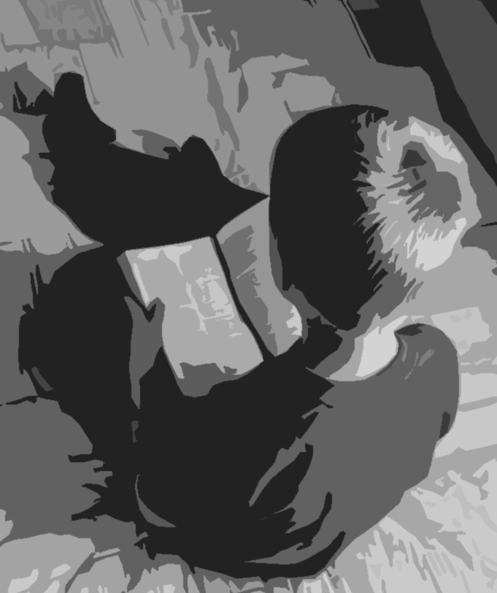

27 We believe in a Church where people of all ages are honoured and respected (Mark 10.13-16)

28 We believe in a Church inspired by the Holy Spirit, blessing and calling us to constant renewal (Titus 3.4-7)

29 We believe in a Church that embraces Spirit-inspired change, excited by who we might become rather than trapped by who we have been (Acts 10)

30 We believe in a Church which seeks for and speaks the truth (2 Timothy. 2.14-15)

31 We believe in a Church which sees all people as travellers on the road to Emmaus (Luke 24:13-32)

32 We believe in a Church which lives out its own belief in Resurrection (Colossians.3.1-11)

33 We believe in a Church which proclaims Christ even when persecuted and martyred (Acts 14.21-22)

34 We believe in a Church whose worship creates space for all that we are as people to respond to all that God is through Christ(1Chr.16.23-34)

35 We believe in a Church where prayer is at the centre, in forms that reflect the diversity of divine creativity (Ephesians 6.18)

36 We believe in a Church where worship is real service, inspiring action that reflects the presence of the living Lord (Psalm 42. 4-5)

37 We believe in a Church where children’s gifts and insights are nurtured and valued (Matthew 18.2-6)

38 We believe in a Church in which the experience of God’s love for us is celebrated as both mysterious and undeserved (I John 4.7-12)

39 We believe in a Church that celebrates the beauty of diversity (Revelation 7.9-10)

40 We believe in a Church where every participant is gifted in ministry and empowered to fulfil their vocation (1 Corinthians 12.27-31)

41 We believe in a Church which believes Christ will return (Revelation 3.10-13)

42 We believe in a Church which loves, nourishes and cares for its leaders (Hebrews 13.17-20)

43 We believe in a Church which refuses to cover up wrong-doing and abusive behaviour, even when it costs its own reputation (James 2. 1-6)

44 We believe in a Church which encourages and nurtures vocations to every kind of ministry (Romans 12.6-8)

45 We believe in a Church that celebrates the gifts of all, lay people and clergy working as equals (Ephesians 4.11-13)

46 We believe in a Church which respects the opinions and insights of those who are not theologically articulate (1 Samuel 3. 7-9)

47 We believe in a Church which proposes faith to all, but imposes faith on no one. (John 6.66-68)

To respond to human need by loving service

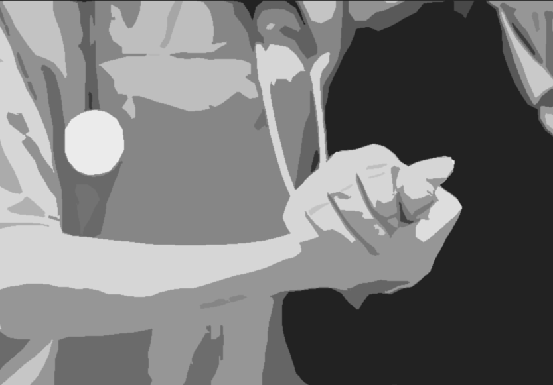

48 We believe in a Church that is yeast and salt in the wider community so that it would be missed if it were to disappear (Matthew 13.33)

49 We believe in a Church where the lonely can find friends (Psalm 68.5-6)

50 We believe in a Church which is committed to the service of people of all faiths and no faith (Isaiah 49.6)

51 We believe in a Church that affirms the continuing vitality of Jewish life, religion, and place of the Jewish people in God’s love(Rom.11.1)

52 We believe in a Church which sacrifices its own needs to those of the last and the least in communities (Isaiah 1.16-17)

53 We believe in a Church that is gifted with the discernment to distinguish what is peripheral from what is central (Philippians 1.9-11)

54 We believe in a Church that is more concerned to ask the right questions than to impose the right answers (Proverbs 5.1-4)

55 We believe in a Church that holds the Bible up to itself as a mirror, revealing its own challenges and potential for goodness (Deuteronomy 6.6-7)

56 We believe in a Church which engages with the whole of Scripture, including difficult, challenging and upsetting texts (2Tim.3.16-17)

57 We believe in a Church which takes all Scripture seriously, Hebrew and Greek, Old and New Testament (Romans 15.4-6)

58 We believe in a Church which allows Holy Scripture to dialogue with the sacred texts of others (1 John 4.1)

59 We believe in a Church which loves the Bible and is proud of its gifts to us, even if we wrestle with it (Joshua 1.8)

60 We believe in a Church which represents God’s mercy towards those condemned by society (Luke 6.31-36 or John 8.1-11)

61 We believe in a Church which is generous in forgiveness (Matthew 18.21-22)

62 We believe in a Church which feeds the hungry, heals the sick, clothes the naked and sets prisoners free (Isaiah 61.1)

63 We believe in a Church which fights for the dignity of all human beings (Luke 8.35)

64 We believe in a Church which believes all human life is sacred to God (Jeremiah 1.5)

65 We believe in a Church which acknowledges its past failings and seeks active repentance in the present (2 Corinthians 7.9-10)

66 We believe in a Church which values joy, friendship, silence, singing and dancing (Colossians 3.16)

To transform unjust structures of society, to challenge violence of every kind and pursue peace and reconciliation

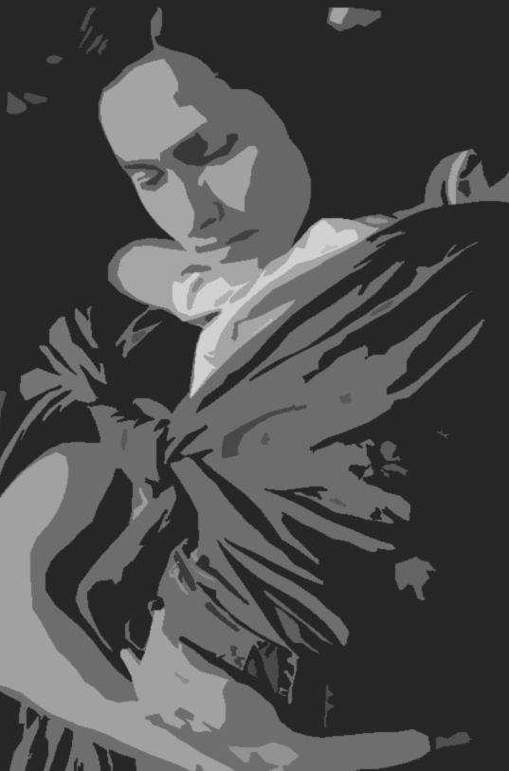

67 We believe in a Church which talks clearly about evil in the world and which refuses to collude with it (Ephesians 6 12-13)

68 We believe in a Church which understands the causes of human suffering (Isaiah 59.1-15)

69 We believe in a Church which sits without judgement alongside people who have no hope or are in despair (Psalm 69)

70 We believe in a Church that is called to love its enemies, to be peacemakers and healers (Matt. 5.44)

71 We believe in a Church that will confront the root causes of social, political and economic ills in the name of a God of justice (Jeremiah 34.17)

72 We believe in a Church which is radically inclusive of people where everyone knows with certainty that they are welcome. (Romans 10.12-18)

73 We believe in a Church which heals itself by affirming and celebrating God’s love in friendships, intimacy, marriage and families(SoS.8.6-7)

74 We believe in a Church which makes loving space for unbelievers, doubters, atheists, and those whose faith is burned out (Matthew 11.28-30)

75 We believe in a Church where differences and disagreements are energising not destructive (Matthew 15.21-28)

76 We believe in a Church characterised by gracious, hospitable speech (Colossians 4.6)

77 We believe in a Church which grieves and laments the evil that human beings do to one another (Lamentations 3.46-54)

78 We believe in a Church that is committed to peace (Zechariah 8. 12; 16-17)

79 We believe in a Church that is ready to die (Acts 21.12-14; or I Cor 15.36)

80 We believe in a Church which sets people free (Galatians 3.23-29)

81 We believe in a Church which models grace-filled community to others (Ephesians 25-32)

82 We believe in a Church which refuses violence, provides sanctuary for its victims, and actively challenges all kinds of abuse (Psalm 12.5)

83 We believe in a Church that holds fast whatever is good (I Thess. 5.21)

84 We believe in a Church which refuses to be undermined by pride, greed, or ambition (Proverbs 8.13)

85 We believe in a Church which is sincerely committed to the priority of safeguarding children, young people and vulnerable adults. (Mt 18.6)

To strive to safeguard the integrity of creation, and sustain and renew the life of the earth



86 We believe in a Church that pays attention to the reality that this is God’s world, blessed by the creator, entrusted to our care (Ps.24.1)

87 We believe in a Church where sacred and secular are not distinguished, where the hand of God is recognised in all things (Isaiah 66.1-2)

88 We believe in a Church which loves, values and seeks the flourishing of the animals and plants of our planet (Gen. 1.20-22)

89 We believe in a Church which visibly stewards earth’s resources and cares for the environment. (Gen. 2. 15)

90 We believe in a Church which seeks to learn from, and contribute to, the sciences and technology (Psalm 8)

91 We believe in a Church which finds God’s goodness in Creation (Psalm 136. 1-9)

92 We believe in a Church which takes seriously the damage we are capable of doing to the planet (Gen. 6. 11-12)

93 We believe in a Church which seeks to understand God’s purposes, rather than assume it knows or can control them (Job 38)

94 We believe in a Church which shows how God is redeeming the whole Creation (Rom. 8.21).

95 We believe in a Church that celebrates with the saints of all ages the extraordinary gift of grace that is Jesus Christ (Rev. 21. 3-7)

Join the conversation about what #webelieve
@95missiontheses
https://www.facebook.com/missiontheologyadvisorygroup/
http://www.anglicancommunion.org/identity/marks-of-mission.aspx
https://www.churchofengland.org/our-faith/mission/mission-theology.aspx
https://www.churchofengland.org/about-us/work-other-churches/reformation-anniversary.aspx
https://ctbi.org.uk/church-commemorates-500th-anniversary-of-reformation/
http://www.anglican-lutheran-society.org/
http://www.lutheran.org.uk/

