Five Themes in a theology of evangelism
Mission Theology Advisory Group

Table of Contents

Theology for Evangelism: five themes 3
Pursuing the Human 3
Creating Community 4
Creating new news 5
Honouring Memory 6
Being the Face of Love 7

The Mission Theology Advisory Group is an ecumenical group formed in partnership between Churches Together in Britain and Ireland and the Church of England



We provide resources in the areas of Spirituality, Theology, Reconciliation, Evangelism and Mission

This resource belongs to our Evangelism series. Please print and share.

Theology for Evangelism: five themes

Pursuing the Human

‘I am the resurrection and the life’ said the priest at the beginning of the funeral. A young person turned round to an adult behind him and whispered ‘what’s “resurrection”?’
Imagine what it is like NOT to be a Christian. Can you? Imagine you know nothing of Jesus, of church, of scripture, and that the whole business of Christian faith and belief is a mystery to you. What do you think that would that feel like? Where do you start when someone asks you ‘what’s resurrection?’
It can be hard for us Christians to get beyond our own faith to understand what it is like to be standing outside looking in. We can’t assume any more that people know what we are talking about and why we have chosen Jesus Christ. So we need a theology of our common humanity under God to make us aware of how God is calling all people around us; how God is working among everyone; and what kind of spiritual questioning is going on among those who have no real contact with Christian faith.

Photo by Bro. Jeffrey Pioquinto, SJ on Flickr
The disciples didn’t really understand resurrection when Jesus talked about it; but everything changed when they experienced the risen Christ for themselves. It didn’t just make sense; it transformed their lives and made their witness unstoppable. In MTAG we’re developing a mission theology of discipleship and evangelism which is rooted in what it means to be a human being. But is means getting outside ourselves into the scary place where Jesus is not yet known. It’s difficult, challenging and exciting.

Creating Community

A woman on the last train home was upset and worried by a very drunk younger woman who was being sick everywhere. Concerned that she was in danger of coming to harm, the woman missed her stop, got the woman into a taxi, got her home and returned her to her parents. The parents were astonished that the woman would put herself out like that. They said, ‘You are my daughter’s Good Samaritan’.
In MTAG we’ve done some work which shows that Christians, especially lay people who are out and about every day, are really good at creating community. Christians, indeed people of faith generally, are less likely just to see others as objects, service providers or commodities and to see through to the needs of other people. The thing is though, many of these beginnings of relationship, of community and neighbourliness are fragile and tissue thin; they can also easily be broken or lost. Acts of kindness, goodness and prayer are not always recognised for their ongoing transformational, kingdom-building power.

Photo by Alberto P Velga on Flickr
There’s something about being a part of the Body of Christ, as people who worship, as people of Scripture and sacrament, which equips us to be neighbours to others and creators of new community. Jesus talked about the need to be neighbours, but in today’s society do we need something to address the parents’ astonishment that a Christian would actually ‘go the extra mile’ for a stranger? What do you think is the theological answer to the question, ‘why should we care?’

Creating new news

A man came to a Christian basics course at his local church but after one or two sessions he stopped coming. The teacher phoned him and asked if he was ok. He said that when he was in a discussion group he mentioned that he had been in prison. After that, no one wanted to talk to him or be in group with him, so he couldn’t see the point in carrying on. ‘I learned stuff in prison’ he said ‘some bad things happened, but some good things too. But everyone’s judging me so I’m not coming any more’.
We talk about the ‘Good News’, but for some people it’s bad news. It’s bad news if becoming a Christian means you have to lose your family and community. It’s bad news if, as a Christian, you’re going to be misunderstood, discriminated against, or maligned for what you believe. It’s bad news if, as a Christian, you’re not welcomed or cared for by the people you would call brothers and sisters. It’s bad news if you make the effort to go to church but can’t find somewhere that feels like home.

Photo by Jon S on Flickr
Lately we’ve spent a lot of time on what might be ‘Good News’ and ‘bad news’ but perhaps we need a theology of evangelism which creates new news. What would that look and sound like? One way for further exploration would be for people to feel that in coming to faith they are invited to be co-creators of the future of the Church, where their stories and experiences, whatever those are, are taken seriously, so that those new Christians can feel they are telling stories of our Church which both attracts and delights others.
When Jesus talked to the woman at the well, he broke a lot of rules and social boundaries to give her some new news, very unexpected news. She went away, a new evangelist, and told everyone about it. What would it take to help people meet Jesus Christ at the wells of today’s society?

Honouring Memory

A person using the Spiritual Journeys site www.spiritualjourneys.org.uk found a poem there by Malcolm Guite that talked of broken mirror shards still reflecting Jesus. He didn’t understand the poem, but he saw himself in the broken pieces, realised God was still with him and resolved to get help.
Do you think evangelism could be not just about a person’s future with God but also about their past? The Samaritan woman at the well told her friends and relatives ,‘Come and see a man who told me everything I have ever done!’ She told people how she was thoroughly known by God, that her past was held in God’s mind and that being fully known she was set free to evangelise others.

Photo by essygle on Flickr
Perhaps we need a better, more holistic theology of evangelism to see where people’s whole lives, as children, as young people, as adults and as older people, equip us to share our faith more widely and more appropriately, no matter where we have come from or what we have done.

Being the Face of Love

When a young motorcyclist was killed, his friends set up a roadside shrine at the spot where it happened. In addition to the candles, cards, toys and flowers, someone brought a bench which people would sit on to remember. One elderly man started to come every day and sit on the bench with a takeaway cup of tea and just talk to the young people who came to mourn. He listened to their stories of loss and bewilderment, their anger, some of which was directed at him: ‘What do You know about it?!’ One day he wasn’t there and some of the young people came to visit the shrine. They immediately demanded to know where he was, because they wanted to tell him about what they’d been doing, show him the poems they’d written about their friend, ask him questions about death and dying. So they had to be told that he was in church –it was Sunday...
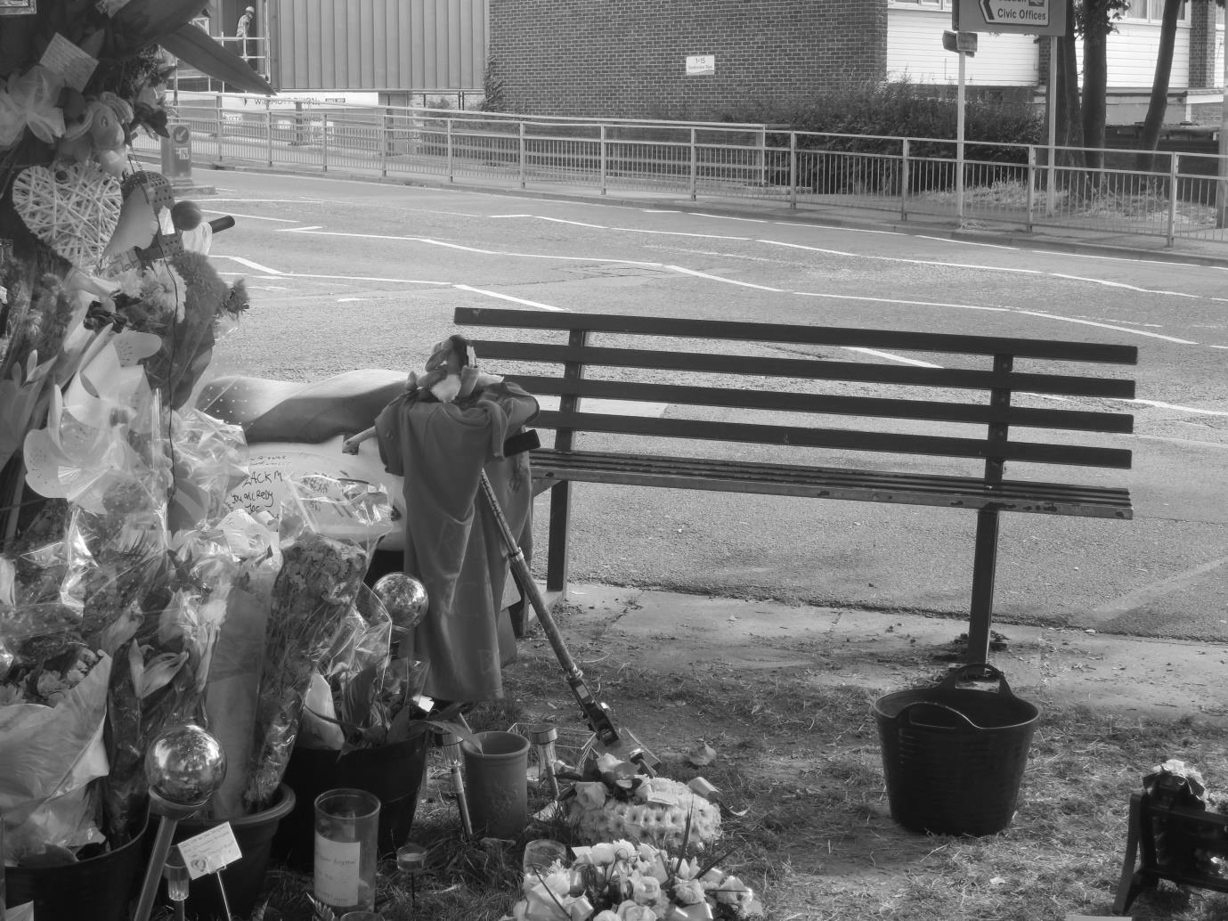
Photo: Anne Richards
What does it really mean to be the face of God’s Love? What would it take for people really to trust us, to find the hope we carry and be drawn to us because of that faith, hope and love? It’s easy to talk about being God’s love to others, but how does that translate into something that shines out through every moment of our daily lives out in the world? What kinds of social action for example, create the bedrock and the conditions for effective, appropriate evangelism and sharing news of Jesus Christ with others?

