Reflections

“Modern slavery is an appalling crime that has no place in today's society. Yet these figures show it is taking place here – often out of sight – in shops, fields, building sites and behind the curtains of houses on ordinary streets.”
Modern Slavery and Organised Crime Minister, Karen Bradley 2014

What does it take to get behind the locked doors and the curtains? Below is a story of Christian love, care and befriending from a charity involved in helping victims of trafficking for you to think about:

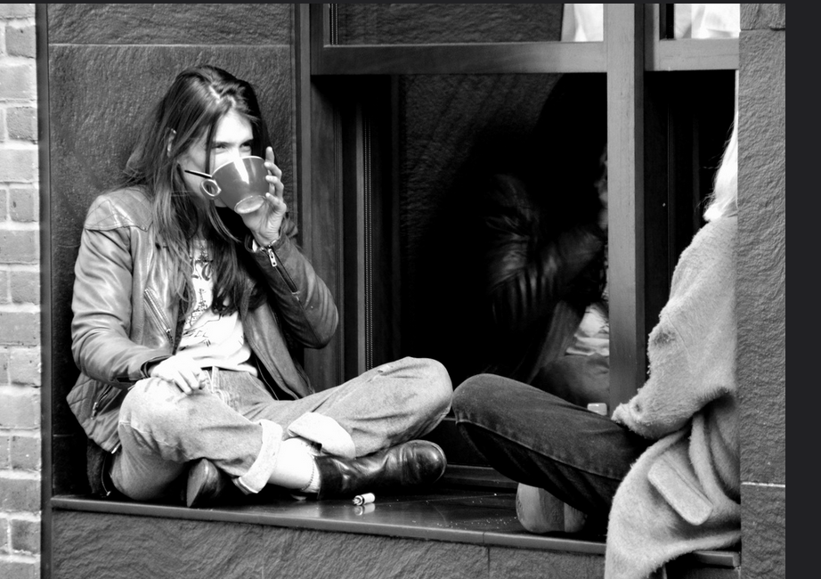
Photo by Sam Carpenter
In 2008, as a group of friends we felt prompted by God to respond to the issue of sexual exploitation in the sex industry and human trafficking. Having no experience or expertise in the area we did the only thing that we knew how to do; pray! So we began prayer walking around the area of our town where the brothels and saunas were each week; praying for the people that they represented. After a few months we knocked on the door of one of the saunas, introduced ourselves and explained we were from the local church and that we pray for them each week and asked if they had anything specifically that we could pray for. The lady who answered the door seemed quite confused, but once she worked out that we weren't joking, she told us how dangerous it had been recently in the sauna and asked if we could pray for their safety. We have come to learn that most people in the sex industry will face a daily risk of violence and exploitation. The woman then encouraged us to knock again the next week to see what they'd like prayer for! So we began to build relationships with some of the women in the different saunas, after a while they invited us in for a cup of tea each week and we spend an hour or so talking about anything and everything - from the big issues in life to what brand of nail varnish we prefer to wear! We have learnt that the people behind the labels are people just like us; with hopes and dreams, shame and pride, fear and pain. As we have become friends with people in the saunas I think that they have also realised that behind our labels of 'Christian" or "middle class" we are also people just like them! We have shared in the ups and the downs of our lives together, and our lives are all the more richer for it. No child dreams of working in the sex industry when they grow up. People enter the sex industry for many different reasons. In our experience the minority would say that they enter it freely. For many they enter the sex industry as a matter of survival; often due to financial need, to sustain an addiction, homelessness, lack of opportunity, or complex vulnerabilities, and others are coerced or forced. Whatever the entry route there is a very real story behind every single person. There are many tales of tragic loss, lack, abuse and pain; and it has been heart-breaking to hear some of these first hand. The majority of people that we have met fear being judged or labelled for their involvement in the sex industry, and this sense of shame can prevent them from building friendships with people in the community and seeking help from statutory services. For people who have been trafficked, the lack of personal freedom makes them even more 'invisible', inaccessible and isolated. So it really does feel like a privilege that God has opened the door for us to get to know people in the sex industry. Some of the women remain working in the sex industry and we've also had the joy of supporting some women to exit it; but our friendship is not conditional and is not based on the choices they make, or whether someone chooses to remain in the sex industry or not. The people that we have had the privilege of becoming friends with in the sex industry display incredible strength, dignity and courage, and they have each taught us so much as they have dared to believe that there is hope and that "nothing is impossible".

Some things to think about:
What do you think this story tells us about the importance and relevance of prayer?
How important is it that friendships come without judgement on people’s choices, mistakes or lifestyles?
What do you think are the risks in such relationships – on both sides?

