Photographs (GREEN 1)
In this section, we invite you to look at some pictures and imagine the stories that could be behind them.
Photographers notice things and have a keen eye for people and situations that other people do not see. Their photographs can often tell stories.
For example: imagine a beach at sunset. Two people are silhouetted walking together at the end of the shore. The scene looks romantic, idyllic. But in the foreground is a large object wrapped in shining plastic, glittering in the sun. It is the drowned body of a person desperate to leave Africa and to get to Europe, who had, quite probably, given his or her identity documents and all their money to gangs of people traffickers. These tragedies have been documented by the photographer Juan Medina http://www.bbc.co.uk/news/magazine-32433547 (warning – the images are distressing). In April 2015 more than 1000 people died this way, so Medina captures in one image the suffering of so many unknown.
Each of the three photos came with some information which is included with the photo. We ask to you to go further and imagine what else you might have done in the same situation to find out the story behind the photo. What might the photographer of the first picture have found out if he wasn’t in a rush? What do you think the second photographer found out about the woman back at the studio? Was the woman in the third photograph really working for free in return for bed and board?
We are not suggesting that any of the subjects were indeed victims of trafficking. But how can you tell? How can you find out the truth about people’s lives?

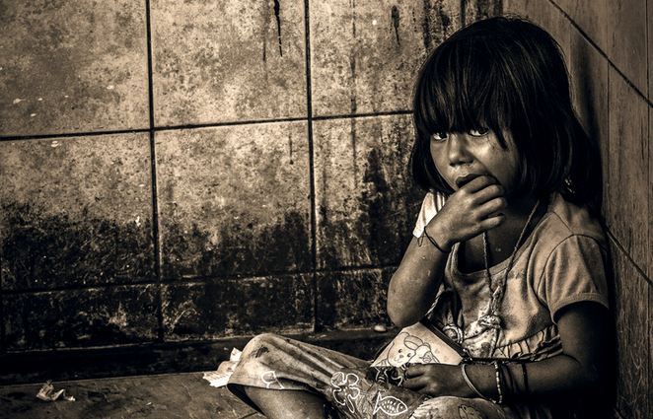
Photo by KamrenB Photography on Flickr
This was taken during a border town visit. My dad and I were in a rush to get back into Thai territory when this girl appeared. I had a 75-300 zoom on my 600D and this was snapped while walking by. This shot almost didn't happen. I'm glad it did because many people I show this to have an emotional response.
- Have a look at this picture
- Give the child a name
- Imagine her story. Why is she there? What is the cup for?
- What would you say to her?
- Who could you talk to about her situation?
- What future would you like her to have?

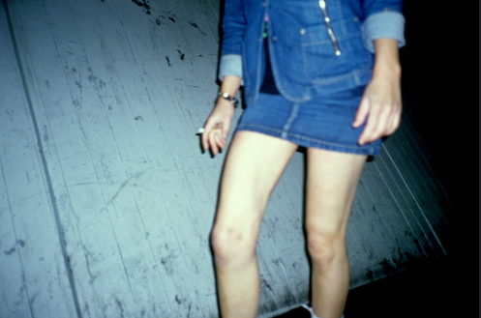
Photo by alessandro isnotaurello √on Flickr
we bought the hooker and took her to our studio...
- Have a look at this picture
- Give the woman a name
- Imagine what her story might be: where is she going? Who is she meeting?
- How would you feel about talking to her?
- How could you find out about whether she was a victim of trafficking?
- Whatever her story, what sort of future would you like her to have?

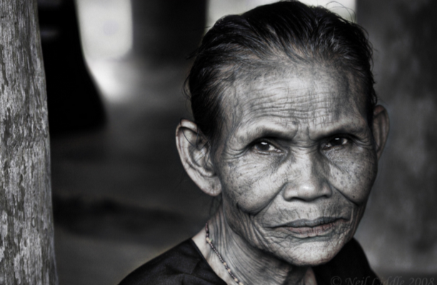
Photo by Neils Photography on Flickr
This lovely lady is forever indebted to the family I stayed with in Toraja. Many years ago, she found herself in serious trouble. Without a home and without a job, she begged to have a place to stay and food. In return, she promised she would help the family in home duties for the rest of her life. This lady was doing the cooking, cleaning and shoving away of children for the family funeral house.
- Have a look at this picture
- Give the woman a name
- Imagine you found her working for nothing in someone’s home. What do think her story might be?
- How would you feel about talking to her?
- How could you find out about whether she was a victim of human slavery?
- Whatever her story, what sort of future would you like her to have?

