People who help
In this section you can find a number of suggestions for charities which are actively engaged in helping people who have been trafficked or which are working to combat trafficking.
What you might like to do is visit one or two of these websites and read about what they are doing to fight against trafficking. Since websites sometimes come and go, you can find more sites using the Wikipedia link at the bottom.
Which of these charities might help our friends? How do you think their stories might change or develop because of the work of people who are trying to stop trafficking?

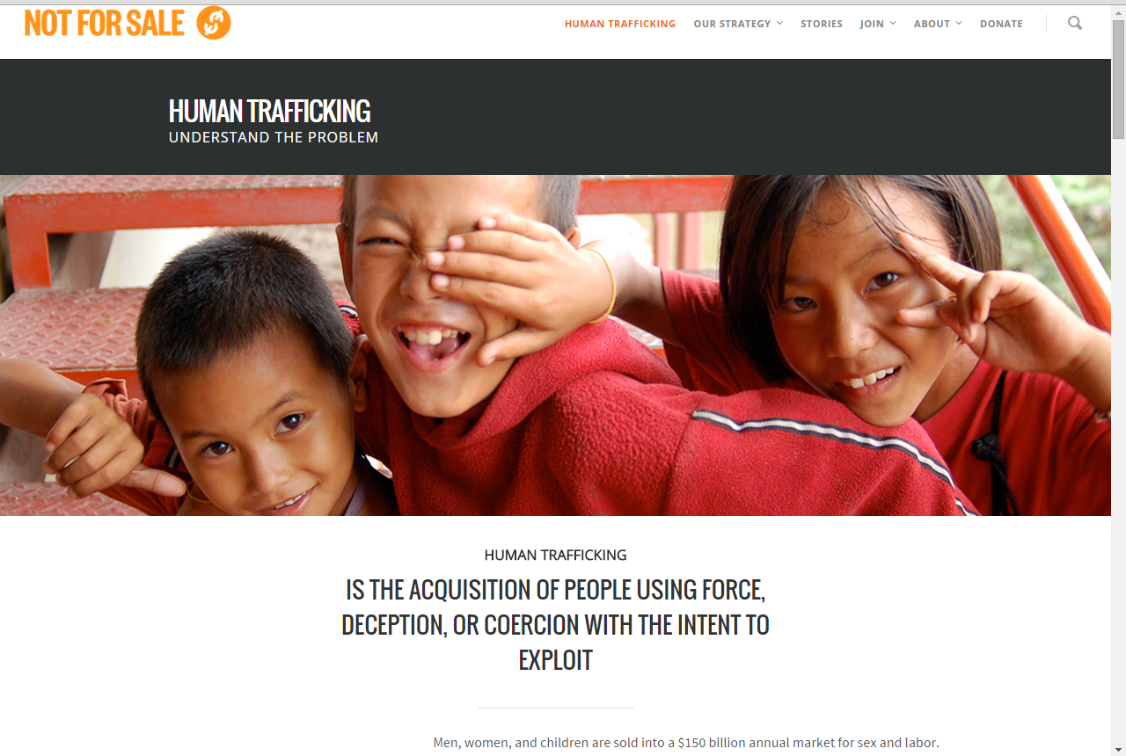
http://notforsalecampaign.org
http://www.barnardos.org.uk/what_we_do/our_work/trafficked_children.htm
http://www.tearfund.org/en/nochildtaken
http://www.unseenuk.org/
http://hopeforjustice.org/
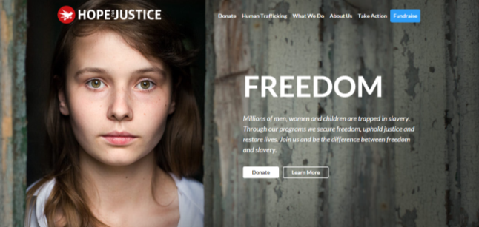
http://www.humantraffickingfoundation.org/
http://www.stopthetraffik.org/
http://www.antislavery.org/
http://www.eavesforwomen.org.uk/about-eaves/our-projects/the-poppy-project
http://www.enterprisingspirit.org/

http://www.ecpat.org.uk/
http://www.beyondthestreets.org.uk/
http://combattrafficking.eu/content/anti-trafficking-organisations
http://www.charistiwala.com
http://en.wikipedia.org/wiki/List_of_organizations_that_combat_human_trafficking

