Meet Jenny (YELLOW 2)
This is Jenny’s story (all names have been changed).
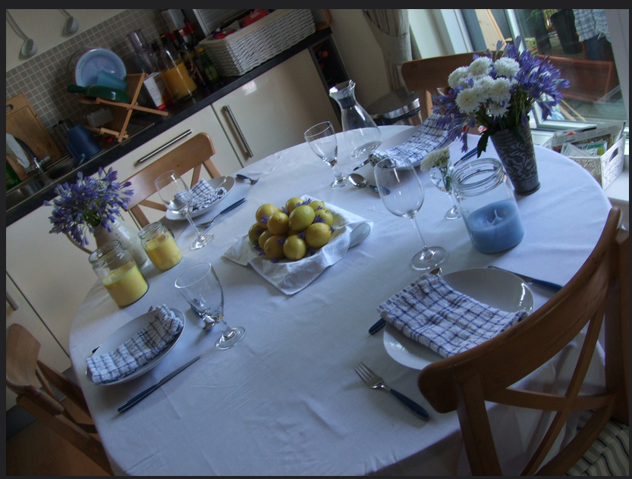
Photo by Elin B on Flickr
Jenny met Shana at work, and they were assigned to work on a project together. She liked Shana and after a few weeks, Shana asked if Jenny would like to go to a dinner party at her house. Jenny readily accepted.
Jenny was impressed by Shana’s house and by her wealthy and successful husband Deep. A number of people had come to the dinner party and she enjoyed meeting them and talking to them. When they sat down for dinner however, she was surprised to see a small, very thin, young Asian woman bringing in the food and serving it. There was something ‘off’ about the woman’s behaviour. Deep seemed annoyed at her presence and tutted loudly when she put the serving dish down noisily. As soon as the food was served, the woman disappeared very quickly, keeping her head down, not looking at Shana or Deep. Jenny was surprised and asked Shana if the woman was a relative. Shana shook her head, ‘servant’.
‘You mean she works for you? Like a housekeeper?’
Shana nodded carelessly and turned to her neighbour to talk about something else. Jenny wouldn’t let it go. ‘That woman lives here, or she has her own place?’
Deep overheard, ‘That’s really none of your business’
Jenny said sorry and got on with her food, but the woman still bothered her, although she really couldn’t say why.
A little later, Jenny decided to visit the loo. On the way, she caught sight of the serving woman again. She thought the woman was getting a mop out of a cupboard opposite the lavatory, but as she passed the woman quickly shut the door. In the small glimpse she had, Jenny thought she saw clothes and something like a bed. She smiled at the woman, but she fled back to the kitchen.
Jenny said nothing more about it, but she was still bothered by the woman and what she was doing in Shana’s house. At work, a couple of weeks later, Shana told Jenny she was going on holiday and was worried about the security of the house. Jenny asked whether the woman would be looking after the house. Shana suddenly became annoyed and said that the woman was a relative with mental health issues whom they had taken in as an act of kindness and that Jenny really should stop obsessing about her. Jenny was offended and the relationship between them cooled. After their project ended, she and Shana didn’t really speak any more.

Some questions:
- How would you have felt in Jenny’s position?
- What would you have said to Shana or to Deep?
- Do you think Jenny was right to be concerned or was she just sticking her nose in?
- What do you think Jenny should have done about the woman, if anything?
- How do you think Jenny would feel if the woman turned out to be trafficked or if it turned out Shana was telling the truth?

