Indicators of Trafficking
The following indicators come from http://www.unodc.org/pdf/HT_indicators_E_LOWRES.pdf
If you have looked at Jenny, Peter and Andy’s stories, you might like to see how many of these indicators were present in their experiences.

People who have been trafficked may:


• Believe that they must work against their will
• Be unable to leave their work environment
• Show signs that their movements are being controlled
• Feel that they cannot leave
• Show fear or anxiety
• Be subjected to violence or threats of violence against themselves or against their family members and loved ones
• Suffer injuries that appear to be the result of an assault
• Suffer injuries or impairments typical of certain jobs or control measures
• Suffer injuries that appear to be the result of the application of control measures
• Be distrustful of the authorities
• Be threatened with being handed over to the authorities
• Be afraid of revealing their immigration status
• Not be in possession of their passports or other travel or identity documents, as those documents are being held by someone else
• Have false identity or travel documents
• Be found in or connected to a type of location likely to be used for exploiting people
• Be unfamiliar with the local language
• Not know their home or work address
• Allow others to speak for them when addressed directly
• Act as if they were instructed by someone else
• Be forced to work under certain conditions
• Be disciplined through punishment
• Be unable to negotiate working conditions
• Receive little or no payment
• Have no access to their earnings
• Work excessively long hours over long periods
• Not have any days off
• Live in poor or substandard accommodations
• Have no access to medical care
• Have limited or no social interaction
• Have limited contact with their families or with people outside of their immediate environment
• Be unable to communicate freely with others
• Be under the perception that they are bonded by debt
• Be in a situation of dependence
• Come from a place known to be a source of human trafficking
• Have had the fees for their transport to the country of destination paid for by facilitators, whom they must payback by working or providing services in the destination
• Have acted on the basis of false promises

CHILDREN


Children who have been trafficked may:
• Have no access to their parents or guardians
• Look intimidated and behave in a way that does not correspond with behaviour typical of children their age
• Have no friends of their own age outside of work
• Have no access to education
• Have no time for playing
• Live apart from other children and in substandard accommodations
• Eat apart from other members of the “family"
• Be given only leftovers to eat
• Be engaged in work that is not suitable for children
• Travel unaccompanied by adults
• Travel in groups with persons who are not relatives
The following might also indicate that children have been trafficked:
• The presence of child-sized clothing typically worn for doing manual or sex work
• The presence of toys, beds and children's clothing in inappropriate places such as brothels and factories
• The claim made by an adult that he or she has “found” an unaccompanied child
• The finding of unaccompanied children carrying telephone numbers for calling taxis
• The discovery of cases involving illegal adoption

DOMESTIC SERVITUDE
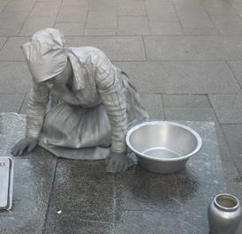

People who have been trafficked for the purpose of domestic servitude may:
• Live with a family
• Not eat with the rest of the family
• Have no private space
• Sleep in a shared or inappropriate space
• Be reported missing by their employer even though they are still living in their employer's house
• Never or rarely leave the house for social reasons
• Never leave the house without their employer
• Be given only leftovers to eat
• Be subjected to insults, abuse, threats or violence
People who have been trafficked for the purpose of sexual exploitation may:
• Be of any age, although the age may vary according to the location and the market
• Move from one brothel to the next or work in various locations
• Be escorted whenever they go to and return from work and other outside activities
• Have tattoos or other marks indicating “ownership” by their exploiters
• Work long hours or have few if any days off
• Sleep where they work
• Live or travel in a group, sometimes with other women who do not speak the same language
• Have very few items of clothing
• Have clothes that are mostly the kind typically worn for doing sex work
• Only know how to say sex-related words in the local language or in the language of the client group
• Have no cash of their own
• Be unable to show an identity document
The following might also indicate that children have been trafficked:
• There is evidence that suspected victims have had unprotected and/or violent sex.
• There is evidence that suspected victims cannot refuse unprotected and/or violent sex.
• There is evidence that a person has been bought and sold.
• There is evidence that groups of women are under the control of others.
• Advertisements are placed for brothels or similar places offering the services of women of a particular ethnicity or nationality.
• It is reported that sex workers provide services to a clientele of a particular ethnicity or nationality.
• It is reported by clients that sex workers do not smile.

LABOUR EXPLOITATION
People who have been trafficked for the purpose of labour exploitation are typically made to work in sectors such as the following: agriculture, construction, entertainment, service industry and manufacturing (in sweatshops).
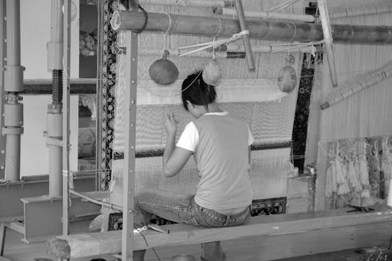

People who have been trafficked for labour exploitation may:
• Live in groups in the same place where they work and leave those premises infrequently, if at all
• Live in degraded, unsuitable places, such as in agricultural or industrial buildings
• Not be dressed adequately for the work they do: for example, they may lack protective equipment or warm clothing
• Be given only leftovers to eat
• Have no access to their earnings
• Have no labour contract
• Work excessively long hours
• Depend on their employer for a number of services, including work, transportation and accommodation
• Have no choice of accommodation
• Never leave the work premises without their employer
• Be unable to move freely
• Be subject to security measures designed to keep them on the work premises
• Be disciplined through fines
• Be subjected to insults, abuse, threats or violence
• Lack basic training and professional licences
The following might also indicate that people have been trafficked for labour exploitation:
• Notices have been posted in languages other than the local language.
• There are no health and safety notices.
• The employer or manager is unable to show the documents required for employing workers from other countries.
• The employer or manager is unable to show records of wages paid to workers.
• The health and safety equipment is of poor quality or is missing.
• Equipment is designed or has been modified so that it can be operated by children.
• There is evidence that labour laws are being breached.
• There is evidence that workers must pay for tools, food or accommodation or that those costs are being deducted from their wages.

BEGGING AND PETTY CRIME
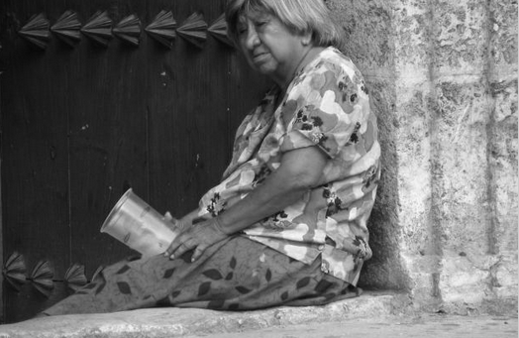
People who have been trafficked for the purpose of begging or committing petty crimes may:
• Be children, elderly persons or disabled migrants who tend to beg in public places and on public transport
• Be children carrying and/or selling illicit drugs
• Have physical impairments that appear to be the result of mutilation
• Be children of the same nationality or ethnicity who move in large groups with only a few adults
• Be unaccompanied minors who have been “found” by an adult of the same nationality or ethnicity
• Move in groups while travelling on public transport: for example, they may walk up and down the length of trains
• Participate in the activities of organized criminal gangs
• Be part of large groups of children who have the same adult guardian
• Be punished if they do not collect or steal enough
• Live with members of their gang
• Travel with members of their gang to the country of destination
• Live, as gang members, with adults who are not their parents
• Move daily in large groups and over considerable distances
The following might also indicate that people have been trafficked for begging or for committing petty crimes:
• New forms of gang-related crime appear.
• There is evidence that the group of suspected victims has moved, over a period of time, through a number of countries.
• There is evidence that suspected victims have been involved
‎

