Engaging with the Bible (BLUE 1)
Below are three passages from the Bible which contain stories which can help us reflect on issues of human trafficking today. Each passage is followed by some suggested questions for discussion.
Genesis 37: 23-24

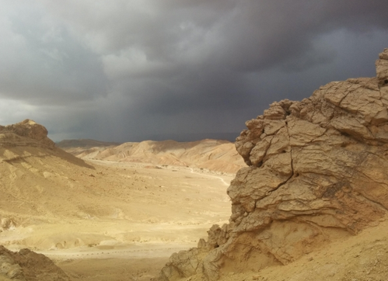
So when Joseph came to his brothers, they stripped him of his robe, the long robe with sleeves that he wore; and they took him and threw him into a pit. The pit was empty; there was no water in it.
Then they sat down to eat; and looking up they saw a caravan of Ishmaelites coming from Gilead, with their camels carrying gum, balm, and resin, on their way to carry it down to Egypt. Then Judah said to his brothers, ‘What profit is there if we kill our brother and conceal his blood? Come, let us sell him to the Ishmaelites, and not lay our hands on him, for he is our brother, our own flesh.’ And his brothers agreed. When some Midianite traders passed by, they drew Joseph up, lifting him out of the pit, and sold him to the Ishmaelites for twenty pieces of silver. And they took Joseph to Egypt.
When Reuben returned to the pit and saw that Joseph was not in the pit, he tore his clothes. He returned to his brothers, and said, ‘The boy is gone; and I, where can I turn?’ Then they took Joseph’s robe, slaughtered a goat, and dipped the robe in the blood. They had the long robe with sleeves taken to their father, and they said, ‘This we have found; see now whether it is your son’s robe or not.’ He recognized it, and said, ‘It is my son’s robe! A wild animal has devoured him; Joseph is without doubt torn to pieces.’ Then Jacob tore his garments, and put sackcloth on his loins, and mourned for his son for many days.

Some things to think about:
- What of motives do the brothers have for selling Joseph into slavery? (You could also read the rest of the story in context if you wanted to explore this more deeply)
- What do you think about the role of lies and deceit in human slavery?
- How do you think Joseph felt about what was happening to him?
- How you think Reuben and Jacob felt about the story they were told?
- Imagine re-telling this story from the point of view of the traders.
- How might this story help us engage with issues of human trafficking today?

Judges 19. 22; 25-28


While they were enjoying themselves, the men of the city, a depraved lot, surrounded the house, and started pounding on the door.... So the man seized his concubine, and put her out to them. They wantonly raped her, and abused her all through the night until the morning. And as the dawn began to break, they let her go. As morning appeared, the woman came and fell down at the door of the man’s house where her master was, until it was light.
In the morning her master got up, opened the doors of the house, and when he went out to go on his way, there was his concubine lying at the door of the house, with her hands on the threshold. ‘Get up,’ he said to her, ‘we are going.’ But there was no answer.

Some things to think about:
- Why do you think the man gave his concubine to the men?
- What issues of power and responsibility are laid out in this story?
- What do you feel about the acts of violence in this story?
- How might this story help us engage with issues of human trafficking today?
Philemon 1.8-21


For this reason, though I am bold enough in Christ to command you to do your duty, yet I would rather appeal to you on the basis of love—and I, Paul, do this as an old man, and now also as a prisoner of Christ Jesus. I am appealing to you for my child, Onesimus, whose father I have become during my imprisonment. Formerly he was useless to you, but now he is indeed useful both to you and to me. I am sending him, that is, my own heart, back to you. I wanted to keep him with me, so that he might be of service to me in your place during my imprisonment for the gospel; but I preferred to do nothing without your consent, in order that your good deed might be voluntary and not something forced. Perhaps this is the reason he was separated from you for a while, so that you might have him back for ever, no longer as a slave but as more than a slave, a beloved brother—especially to me but how much more to you, both in the flesh and in the Lord.
So if you consider me your partner, welcome him as you would welcome me. If he has wronged you in any way, or owes you anything, charge that to my account. I, Paul, am writing this with my own hand: I will repay it. I say nothing about your owing me even your own self. Yes, brother, let me have this benefit from you in the Lord! Refresh my heart in Christ. Confident of your obedience, I am writing to you, knowing that you will do even more than I say.

Some things to think about:
- What is Paul saying about Onesimus?
- What difference might this change make to the Christian community?
- How do you think Onesimus felt about what Paul was trying to do?
- How might this story help us engage with issues of modern day slavery today?

