Being Vigilant (PINK 2)
It is easy enough to learn about the problems of human trafficking, but how do we have to change to meet the challenges of identifying and stopping trafficking in our own communities?
The first issue is one of awareness. What sixth sense do we possess that tells us that something is not quite right or that things are not as they should be?
All of us perhaps need to become more aware of the communities around us. That doesn’t mean we should spy on people or intrude into their business, but just to make a little more time to know what is going on in our vicinity. Many people today spend a lot of their time talking on mobiles, listening to music or talking on phones, even when they are travelling around. That makes it more difficult for people who are in trouble to make themselves known, even when they are in plain sight.

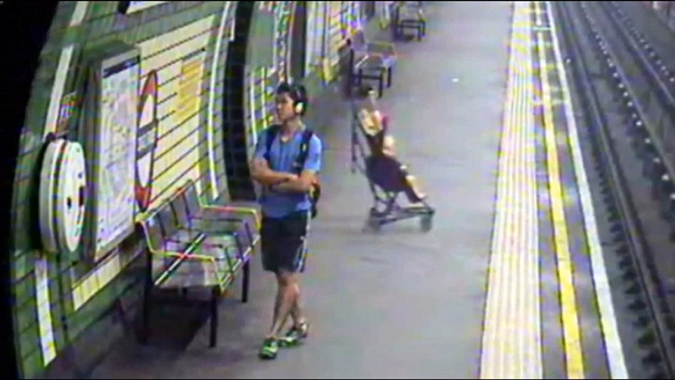
http://www.dailymail.co.uk/news/article-2721963/Heartstopping-moment-child-pushchair-falls-TRACKS-London-Tube-train-rescued-mother-just-seconds-spare.html
For example, this baby in a stroller fell on to the tracks while the man in the photo was entirely unaware that anything was happening. Fortunately the baby was rescued, but it seems amazing that this could happen while the man, a couple of yards away, was entirely oblivious. But sometimes we can be just as oblivious to what’s around us too.
So how can we become more aware? Here are some ideas:
Who is my neighbour?
Have a stroll around where you live. How many neighbours do you know by name, or by sight? How many people do you feel comfortable saying hello to, or smiling at when you meet them?
When you are out and about in your area, have a look at the buildings you pass by. Do you know what they are all for? Are there any with bars on the windows or locked doors?

Who is travelling with me?
If you’re on a train or bus, ferry crossing or at an airport, are there young people or groups of people who seem lost, frightened, or wondering what to do next?
If you work with lorries or containers, it might be especially important to be vigilant. For example, in August 2014, workers at Tilbury Docks in Essex heard shouting coming from one of the containers that came in off a ship and discovered 35 terrified people trapped inside, one of whom had died. http://www.independent.co.uk/news/uk/home-news/tilbury-docks-man-dies-after-over-30-adults-and-children-are-found-in-container-9673137.html

Being safe:
If you suspect someone is a victim of trafficking don’t try and tackle the matter just on your own. Get help: call the local police (101) or any other authorised agency
Crimestoppers – 0800 555 111
The Salvation Army – 0300 303 8151
UKHTC – 0844 778 2406
NSPCC CTAC – 0808 800 5000

For a list of all contact numbers please visit:
http://www.nationalcrimeagency.gov.uk/about-us/what-we-do/specialist-capabilities/uk-human-trafficking-centre/national-referral-mechanism
Another important matter is to make sure that if you discover trafficking happening that you don’t do something to make matters worse: it is very important that a victim of trafficking is not put in more danger due to the actions of a person trying to assist them. So make sure:
- The person consents to be helped and understands what you’re offering to do to help.
- Tell them about their rights to assistance and protection
- Refer them to responsible agencies

