Being Responsible
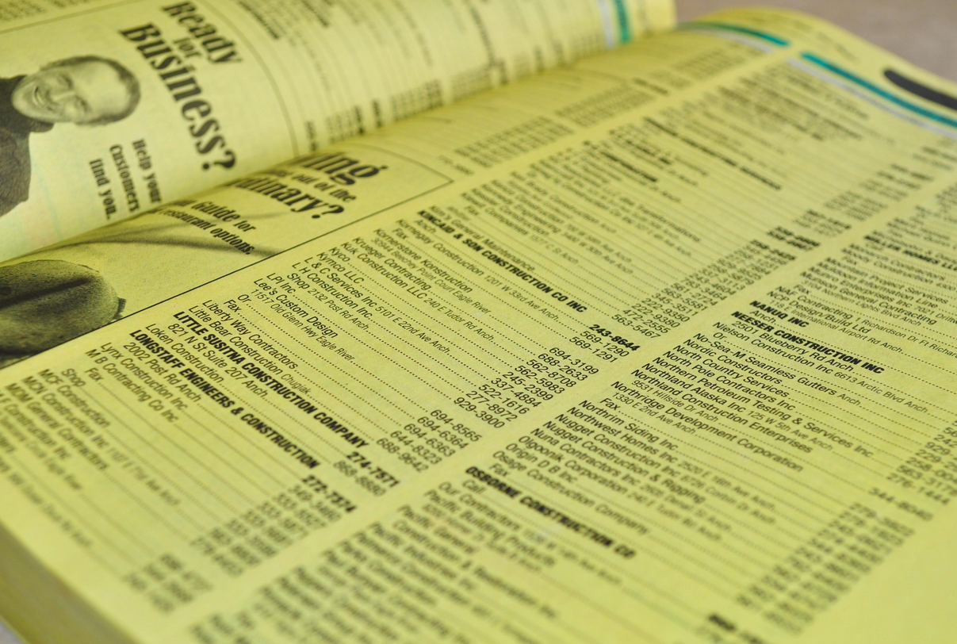

There are a number of things we can all do in our own lives which can change the conditions in which traffickers flourish. For example:

Sex
The journalist A J Jacobs, in The Year of Living Biblically, tried to address the issue of living a pure life by banishing from his life all temptations to lust. This was difficult as he works for Esquire, a magazine which interviews celebrities about their sex lives and publishes pictures of women and men in alluring poses.
A J Jacobs started by covering up all photographs and images which he thought might inspire lustful thoughts but then discovered something odd. Having previously been previously inured to billboards, magazines, scenes in film and TV, by trying to avoid them he discovered he could not think of anything else. Covering up photos just made him think about what was underneath and the more he tried to avoid sex in our western culture the more he found himself faced with it. This showed that we are so surrounded by sexual images and ideas in our culture that for the most time we neither notice nor are aroused by it: it is just there, playing into our subconscious all the time and we never notice how we are affected by it. When we become consciously aware of it, it affects us and makes us more uncomfortable.
The fact of sex work is a bit like this. Most of the time we never think about it. We read about or hear on the news about child sex abuse, child sex tourism and other crimes with horror and distaste without recognising the sexualisation of our culture all around us.
Many of us would feel deeply uncomfortable about walking through a red light district or finding out what goes on in strip clubs. But that can also mean that the victims of trafficking can be hidden in plain sight.
One of the things we can do is to become more aware of the sex industry all around us.

Asylum seekers and refugees
People trafficking often occurs when people are desperate to get away from persecution or the murderous intent of others. Gangs take advantage of people, often demanding money or identity documents and then stranding people or leaving them in dangerous situations.

Some people believe asylum seekers, refugees and illegal immigrants are only in the UK to sponge off our benefits system and to receive healthcare. So it is up to us to work in the ‘gap’ between the plight of people who may be stranded after being deceived and those who see them as a menace. It may help if we are willing to listen and to hear their stories without judgement in order to determine what kind of help they require.

Labour
Another thing we can do is be responsible when we employ people’s labour, whether that’s some work being done on our houses and gardens or if we run a business. Make sure that people are properly employed, paid, have proper equipment and breaks and are not coerced into what they are doing.
Money
Some people, especially children, may be trafficked for begging. While Christians may wish to help people who are homeless and in need it is worth considering what else a young person or child asking for money may be experiencing. Perhaps food and drink would be a better gift, or a bit of time to talk to them and see if they will trust you with their story.

Organ donation
If more people carry an organ donation card then there would be more organs available for transplant and the temptation to traffick organs would be reduced.

Prayer
It is important always to hold all those involved in trafficking in prayer. By regularly praying for them, we will not forget them, and our prayer habits will make us more aware of those out there who need help.

