Racial Justice Sunday 2014
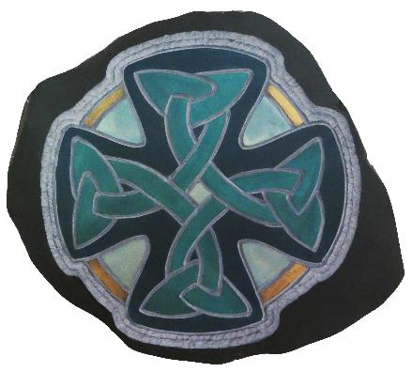
A Celtic Journey:
a
Celtic Welcome

‘Finding a large room between narrow walls.’
Waldo Williams (1904-1971)

Prepared by the Cytûn: Churches Together in Wales’ Racial Justice Network
Presented by Churches Together in Britain and Ireland

Introduction


This year’s Racial Justice Sunday materials are offered by the Cytûn: Churches Together in Wales’ Racial Justice Network as a gift from a modern, diverse and sophisticated liturgical culture profoundly aware of the pilgrimage journeying of its own rich Celtic roots and a current imperative to find newer expressions of welcome offered to Christians from the global community.
The materials are offered specifically from a modern bilingual national environment that is increasingly aware of its own fragility and vulnerability. That same national environment seeks to celebrate the richness of its own cultural and ethnic diversity and welcome more modern migrants embracing, particularly the most vulnerable who have fled violence, war and persecution, through innovative schemes and welcoming public policy conversations around inclusion rather than integration. A conversation that seeks to place an emphasis more on what recent communities arriving in Wales have to celebrate and offer in the shared space of a still new devolved civic nation rather than on how they may be assimilated into the host community.
Cytûn, of late, has rejoiced in being able to welcome and serve a growing number of ethnic minority congregations. During the build up to the 2013 Christmas celebrations, the Millennium Centre, Cardiff hosted a world record breaking Christmas Nativity play embracing the participation of over 50 nationalities. Cytûn also seeks to serve in the context of unpalatable challenges. This material is offered to the backdrop of the harsh realities of a hardening of attitudes concerning migration and race within Wales.

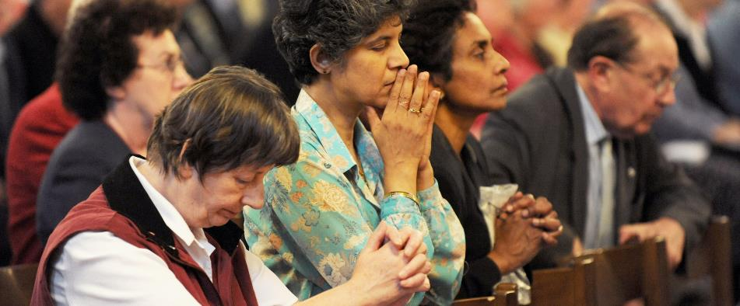

This year’s worship is shaped along the traditional pattern of Morning Prayer. It does so in 2014 partly to mark the passing of 350 years since the publication of the Book of Common Prayer in Welsh. Alongside the publication of the Welsh Bible in 1588, the Book of Common Prayer not only gave the Welsh language a status in law not afforded the other Celtic languages of the British Isles but may have pointed the way, many centuries later, to the legislative support now offered to a diversity of communities marked by the differences of protected characteristics: including race and religion or belief.
The liturgy offered here, however, seeks to be both catholic and Celtic: universal and particular, temporal and eternal. Even at the height of their ancient civilization, some six centuries before the birth of Christ, the Celts wrote down nothing of themselves. Yet, from ancient European roots, the stories of: their hierarchical societies, their senses of belonging as peoples, their warring and conquests, their commitments to land and industry and their forging of fine arts have endured in oral traditions and in our kindling of imagination. Their stories of journeying – for so many reasons - are our stories: their quest for deeper beliefs – explored in so many ways - touches upon our faith as experienced here through journeying and welcoming.

‘Worship: journey and welcome’

Hymn

- The Blessings of Many Beginnings

‘God give me the strength to hold on, and the strength to let go.’
Michael Leunig

The world belongs to God,
The earth and all its people.

How good it is, how wonderful,
To live together in unity.

Love and faith come together,
Justice and peace join hands.

If Christ’s disciples keep silent
These stones would shout aloud.

Open our lips, O God,
And our mouths shall proclaim your praise.

'The Morning Service: Opening Responses', Iona Abbey Worship Book
- The Absolutions of Altered Directions
‘We will have to repent in this generation not merely for the hateful words and actions of the bad people, but for the appalling silence of the good people.’
Martin Luther King
'Letter from Birmingham Jail'
April 16th, 1963

“With what shall I come before the Lord,
and bow myself before God on high?
Shall I come before him with burnt offerings,
with calves a year old?
Will the Lord be pleased with thousands of rams,
with ten thousands of rivers of oil?
Shall I give my firstborn for my transgression,
the fruit of my body for the sin of my soul?”
He has told you, O man, what is good;
and what does the Lord require of you
but to do justice, and to love kindness,
and to walk humbly with your God?
Micah 6: 6-8 (NRSV)

God, the Father of mercies,
has reconciled the world to himself
through the death and resurrection of his Son, Jesus Christ,
not counting our trespasses against us,
but sending his Holy Spirit
to shed abroad his love among us.
By the ministry of reconciliation
entrusted by Christ to his Church,
receive his pardon and peace
to stand before him in his strength alone,
this day and evermore. Amen.

Kyrie Confession, Book of Common Prayer
3. The Jubilate Journey

In work and worship
God is with us
Gathered and scattered
God is with us
Now and always
God is with us.
'An Act of Prayer For Use When Community Gathers',
Iona Community Members’ book

Jubilate

- O be joyful in the Lord, all the earth;
serve the Lord with gladness
and come before his presence with a song.

2. Know that the Lord is God;
it is he that has made us and we are his;
we are his people and the sheep of his pasture.

3. Enter his gates with thanksgiving
and his courts with praise;
give thanks to him and bless his name.

4. For the Lord is gracious; his steadfast love is everlasting,
and his faithfulness endures from generation to generation.

Psalm100
4. An Old Testament Reading
Suggested: Genesis 12: 1-9, Deuteronomy: 1 1-8 or Ruth: 1 6-22.

Song of Ezekiel

1. I will take you from the nations,
and gather you from all the countries.

2. I will sprinkle clean water upon you,
and you shall be clean from all your uncleannesses.

3. A new heart I will give you,
and put a new spirit within you,

4. And I will remove from your body the heart of stone
and give you a heart of flesh.

5. You shall be my people,
and I will be your God.
Ezekiel 36.24-26,28b (NRSV)
5. A New Testament Reading
Suggested: Acts 16: 1-15, Philippians 3: 12- 4: 1 Revelation 21: 1-7.

Saviour of the World

1. Jesus, Saviour of the world,
come to us in your mercy:
we look to you to save and help us.

2. By your cross and your life laid down,
you set your people free:
we look to you to save and help us.

3. When they were ready to perish, you saved your disciples:
we look to you to come to our help.

4. In the greatness of your mercy, loose us from our chains,
forgive the sins of all your people.

5. Make yourself known as our Saviour and mighty deliverer;
save and help us that we may praise you.

6. Come now and dwell with us, Lord Christ Jesus:
hear our prayer and be with us always.

7. And when you come in your glory:
make us to be one with you
and to share the life of your kingdom.

Common Worship
6. Of Believing
I will not die an unlived life.
I will not go in fear
Of falling or catching fire.
I choose to inhibit my days,
To allow my living to open to me,
To make me less afraid,
More accessible,
To loosen my heart
Until it becomes a wing,
A torch, a promise.
I chose to risk my significance:
To live.
So that which came to me as seed,
Goes to the next as blossom;
And that which comes to me as blossom,
Goes on as fruit.
Dawna Markova
Or

We believe in God
Who takes our smallest moment of hope
And grows it forth like a tree
with spreading branches
for the sheltering of new life.

We believe in Jesus Christ
Who walks tall among us,
Seen in our faces, felt in our hearts,
Bedded deep in the longing of our souls
For all that is true, just and full of hope.

We believe in the Holy Spirit
Who waits on our moments of openness
and springs into the unknowns
with joy and delight,
that we may be called on
beyond where we thought we could go
where every step is walked on holy ground.

Dorothy McRae-McMahon, Australian writer and theologian

In all our travelling
May your footsteps guide us

In our journeying to work and returning
May your footsteps guide us

Within our homes and families
May your footsteps guide us

In our leisure time together
May your footsteps guide us

In difficult situations and conflict
May your footsteps guide us

As we stumble on the way
May your footsteps guide us

In the travelling of our faith
May your footsteps guide us

As we place our trust in you
May your footsteps guide us

In all our travelling. Lord,
may it be your footsteps
in which we place our feet.

From Heart2Heart, John Birch

Let us pray with confidence as our Saviour has taught us

Our Father, who art in heaven,
hallowed be thy name;
thy kingdom come;
thy will be done;
on earth as it is in heaven.
Give us this day our daily bread.
And forgive us our trespasses,
as we forgive those who trespass against us.
And lead us not into temptation;
but deliver us from evil.
For thine is the kingdom,
the power and the glory,
for ever and ever. Amen.
Common Worship
Hymn

7. Prayers and Meditation (faces on the journey)
The following prayers, focused on the lives of mainly unknown travellers may be used on their own before the mediation or alongside other prayers.
Prayers
O God, the creator and preserver of all, we pray for people of every race and in every kind of need: make your ways known on earth, your saving power among all nations.
Common Worship

Macrinus (North African Migrant from Roman times)
We think of Macrinus, one migrant from north Africa. Writing on a bowl bearing his name from Roman times, found in Holt near Wrexham, suggests that he was amongst the first Africans to migrate to Britain.

Blessed are You, Lord Jesus Christ.
You crossed every border
between Divinity and humanity
to make your home with us.
Help us to welcome you in newcomers,
migrants and refugees.

Blessed are You, God of all nations.
You bless our land richly
with goods of creation
and with people made in your image.
Help us to be good stewards and peacemakers,
who live as your children.
Blessed are You, Holy Spirit.
You work in the hearts of all
to bring about harmony and goodwill.
Strengthen us to welcome those
from other lands, cultures, religions,
that we may live in human solidarity
and in hope.

God of all people, grant us vision
to see your presence in our midst,
especially in our immigrant sisters and brothers.
Give us courage to open the door to our neighbors
and grace to build a society of justice.
Pax Christi
Brynach (Abbot)
We think of Brynach, one Celtic saint of the many. He travelled from Ireland to Brittany and then to Wales establishing a series of monasteries as places of worship and service.
O Divine Master,
grant that I may not so much seek
to be consoled as to console,
to be understood as to understand,
to be loved as to love.

For it is in giving that we receive,
it is in pardoning that we are pardoned,
and it is in dying that we are born again
to eternal life.
St Francis of Assisi
Joseph Potiphar (a black boy ‘belonging to’ Sir Rowland Gwin)
We think of Joseph Potiphar, one black baby boy. Perhaps the first black person to be baptised in Wales in St John’s Church, Cardiff on 30 May, 1687.
O God,
you created all people in your image.
We thank you for the astonishing variety
of races and cultures in this world.
Enrich our lives by ever-widening circles of friendship,
and show us your presence
in those who differ most from us,
until our knowledge of your love is made perfect
in our love for all your children;
through your Son, Jesus Christ our Lord.
Lutheran Book of Worship
Willis (a freed slave)
We think of Willis, one freed slave. Amongst the first slaves from America, who on arriving at Swansea Bay on the St Peter, was granted emancipation in Britain and Ireland.
God of freedom, be with the people enslaved around the world. Help them to remember that they have dignity and worth. Guide us as we endeavour to end human trafficking and work for freedom for all people.
Intercommunity Peace and Justice Center
Käte Bosse-Griffiths (refugee from the Nazi persecution)
We think of Käte Bosse – Griffiths, one refugee. Born and brought up in Luther’s own town, Wittenberg, before having to flee Nazi persecution in 1936 because of her Jewish ancestry. From her adopted home in Swansea, she became a strong advocate for the Welsh language and culture.
Almighty and merciful God, whose Son became a refugee and had no place to call his own; look with mercy on those who today are fleeing from danger, homeless and hungry. Bless those who work to bring them relief; inspire generosity and compassion in all our hearts; and guide the nations of the world towards that day when all will rejoice in your Kingdom of justice and of peace; through Jesus Christ our Lord. Amen.
Church of England
Meditation

Hymn

8. The Blessing

May the road rise up to meet you.
May the wind be always at your back.
May the sun shine warm upon your face;
the rains fall soft upon your fields and until we meet again,
may God hold you in the palm of His hand. Amen.
traditional Gaelic blessing

Acknowledgements
P2. Photo: Matt Hamm
P3. Photo: © Mazur/catholicchurch.org.uk
p.4 'The Morning Service: Opening Responses', Iona Abbey Worship Book, Wild Goose Publications, Glasgow (2001), p.15.
p.5 Micah 6:6-8 and p.7 Song of Ezekiel from The New Revised Standard Version (Anglicized Edition), copyright 1989, 1995 by the Division of Christian Education of the National Council of the Churches of Christ in the United States of America. Used by permission. All rights reserved.
Prayer from Book of Common Prayer, rights in which are vested in the Crown, is reproduced by permission of the Crown's Patentee, Cambridge University Press.
p.6 'An Act of Prayer For Use When Community Gathers', Iona Community Members’ book, © Iona Community, p.6.
Psalm 100 from The Common Worship Salter © The Archbishop’s Council
p.8 Saviour of the World from Common Worship © The Archbishop’s Council
p.9 Material excerpted from the book, I WILL NOT DIE AN UNLIVED LIFE ©2000 Dawna Markova, with permission from Red Wheel/Weiser, LLC Newburyport, MA and San Francisco, CA www.redwheelweiser.com
Dorothy McRae-McMahon, Liturgies for the Journey of Life, SPCK
p.10 Prayer from Heart2Heart - Contemporary Prayers and Liturgies, John Birch (www.faithandworship.com)
Lord’s Prayer from Common Worship © The Archbishop’s Council
P.11 Prayer from Common Worship © The Archbishop’s Council
P. 13 From Lutheran Book of Worship copyright © 1978 Lutheran Book of Worship admin. Augsburg Fortress. Reproduced by permission.
Prayer for those enslaved, Intercommunity Peace and Justice Center (www.ipjc.org)
A Prayer for Refugees from Church of England

